Integrated Solid Waste Plan
For the Village of Solomon

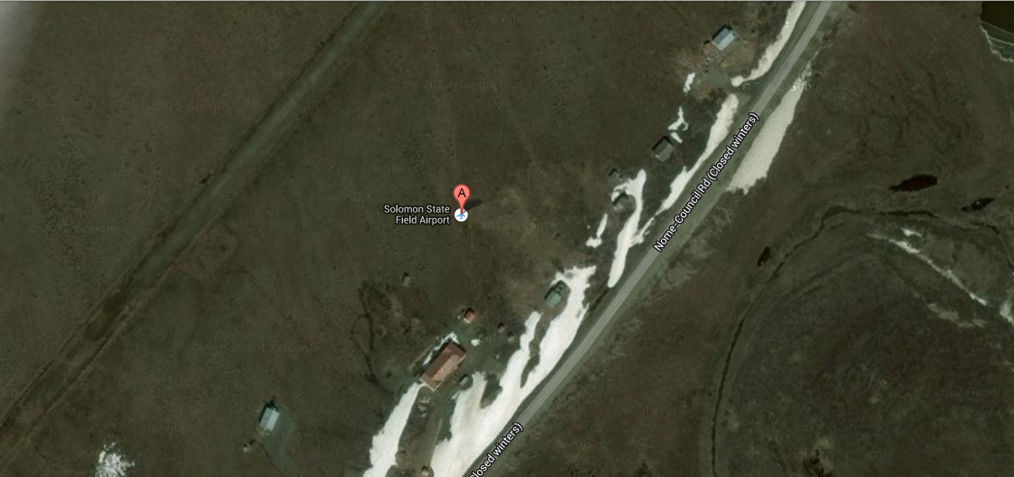
Community Center

August 7, 2013

Last Revision on November 9, 2016
Integrated Solid Waste Plan
For the Native Village of Solomon

Compiled by:

Village of Solomon’s Environmental Coordinator

Additional Special Acknowledgements:
We would like to thank the Elders in our community for their valuable words of guidance. We would also like to thank the Environmental Planning Committee for their efforts toward the Village of Solomon’s environmental issues, Environmental Protection Agency for Solomon’s IGAP Grant and all the guidance put forth towards aiding Solomon’s Environmental Coordinator from surrounding entities and resources.

Introduction And Description Of Community 3
1.1 Mission and Values 3
1.2 Location and Climate: 3
1.3 Additional Critical Community Logistics Relating to Waste Management 3
2. Taking Care Of Our Wastes Properly 4
2.1 Elder Guidance: Error! Bookmark not defined.
2.2 Elders’ words: Error! Bookmark not defined.
2.3 Environmental Planning Committee: 4
2.4 Tribal Surveys 4
2.5 Tribal gatherings/ Youth camp 7
2.6 Community Education, Outreach, and Voiced Concerns 7
2.7 Public Outreach Printed Materials 8
2.8 Health and Environmental Issues 9
3. Current Solid Waste Management Program And Practices 10
3.1 Summary of Waste Generation 10
4. Recycling, Reducing, Rejecting, & Reusing Programs 10
5. Additional Related Waste Concerns For Subsistence 12
6. Climate Change Planning 12
7.1Summary of Programs 13

Introduction And Description Of Community

Mission and Values
By 2018, Village of Solomon (VOS) envisions to work with the Solomon Native Corporation (SNC) for capacity building, to create new projects together, enhance the local economy while staying true to subsistence traditions, to be empowered, and as a community- to enhance and strengthen social and economic future, strive for unity, engage and empower our youth to be leaders, and to utilize our elders and youth to revitalize our culture and traditional values.

The VOS tribal members listed the top five Environmental issues that were voted in a survey fall 2013. In May of 2014, invitation letters were sent to tribal members to apply for the first time Environmental Planning Team. The idea was to address each issue, discuss short-term/long-term solutions and action plans. VOS hopes to build relationships with SNC, Kawerak, Norton Sound Regional Hospital, State of Alaska, Environmental Protection Agency (EPA), Norton Sound Economic Development Corporation (NSEDC) and any other tribal entity in implementing such solutions.

Location and Climate:

Solomon is located on the west bank of the Solomon River, one mile north of the Norton Sound, a 30 miles east of Nome on the Nome-Council Highway. It lies at 64.560830 North Latitude and -164.43917 West Longitude. Solomon is located in the Cape Nome Recording District. The climate is both continental and maritime. Summers are short, wet and mild. Winters are cold and windy. The Temperatures range from -30 degrees, well into the 80’s.

Additional Critical Community Logistics Relating to Waste Management

Solomon is a seasonal village with the most activity during the summer months. When Tribal members are in Solomon, the Solid Waste is kept in the sheds of the cabins or in the Community Center until campers return to Nome and dispose of waste in the City of Nome’s landfill. VOS’ Local Economic Development Plan (LEDP) was created in June 2011 with 11 listed Village priorities that are re-prioritized each year in the annual meeting. Waste Management has always been ranked in the top 5. Currently, it is listed as #3 (August 2014).

Taking Care Of Our Wastes Properly

Environmental Planning Committee:
A Committee was formed on June 25th, 2014. This committee was comprised of 5 members. They represented different parts of our community. Their job was to make sure that our plan fits our community and will work best for our community. Between two meetings, their ideas included:
- Making sure that we find solutions which are environmentally safe, economical and effective to benefit the whole community.
- Creating a solid waste management program by purchasing a trailer to haul gathered waste using the bear safe trash cans that were purchased under the IGAP grant. User policies will be signed in order to receive a trash bin to ensure clean organized trash disposal.
- Recycling program. Crushing our aluminum cans to combine with home recycled aluminum cans. The plan is to send the cans using our Alaskans for Litter Prevention and Recycling (ALPAR) account for free on Northern Air Cargo to Anchorage and get paid $0.35/lb. Proceeds will go to trash collectors.
- To purchase clean up supplies for a fall and spring clean-up. It is suggested that VOS provides lunch.
- Work closely with NSEDC’s program to increase salmon counts. SNC has been working with NSEDC and Alaska Department of Fish & Game for the last few years on chum rehabilitation. VOS plans to follow updates and offer support in ways they can.
- To fill our existing 200 gallon potable water tank purchased through the IGAP grant and to keep that maintained. The long term idea is to insulate a 500 gallon potable water tank and bury it in Solomon, and to refill an empty tank to haul back and forth.

The committee will meet two more times. The following people have served on our committee:

- Grace Davenport, Tribal member
- Cheryl Komakhuk, Tribal member
- Greg Timbers, President & CEO of SNC, Tribal member
- Deilah Johnson, Environmental Coordinator, formal Council member
- Tim Stettinger, Tribal member

Tribal Surveys
Two community surveys were sent out regarding concerns and suggestions toward Solomon’s environment. The first survey was on the environmental issues, and the second survey was on solid waste. These surveys were conducted in spring 2013 by the IGAP staff.

The top concern from our tribal members is ‘Safe drinking water.’

Environmental Issue survey, copied and pasted into plan.
___________________________________________________________________________
Complete Environmental Survey by April 19 and Enter to Win a $75 Carrs/Safeway Gift Certificate

There may be serious environmental pollution problems in our village. We need your help in ranking the environmental issues identified below. This survey form is designed to obtain your input to develop our village environmental plan. Our goal is to make our community a healthier place to camp and subsistence gather. Your participation in this survey will greatly assist us in reaching our vision and goals, and will help us address serious environmental issues in our village.

Listed below are some environmental health problems or issues that may need to be addressed. Each environmental issue below should be ranked as to how important you believe that issue is in our village.

Safe drinking water | 1 | 2 | 3 | 4 | 5
Beach and river bank erosion | 1 | 2 | 3 | 4 | 5
Grave site land bank erosion | 1 | 2 | 3 | 4 | 5
Community dump/landfill site | 1 | 2 | 3 | 4 | 5
Construction material left behind by contractors | 1 | 2 | 3 | 4 | 5
Annual clean-up program | 1 | 2 | 3 | 4 | 5
A environmental planning team | 1 | 2 | 3 | 4 | 5
Indoor/outdoor air pollution (wood smoke/road dust) | 1 | 2 | 3 | 4 | 5
Fuel oil/hazardous waste spills and soil contamination | 1 | 2 | 3 | 4 | 5
Trash left in/around village | 1 | 2 | 3 | 4 | 5
Spring/fall storm damage | 1 | 2 | 3 | 4 | 5
Salmon enhancement | 1 | 2 | 3 | 4 | 5
Dead animals and fish along river beds | 1 | 2 | 3 | 4 | 5
Old buildings like the collapsed covenant church | 1 | 2 | 3 | 4 | 5
Starting a recycling program for community center | 1 | 2 | 3 | 4 | 5
Other (please list):___________________________ | 1 | 2 | 3 | 4 | 5
“1” is the lowest ranking---not very important or not a issue and “5” is the highest ranking---very important or a big issue.

Please identify any areas in or around Solomon that you are aware of that have soil contamination:
________________________________________________________________________________________________________________
________________________________________________________________________________________________________________
________________________________________________________________________________________________________________
Please identify any areas in or around Solomon that have debris that you would like to see cleaned up:
________________________________________________________________________________________________________________
________________________________________________________________________________________________________________
________________________________________________________________________________________________________________
Please use the space below for comments and suggestions on other environmental issues that you may have and that need to be addressed.

________________________________________________________________________________________________________________
_____________________________________________________________________________________________________________
This survey is very important to our tribe, and thank you for taking the time to fill it out. The results of the survey will be posted in the next newsletter.
____________________________________________________________________________
Solid Waste survey, copied and pasted into plan.
Solid Waste Management Plan Questionnaire
This questionnaire is to get a assessment on how much Solid Waste is our Village making and how it’s disposed off currently, and how we can as a Tribe deal with Solid Waste and how we can improved our Solid Waste Management for the Future.
1) Approximately how often do you stay at Solomon overnight?
- I don’t overnight at Solomon
- 1-2 times per year
- 3-4 times per year
- 1-2 times per week (when the road is open)
- 3 or more times per week (when the road is open)
- Other: (please describe)____________________________
2) Do you go to Solomon during the winter months?
- I don’t overnight at Solomon
- 1-2 times per year
- 3-4 times per year
- 1-2 times per week (when accessible by snow machine)
- 3 or more times per week (when accessible by snow machine)
- Other: (please describe)____________________________

3) When you are at Solomon how do you store or waste? (Trash, garbage or other)

4) How much waste do you accumulate while there?

5) How do you get rid of your waste?

6) How are you disposing of human waste? (Example-honey bucket, outhouse, other)

7) Are there any challenges with current waste management?

8) What would improve the current waste system?

9) Is there any other Solid Waste issues?

Tribal gatherings/ Youth camp
We hold three tribal gatherings a year and report all updates regarding Solomon’s environment to community.

Community Education, Outreach, and Voiced Concerns
At the upcoming annual meeting, which will be held on September 26th, 2014 in Nome, the tribal members will be educated on recycling, and proper disposal of waste. They will be educated by a well put together presentation by the Environmental Coordinator, then given a quiz. Prizes will be awarded upon passing the quiz. The tribal members located in the Anchorage area will have a tribal gathering on October 19th, 2014 and will also have the same opportunity taking the quiz.

This is what people are saying in our community related to solid waste management:
- Old store clean up
- The late Franklin Okitkon’s cabin cleaned up
- Dust control
- The drums by the river need to be cleaned up
- Glad the environmental issues are being addressed
- Clean up the church and around other buildings
- There is debris all around the village
- Clean up the old water tank

Public Outreach Printed Materials

VOS creates two newsletters annually, with E.P.A’s grant, VOS has been able to hire an Environmental Coordinator who has been writing reports specifically for the newsletter. These reports have been educational material to help tribal members learn to reduce, reuse, and recycle what they can within their household. The Environmental Coordinator also creates bi-annual Environmental Educational postcards for members who are not on the ‘3R’s of the Bering Strait Region’ Facebook page. The Environmental Dept. also collaborates with the Tribal Coordinator to develop an annual Environmental educational calendar and showcase membership throughout.

Here are some excerpts from the fall 2014 newsletter:

.
“Inconvenience and being too lazy to put forth the effort is one of the biggest reasons people choose to not recycle. It doesn’t take too much of your time, it’s rewarding in the end.
It’s never too early to teach your children to recycle. Put pictures on the bins so they can match the item they are tossing with the correct bin.
The process of recycling paper instead of making it from new materials generates 74% less air pollution and uses 50% less water.
Recycling one ton of paper saves around 17 trees, 463 gallons of oil, 6,953 gallons of water, and 3 cubic yards of landfill space.
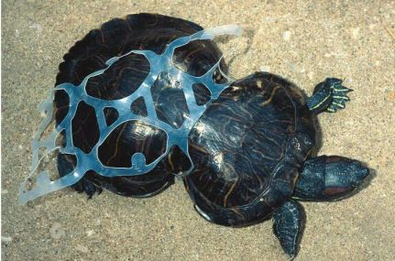
Glass can be reused infinitely if recycled.
Did you know that, over 46,000 pieces of plastic debris float on every square mile of the ocean? How often are we eating food directly from the ocean?

RECYCLING NEAR YOU:
Anchorage Recycling Center, Location: 6161 Rosewood Street, Anchorage. Hours: 24 hours a day, 7 days a week; regular weekday business hours for redemption of aluminum cans. Accepts: Aluminum cans, steel cans, mixed paper, corrugated cardboard, newspaper, #1 PET plastic bottles, #2 HDPE plastic jugs, plastic bags and film, glass bottles and jars
Anchorage Regional Landfill Recycling Area. Location: Hiland Road, Eagle River. Hours: During regular landfill hours; Mon.-Fri. 7:30am - 5pm, Sat. 8am - 5pm. Sun closed. Accepts: Aluminum cans, mixed paper, corrugated cardboard, newspaper, #1 PET plastic bottles, #2 HDPE plastic jugs, glass bottles and jars. The Municipality is evaluating the need to establish additional community recycling centers, potentially on the east side of Anchorage and Girdwood. Other drop-off locations for specific items exist throughout Anchorage. For More information call: (907) 343-6262 (customer service line)
Nome City Recycle Center. Located on Warren Place. Open 24/7. Accepts: Newspapers, Lead-acid batteries, cardboard, glass, Electronics, aluminum cans. Does not accept, tin cans, plastics, Styrofoam or fluids of any kind. Please be courteous when dropping off recyclables by putting your items in appropriate piles for organization.
Nome City Landfill, located at 3.0 mile Beam Road, open every Saturday. Winter Hours: 11-4 pm, Summer hours: 9-4pm. segregated piles and bins at landfill for: wood, glass, metals, copper, aluminum cans, electronic waste, cardboard and burnables, refrigerators and freezers.
For folks in the Lower 48, go to http://www.call2recycle.org/locator/ and type in your zip code for a list of recycling center locations.
Remember the 3 R’s------------------------- REDUCE, REUSE & RECYCLE”

In each Recycling reminder to membership, a Recycling locator is always printed. The Environmental dept. has also been able to host bi-annual Educational IGAP gatherings with IGAP updates for membership, has hosted several City of Nome community events such as; Mug Shot week- the idea is to get caught using a reusable mug and get recognized on a Tv channel and a chance to win some great donated prizes; A Swap Drive- which was an event hosted in the middle of the City of Nome to have community members show up with items they no longer want and instead of bringing to the landfill, to swap their items with other items from other community members; Earth Day Pledging – Environmental Staff went around the town for two weeks to gather pledges from community members to agree to not use plastics for one day or to carpool, walk or ride a bike for one day, they successfully raised over 400 pledges; VOS Hosted an Environmental Educational Youth Summit targeted to the Youth of the Nome area, about 50 youth were in attendance for a full day of environmental educational fun; and last but not least, VOS hosted a Climate Change Youth & Elder Camp in Solomon for 5 days for VOS Youth membership.
Outreach and Education quickly became a priority for the Environmental Dept. and has become well known for their efforts in raising awareness.

Health and Environmental Issues

Based on the above analysis of our current situation, our primary health and environmental issues related to solid waste management from the survey are:
- Lack of waste disposal resources which has caused trash to fly around the Village. Waste material has not been disposed of properly.
- Unsafe drinking water
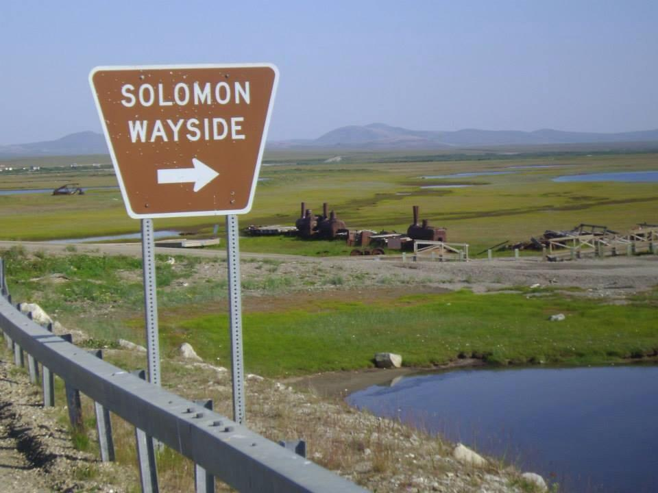
- Decrease in salmon population in our Solomon River. Salmon has always been a very active healthy part of Solomon’s subsistence way of living. Old broken down equipment left all over the village is a risk for contaminants in the soil and River.
- Gravesite land bank erosion
- Waste Management has become obsolete since it was a live city in the early 1900’s.
The Traditional Council has requested a backhaul project to remove the fallen down, rusted old fuel tank and the fallen down church, which they recently had tested for asbestos, which came back positive for asbestos. This has become a huge concern as it is in the middle of the Solomon community.

3. Current Solid Waste Management Program And Practices

Currently Solomon has maintained a communal mobile trash trailer and created a recycling pickup program for membership. The Solomon residents were distributed bear safe trash cans and signed a user policy to keep their waste clean and organized when delivered to the trash trailer.

3.1 Summary of Waste Generation
Solomon uses their communal mobile trash trailer for trash accumulated in Solomon. This has been extremely helpful for residents as they were also given bear safe trash cans and agreed to keep everything clean and covered. During this time, the VOS Environmental dept. was also able to order stackable recycling bins for their use to encourage recycling, which Environmental staff will pickup their full bags of recyclables. This was all accomplished through the IGAP FY15 grant. The final big project for Solomon is to remove the scrap metal and asbestos buildings located in the Solomon environment.

4. Recycling, Reducing, Rejecting, & Reusing Programs

Elders have always recycled, their grandmothers and grandfathers, and their grandmothers and grandfathers recycled. This was something that everyone in the community practiced. Around the 1960s and 1970s people started generating a lot more waste. VOS did not have a way to recycle all the new wastes. Elders say they got lazy and stopped recycling or reusing because they became overwhelmed with new things. Now there are ways to recycle some of these wastes so we have begun following our Elders’ advice about not wasting and to recycle again. We also know that many of these wastes are harmful to us, we are trying to reduce our use and keep them out of our trash bins and camps by utilizing the new recycling bins which the Environmental Coordinator created informational brochures on recycling facts in Nome.
Topic | Link
Recycling info on Zender – additional info on packing, resources | http://www.zendergroup.org/recycling.htm  http://www.zendergroup.org/docs/recycling_buyback.pdf
Storing wastes / Reuse Shed for Household Hazardous Wastes | http://www.zendergroup.org/reuse_shed.html
An updated summary of recycling resources | http://www.zendergroup.org/docs/swm_resources.pdf
Recycling information on AERHO | http://www.aerho.org/projects/recycle_list.html  http://www.aerho.org/projects/recycle_resources.html
Evaluating and comparing solid waste management methods including recycling, reducing, composting etc. ANTHC/ANHB SWM Guide Workbook 4 | http://www.zendergroup.org/anhbguide/4.pdf
ALPAR, Greenstar, Recycling options in Fairbanks | www.alparalaska.com/ http://www.greenstarinc.org/  http://iagreenstar.org/wp-admin/docs/Recycling_Options.pdf
Recycling bins/containers | http://www.zendergroup.org/docs/Recycling_bins.pdf
Recycling fishing nets | http://www.zendergroup.org/docs/fish_nets.pdf

Recycling, Reducing, Reusing Resources Section
You can also refer to the newsletter for more info on recycling in the area you currently reside. (Section 2.7, page 24)

5. Additional Related Waste Concerns For Subsistence
With the current concern for salmon enhancement in the Solomon area, SNC has been working with NSEDC and Alaska Department of Fish & Game on rehabilitating the salmon in the Solomon River. “Salmon Enhancement,” has been listed on the Village Priority list of Solomon’s Local Economic Development Plan since it was created in 2011. Proper action has been taken. SNC’s President and Environmental Planning Committee member stated he will report updates to the Village of Solomon community. This project is ongoing and will continue to progress until the concern is depleted. VOS’ Environmental Coordinator is going to offer support in all ways possible towards this project.

6. Climate Change Planning
River flooding and climate change affects the Solomon area by causing road damage and sloughing of land at the graveyard. Every year the land under the Community Center/Bed & Breakfast shifts and causes need for repair. The Village of Solomon collaborated with Nome Eskimo Community in adaptation planning for strategies in climate change events. Under the 2016-2020 VOS Local Economic Development Plan, Climate change has been listed as a Village Priority and hopes to assess the effects in Solomon currently and in the future.

Project Need and Benefits
Community members would like to see repair of both the graveyard and the roads around Solomon. They believe that by working together to find funding and sub-contracting with SNC that they can repair damage that has been done over the last 10 years. Meanwhile they hope to find funding to study the long term effects of climate.

List of Climate Change-Solid Waste Resources
Topic | Link
To find out the predicted temperature and precipitation for your village, go to | http://www.snap.uaf.edu/charts.php
Climate Change Resources | http://www.zendergroup.org/climate.html  http://www4.nau.edu/itep/climatechange/
This is a broad, complex topic that differs village to village. To discuss climate change as relates to your solid waste, and get additional ideas, assistance, links on this topic, such as where the grants, information, good contacts. | Contact us at www.zendergroup.org . ph 277-2111

7. Summary Of Programs And Actions

The above sections have identified our solid waste situation, concerns, and the actions/improvements that we would like to implement. This section reviews these actions and summarizes our community priorities. Below lists the primary actions and programs we have identified. Also listed are criteria that our community and council have developed as most important in prioritizing and selecting the actions and programs to be implemented. .

7.1Summary of Programs
The following actions, together with the staffing required, are to be approved:

- Focus education on reducing, reusing, and recycling. Requires IGAP staff, newsletter space for tips and facts for tribal members and educational material.
- Purchase adequate mobile communal dumpster for Village. Requires IGAP staff and IGAP grant money, potential trash collectors/job responsibilities.
- Distribution of Bear safe trash cans. Requires an adopted user policy.
- Employee to fill and maintain existing 200 gallon potable water tank for active summer months in Village. Requires employee and list of responsibilities.
- Keep ALPAR account active. Requires Environmental Coordinator to encourage the recycling of aluminum cans and coordinate shipping arrangements.
- Discuss the possible purchase of an insulated 500 gallon potable water tank for long-term solution in Village in Council meetings. Requires Environmental Coordinator to address topic in Council meetings with abundant research for support.
- Create Bi-annual clean-up in Village (Spring & Fall). Requires the purchase of cleaning supplies under the IGAP grant money, volunteers and for VOS to provide lunch.
- Backhaul the church and tank, assess the rest of Solomon’s environment for scrap metal cleanup. This will require IGAP Staff, Grant funds, hiring a certified contractor that can handle asbestos and a full environmental assessment with the Solomon Native Corp. President, Traditional Council President and the Contractor to assess the land and properties.

Program implementation will be discussed if/when Solid Waste Management Plan is approved.

****************Print this letter on your Tribe’s Letterhead***********************

August 29, 2014

The Solid Waste Management Plan developed by the Village of Solomon Environmental Coordinator in August 2014 has been reviewed and approved by the Village of Solomon Tribal Council.

Council President Date

Tribal Administrator Date

Copyright Information

Alaska Integrated Solid Waste Management Plan (AISWMP) Template Version 7.6. The ASIWMP was developed by Zender Environmental Health and Research Group (“Zender Environmental”), www.zendergroup.org. Funded by Zender Environmental, USDA Rural Development, Alaska Native Tribal Health Consortium, and AK Forum. © Copyright 2007, 2008, 2009, 2010, 2011, 2012, 2013. The AISWMP was created for individual Tribes and rural communities to develop their own solid waste plans. Individual Tribes, First Nations, or communities who do not use sub-contractors in preparation of this plan may delete the footer in this template in its entirety. All other entities, including sub-contractors to governments, agencies, and Tribal and non-Tribal non-profits, must request permission for use, and use the appropriate citation methodology (e.g. “based on”, “modified from”, “excerpted from”, etc. in a location to be determined by extent and purpose of use). The footer may then be deleted upon approval of request to Zender Environmental.

