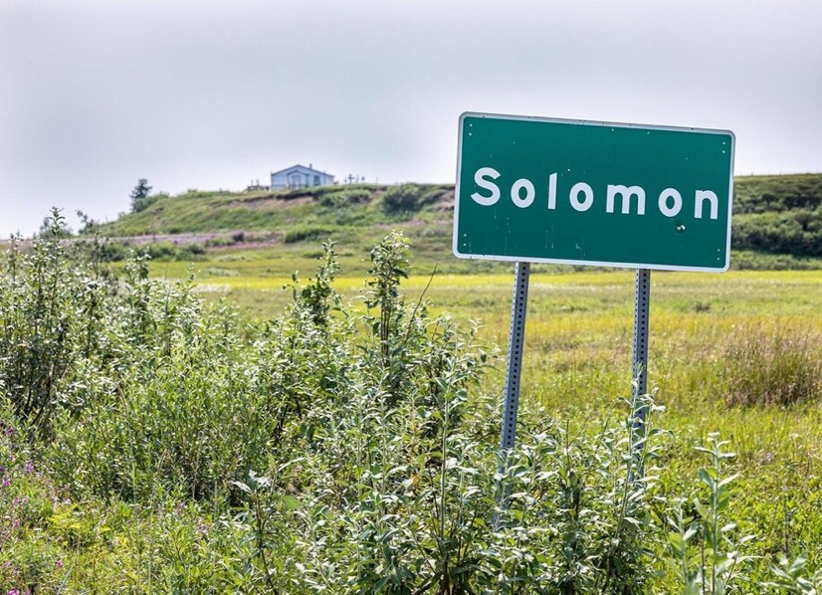
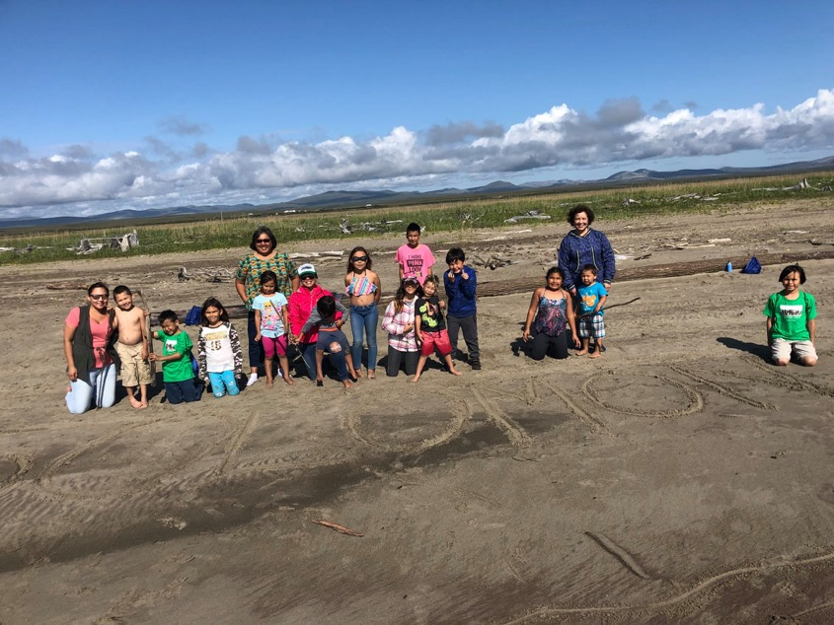
UPDATED PRIORITIES
Pictured L to R: Amy & Grafton Johnson, Brandon Henry, Tahlula Johnson, Annette & Sophia Piscoya, Deilah Johnson, Ethan Piscoya, Autumn Johnson, Sara James, Phillip Henry, Tristan Hudson, Jack James, Mia Piscoya, Fitz Piscoya, Cheryl Kalerak and Skyler Henry. Youth Camp 2019
VILLAGE OF SOLOMON
LOCAL ECONOMIC DEVELOPMENT PLAN
2021 -2026

(2021–2026)

On April 24th and May 6th, 2021, members from the Village of Solomon participated in a community gathering with the goal of updating the Local Economic Development Plan (LEDP) and the Jointly Approved Development Priorities 2016-2020. Participants were invited to share their goals and ideas for the village and the community in the next 5 years. These discussions were focused on the 5 priority areas: Health & Wellbeing, Community Connectedness, Infrastructure, Education & Youth Services, and Environment. The top goals within each category for 2021 -2026 are listed below: REVISED DURING SEPTEMBER 16, 2022 ANNUAL MEETING

PRIORITY AREA 1: Health and Well-Being

PRIORITIES 2021–2026

- INCREASE CONNECTION TO THE TRIBE (Holding youth camp regularly)
- ESTABLISH & MAINTAIN AFFORDABLE HOUSING (including logistics like water, sewer, electricity)
- ESTABLISH AND MAINTAIN A TRIBAL COURT (Children’s cases, Civil Diversion agreements and culturally appropriate sentencing)
- PROTECT AND MAINTAIN THE ENVIRONMENT, PROTECTING WATERSHED HABITATS INCLUDING PROTECTION FROM MINING
- INCREASED FOCUS ON HEALTH AND WELL-BEING OF TRIBAL MEMBERS
- TEACH YOUTH ABOUT OUR GATHERINGS, FOOD, HUNTING, AND PRESERVING OUR LANGUAGE

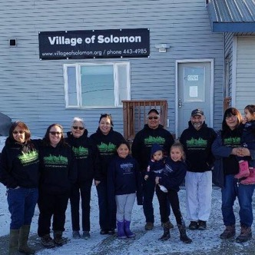
- Find more opportunities for elders to connect with youth - share with youth things like hunting, fishing, household repair, sewing, preserving food, medicinal plants skills, salves, animal husbandry, preparing natives foods and sharing recipes.
- More planned group activities (in-person or virtual): dinners, potlucks, game nights, movies, discussions, exercise classes.
- More opportunities to learn the language; whether online or in-person.
- Find ways for youth and community members to learn about our cultural identity and the history of Solomon.
- Expand focus on things like traditional knowledge, boarding schools; knowledge of place names; and family trees.
(Pictured L to R: Clara Tootkaylok, Kirsten Timbers, Helen Larsen, Liz Johnson, Britney Payenna, John Komakhuk, Sebastian Johnson, Autumn Johnson, Timothy Stettinger, Kim Henry & Sabiohn Johnson. In front of the new Tribal Office headquartered in Nome)
- Increase ways to be active for youth: rental of bikes; virtual competitions for physical activities; playground activities; monkey bars.
- More access to health resources for tribal members: resources to quit smoking; virtual support groups for mental health
- Hold the Youth camp on a regular and consistent basis; involve community elders and others in coordinating and organizing the camp and provide opportunities for more youth to attend.
- Expand subsidized housing for tribal members
- Work to have more people involved in tribal affairs and governance.

PRIORITY AREA 2: Community Connectedness
- Look for ways to provide more travel opportunities between Alaska and the lower 48 for those living out of state.
- Having high quality internet is a priority to keep community connected; allows for more opportunities to connect during virtual meetings and gatherings, as well as things like having pen pals.
- Community should make and design a village of Solomon logo to wear with pride
- Find opportunities for getting together to work on our subsistence catch i.e. have someone hunt with for the tribe and have others prepare the catch and provide to community. This is a chance to share traditions about food preparation and preservation.
- Increase connections to and among the tribe by doing things like holding monthly tribal gatherings.

PRIORITY AREA 3: Infrastructure
- Improve maintenance of the road, the graveyard, wastewater treatment, and the B & B building.
- Create or find more office space to accommodate increased tribal staff and activities.
- Expand housing that is affordable for elders and other community members.
- Explore renewable energy opportunities in the community and at tribal facilities.
- Improve conditions at the B&B: things like building a playground/Monkey Bar area and ensuring better internet connectivity.
- Put names on gravesites and take better care of the graveyard.
- Find ways for the community to participate in environmental observation and action.

PRIORITY AREA 4: Education & Youth Services
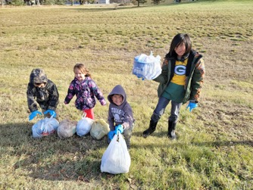
- Find more ways for the tribe to connect while also educating the youth through things like arts and crafts, language and dance classes, food preparation and community gatherings.
(Pictured L to R: Tobias & Penelope Huntsman,
Riley Brooks & Presten Sund)
- Continue the Youth Camp and involve more elders and community leaders.
- Improve and enhance services that will assist struggling families such as counseling services, drug and alcohol treatment options, parenting education, and discussions about support services.
- Provide ways for youth to access counseling and mental health services so that they can understand what is happening to them.
- Provide school supply reimbursement and expand assistance to other items students need.
- Continue to have the youth council.
- Create a program of monthly education classes for whole community and voted on by the tribe.
- Provide more educational opportunities for youth to learn where we come from and to learn lnupiaq as well as about assimilation and boarding schools.
- Create a program where elders sponsor a youth for guidance and teaching.
- Explore incentives to keep the youth involved with the tribe and create or fund programs around youth wellness.

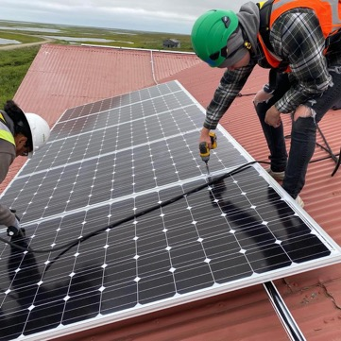
PRIORITY AREA 5: Environment
- Have active involvement from tribal members in responding to any mining activity that is happening in and around Solomon.
- Educate the community about climate change and how it affects our tribe and our future.
- Explore community-wide initiatives for fish habitat restoration, pollution control measures, ways to mitigate flooding, and disaster preparedness.
- Continue to participate in fish weir project with ADF&G
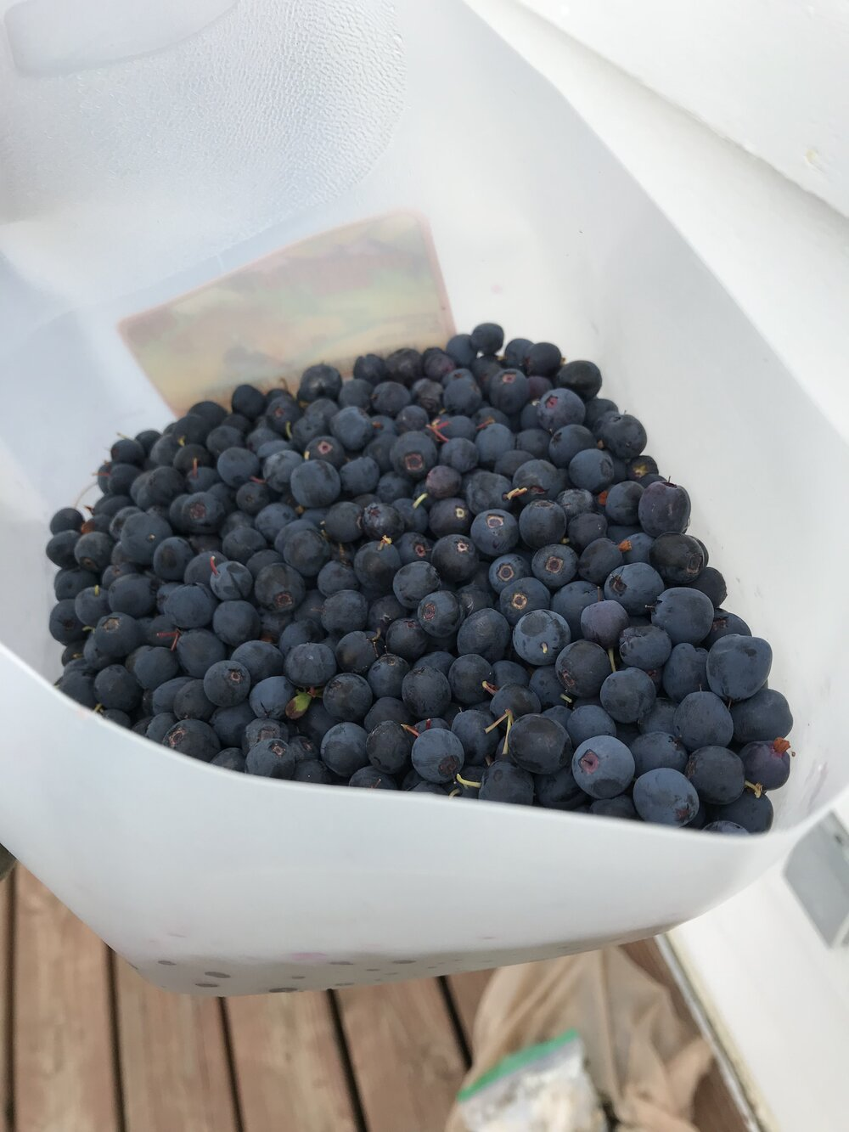
- Create youth and elder environmental ambassadors who can speak and educate community and others on environmental conditions in and around Solomon.
(Brewster Bohn assisting the rooftop solar panel
install July 2021)

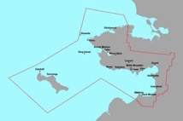
Introduction

Solomon was settled by Inupiaq Eskimos of the Fish River Tribe and was noted on maps as “Erok” in 1900. Erok was a summer fish camp for the Fish River Tribe and later became a permanent settlement.

The original site was situated in the delta of the Solomon River and was moved to a place known as Jerusalem Hill. Solomon was a fast-growing community in the gold rush days of 1899 and 1900 when gold fever was the instigation for expansion on the Seward Peninsula. During the big strike for gold there were anywhere from three to seven enormous dredges scouring the Solomon area for the precious yellow metal. By 1904, this gold rush boom town was the supply center for the Solomon River miners and was the third largest Seward Peninsula town. It was also the southern terminus of the Council City and Solomon City Railroad. After the gold mine rush Solomon returned to a predominately Alaska Native community of subsistence reindeer herders and miners. The BIA School shut down in 1956 requiring all families with children to relocate to Nome or Anchorage. Many families returned to Solomon during the summer months for subsistence activities. There were a handful of people that continued to live in Solomon year-round. Solomon had year-round residents until 2005 when the surviving original residents permanently relocated to Nome.

Solomon comes alive in the summer with the operation of the Solomon Bed and Breakfast/Community Center and family subsistence camps. Solomon was incorporated as Solomon Native Corporation (SNC) in 1975. There were 37 original shareholders of SNC, owning a total of 67,000 acres of in and around Solomon. SNC provides campsites to its shareholders and engages in land use agreements for material sales, mining exploration and production. The original shareholders of SNC were also recognized under the Village of Solomon, and many current shareholders and their descendants/relatives are also Tribal members. The Village of Solomon was organized under the Indian Reorganization Act (IRA) of 1993 as a Federally Recognized Tribe. The Village of Solomon’s initial authority was mainly political as the tribal governing body. The primary purpose of the Village of Solomon is to design and implement programs for increased quality of life and well-being of its family and tribal members who reside in Nome and elsewhere. The Village of Solomon currently has about 140 tribal members.

Almost all of the tribal members who live in the region live in Nome year-round. Nome was historically inhabited by Alaska Natives, but the discovery of gold in 1898 brought thousands of non-Natives to the area. The city was incorporated in 1969. The current population is 3,721.

- Purpose of the Solomon Local Economic Development Plan 2021-2026
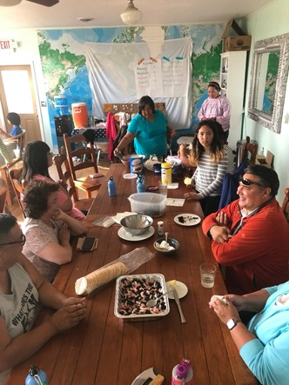
The City of Nome as a state- recognized governing body and the Village of Solomon as a federally recognized tribe have assumed diverse powers under federal and state laws. These include the protection of life, property, and the environment threatened by natural or technological disasters. The City of Nome and the Village of Solomon, contract with various federal, state, and other organizations to administer governance, infrastructure, public services, education, economic programs, environmental program, and social or cultural programs. The Village of Solomon and Solomon Native Corporation have worked together on joint projects such as the Solomon Bed and Breakfast. In addition, both SNC board members and the Village of Solomon Council members joined together in the creation of this strategic plan.
Planning is a critical step in the ongoing development of the community and its efforts to improve community conditions and the well-being of its members and residents. To better meet the needs of the tribal members, the Village of Solomon and the Village of Solomon developed this five-year strategic plan which is structured to:
- Provide the tribal community with a complete inventory of existing demographics, races, social conditions and services, economic conditions and activities, public services provided, and public and private facilities.
(Pictured L to R: Kooper Piscoya, Cheryl Kalerak, Kim Henry, Annette Piscoya, Helen Bohn, Sara James, Brian James. Youth Camp 2019)

- Equip the tribe with the basic informational tools of local planning that accurately show land status and ownership as well as traditional resources and subsistence areas.
- Provide a section setting forth policies, goals, and standards for the tribe relative to each major component of the plan.
- Provide implementation strategies for development priorities, including land use, public facilities and services, capital improvements, economic development and tribal governance.
- Place emphasis on the crucial development issues; economic and resource development, land use planning and needs of the tribe with regards to infrastructure, and priority capital improvement projects.
- Involve key decision makers to assist in the identification of common goals and direction to achieve those goals.

Planning Process and Public Involvement
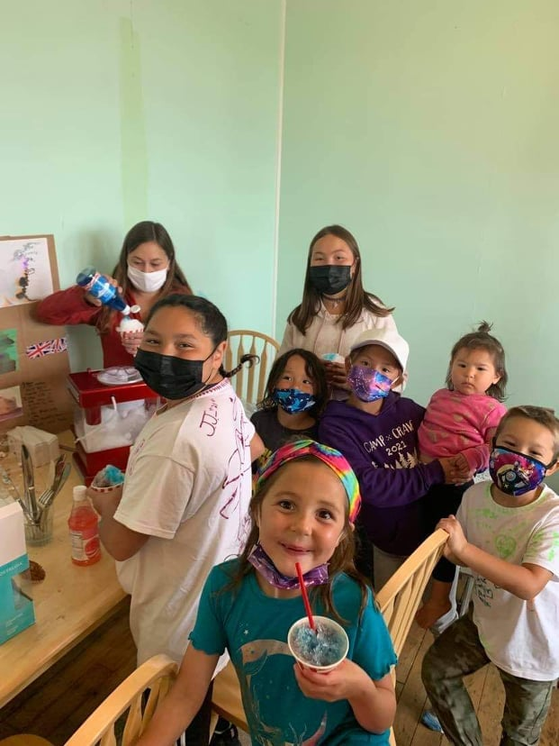
The Village of Solomon published a successful local economic development plans in 1998, 2011, and 2016. The tribe also jointly participated in a Local Economic Development Plan with the other three Nome-based tribes in 2004. Many of the priorities in that plan turned into successful development projects that were completed. New priorities for the Solomon area were approved on April 26, 2016. The 2016-2020 Local Economic Development Plan was reviewed and approved September 23, 2016. On April 24th and May 6th, 2021, members from the Village of Solomon participated in a community gathering with the goal of updating the Local Economic Development Plan (LEDP) and the Jointly Approved Development Priorities 2016-2020. These meetings were held over Zoom due to COVID-19 precautions, and all members were invited to participate and offer feedback on priorities for 2021-2026, as well as the previous development priorities. The meeting report with expanded notes is available as APPENDIX A.

(Pictured L to R: Penny Schaeffer, Brittney Payenna, Tessa Timbers-Payenna, Ethan, Sophia, Adeline Piscoya, Tristan Hudson. Back: Rose Paniptchuck. Annual Meeting 2021)

Accomplishments during 2016-2020

2016 Top Priorities – Jointly approved on 4/26/2016
- Obtain a tribal community hall/office in Nome. We have purchased a 2 story building in Nome and designed the remodel into a tribal office.

- Expand and improve our ICWA services. We have an open tribal court and adopted our first children’s code ordinance.

- Assess effects of climate change and collaborate for Salmon enhancement and testing in Solomon. The Environmental dept. has received a grant from the Army Corp of Engineers, Alaska Division to conduct habitual fish studies as well as bird habitat throughout the watershed with 5 focal points. The comprehensive feasibility study will provide data to complement the water quality monitoring data provided by the IGAP grant program.

- Fully effective operation of the Solomon Bed & Breakfast (business plan, obtain land, tourism development, gift shop, alternative and renewable energy). We have installed a 7kW rooftop solar panel system with adequate battery storage at the Community Center/B&B in Solomon.

- Create and manage our own transportation program for Solomon (roads, boat harbor, airstrip).

- Improve our language resources in our dialect (immersion school, educational resources, writing children’s books and Solomon history books). We have supported the language immersion program at the Nome Public Schools

- Improve access in public schools to learn tribal government, Alaska Native history, and math and science using our environment as a tool.

- Advocate for restorative justice and tribal input into culturally appropriate sentencing of our tribal members. We are an active tribal court with approved tribal court ordinance. We are currently working on implementing our tribal court plans.

9. Work with other Nome-based tribes to develop culturally related classes and activities for all ages to pass on cultural knowledge and promote wellness.
10. Improve education and enforcement of land use rights in and around Solomon. VOS & SNC have been working together and collaborating on land use rights.

11. Clean up land and old church site, improve drainage, and add historical markers in and around Solomon. ACQUIRED EPA FUNDING TO REMOVE CHURCH DEBRIS AND ASBESTOS

12. Advocate for an affordable family-friendly laundry/washeteria/carwash in Nome.
*Due to the COVID19 pandemic, VOS has had to respond to a public health emergency by establishing, implementing policies, programs and services for the tribal community.

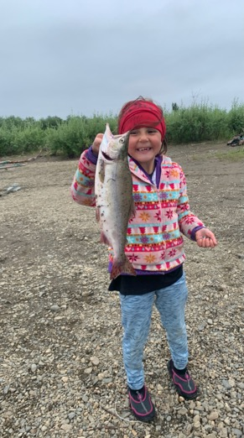
Community Description
(Tessa Timbers-Payenna holding fish)

Location
Solomon is located on the west bank of the Solomon River, 30 miles east of Nome. It lies one mile north of Norton Sound. It lies at approximately 64.560830 North Latitude and - 164.439170 West Longitude. (Sec. 03, T011S, R029W, Kateel River Meridian.) Solomon is located in the Cape Nome Recording District. The area encompasses 15.6 sq. miles of land and 0.1 sq. miles of water. The climate is both continental and maritime. Summers are short, wet and mild; winters are cold and windy. Temperatures range between -30 and 56. Annual precipitation is 16 inches, with 54 inches of snowfall.

History and Culture
At the time of contact with Europeans, the Inupiat had an established seasonal fishing and hunting camp site on the sand spit between the Solomon and Bonanza Rivers. Based on the information received from the Inupiat at Little Diomede Island in 1779, Solomon was known as Amutach
on the map of Russian explorer Ivan
Kobelev. At the turn of century in 1899 gold was discovered in the gravels of the Solomon River. The gold rush during the summers of 1899 and 1900 brought thousands of people to the Solomon area. At different times three to seven enormous dredges worked the Solomon River. By 1904 Solomon had seven saloons, a post office, a ferry dock, horse stables, and a school house and was the southern terminus of a narrow gauge railroad. The Council City and Solomon City Rail Road intended on laying tracks to the gold mine town of Council but fell 20 miles short of that goal when they went bankrupt in 1907. They did provide limited service to miners in the Solomon River from 1904-1907, with runs from the Bonanza channel to the East Fork of the Solomon River. In 1913, the railroad was washed out by storms and the remains of the train can still be seen in Solomon next to the Bonanza Bridge and is the world renowned ‘Last Train to Nowhere’.
In the years following the gold rush and storm Solomon changed from an all Caucasian mining town to a predominately Inupiat village. The people relied on subsistence and reindeer herding for their livelihood. In 1918, the flu epidemic struck Solomon and over half of the 62 residents died of the influenza and were buried in a mass grave. In 1939, the community relocated to the present site, which was formerly known as Jerusalem Hill. The BIA constructed a large school in 1940 which now serves as the Community Center and Bed & Breakfast.
During World War II a number of families moved away from Solomon. The BIA School was shut down in 1956 requiring all families with children to move to communities with schools, many of whom went to Nome and Anchorage. Solomon continued its mail license until 1958 when there were too few residents to support the mail contract. The Solomon Roadhouse operated until the 1970s and served as the last checkpoint for the Iditarod, the Last Greatest Race on Earth, during its first several years. The Safety Roadhouse now serves as the last checkpoint before Nome.
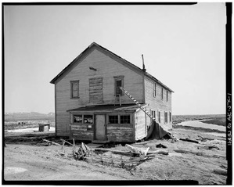
Today Pete Curran’s family still owns the old roadhouse structure though it is not in service, including his original Native Allotment approximately 7.2 acres in size. There are also other Native Allotments in the surrounding areas, as well as other areas where other individuals have cabins/structures, some of which are on their own property as well as SNC property.
Historically the Malemiut, Kauweramiut and Unalikmiut have occupied the region. Today the four tribes that reside
in Nome are the Village of Solomon, King Island Native Community, the Village of Council and Nome Eskimo Community.
Around 1870 to 1880, the caribou declined on the peninsula and the general diet changed. Reindeer were introduced in the late 1800’s and muskoxen in 1960’s. Both were government projects to help supplement the available food sources in Alaska.
Gold was found as far back as 1865, but a strike in 1898 brought thousands of people and the population in Nome grew to over 20,000. After the creeks had been staked, gold was discovered on the beach. A railroad and telephone line was built from Nome to Anvil Creek, and the City of Nome was formed in 1901. By 1902 large mining companies with better equipment took over the smaller mining operations. Since the first strike Nome's gold fields have yielded $136 million. The depletion of gold, a major influenza epidemic in 1918, the depression, and World War II, and a fire in 1934 have each greatly affected Nome's population.

In 2010 US Census the Bering Strait region approximately 76% of the population was recognized as Alaska Native. The US Department of Labor 2015 unemployment rate for the Bering Strait was 10.8%, whereas the state average was 6.6% and the national average was 4.8%. The US Census 2009-2013 American Community Survey 5-Year Estimates report the median household income in 2010 for the Bering Strait region was $49,974, per capita income was $20,271, and 27.7% of residents were living below the poverty level.

Government, Retail services, transportation, mining, medical and other businesses provide year-round income. Tourists visit the community in the summer and winter and provide income to some of the local businesses in Nome. Although many employment opportunities are available, subsistence activities are prevalent in the area. Nome is the finish line for the 1,100-mile Iditarod Sled Dog Race, the halfway point for the Tesoro Iron Dog Snowmachine Race and many other local races and events.

Nome is connected to three other villages by roads. The nearest villages are Teller, Solomon and Council. Solomon and Council are not occupied year -round. In the wintertime trails are staked across the land and ice for travel by snow machine. The roads, rivers and the ocean are used for travel in winter and summer. Local airlines provide service year around, weather permitting.

Government, Corporations, and Service Providers

City of Nome
Nome was incorporated as a first- class city within an unorganized borough in 1901. It has a manager or “strong mayor” form of government, and regular elections are held in October. The city council meets twice a month.

City owned/operated properties or services include the new police/public safety building, old fire hall, electric utilities, water plant, landfill, mono-fill, old library/museum, new Richard Foster building (museum/library), recreation center, swimming pool, visitor center building, animal control building, mini convention center, old St. Joseph’s Church, Port of Nome, Nome Public Schools, and Public Works building. The city employs 100-120 people. Various board meet including:

- City council  - School board  - Utility board | - Port commission  - Planning Commission  - Museum and Library Commission

Nome and Regional Planning Organizations
City of Nome Planning Commission, Bering Strait Development Council, and Kawerak Community Planning & Development Program.

Regional Services & Facilities
BSRHA, NSHC, Kawerak, NSEDC, BSSD, NACTEC, and UAF-NWC.

State of Alaska Services & Facilities:
Nome Courts, State District Attorney, Alaska State Troopers, Anvil Mountain Correctional Center, Alaska Dept. of Fish and Game, DOT, OCS, DMV, Alaska Health and Social Services, and Alaska Army National Guard

Federal Services & Facilities:
National Coast Guard, Army Corp. of Engineers, HUD U.S. Post Office, US Dept. of Fish and Wildlife, FAA, BIA, BLM, US Customs, USDA, National Park Service, and National Weather Service.

IRA or Traditional Councils in Nome
The federally recognized councils conduct tribal government affairs for their membership. The councils own and operate various buildings, businesses, or programs. Tribes collaborate with Kawerak, Inc., the regional non-profit Native organization, and other regional entities.

Village of Solomon Information
The federally recognized Village of Solomon conducts tribal government affairs for their membership, and maintains a tribal office in Nome. Activities include: grant writing and project planning, accounting and program management, updating tribal enrollments, providing burial assistance, providing emergency assistance, hosting youth and elders camps, organizing social gatherings and hosts events. The Council meets regularly to update policies and ordinances, owns and operates the Solomon Bed and Breakfast and administers several grants including and EDA, Rasmuson, and NSEDC, as well as an EPA IGAP grant that funds the environmental program.

The Village of Solomon is governed by a seven member tribal council which includes one youth member and one elder member. Solomon tribal members have access to receive services and programs through Kawerak that include:
- Burial Assistance
- Continuing Education Program
- Direct Employment Assistance
- Higher Education Scholarships for High School Students
- Vocational Assistance Training
- Welfare Assistance
- Business Development Assistance
- COVID-19 Relief Services

CORONAVIRUS PANDEMIC
The Village of Solomon Traditional Council approved a Resolution in August 2020, declaring a public health emergency due to the novel coronavirus pandemic and implemented several relief services for tribal members near and far. Such services include; a covid19 financial assistance grant program, internet support, electricity support, a laptop for each household as well as distributing ‘CARES’ kits to each household that included items such as; hand sanitizer sprays/gels, trash bags, toilet paper, masks made by a tribal member, a berry bucket, disinfectant sprays, bleach and soap which the Council and support staff are able to distribute the CARES kits twice.

The US Treasury allocated tribal set aside funds in 2020 under section 601(a) of the Social Security Act, as added by section 5001 of the Coronavirus Aid, Relief, and Economic Security Act (“CARES Act”). The CARES Act established the Coronavirus Relief Fund (the “Fund”) and appropriated $150 billion to the Fund to be expended by December 31, 2020. The following year, in 2021, the Administration approved the American Rescue Plan; The American Rescue Plan Act of 2021 is a $1.9 trillion coronavirus rescue package designed to facilitate the United States’ recovery from the devastating economic and health effects of the COVID-19 pandemic. The nearly $2 trillion price tag makes this economic rescue legislation one of the most expensive in U.S. history. It one part of President Biden's Build Back Better plan, which also includes the American Jobs Plan and the American Families Plan.

With available funding to address the ongoing Covid pandemic, the traditional council has made it a priority to conduct and discuss special Covid council meetings on a monthly basis to address and acknowledge the challenges and struggles each tribal member is facing and ensure that the entire community as a whole are being served through such an unprecedented time in World History. With the tribal funding; the council was able to develop and approve policies in order to assist the tribal community with such Covid relief services, as well as arrange a quarantine cabin for the community to utilize if/when a tribal member needs to isolate due to the coronavirus or any variant of the virus.

Not only has the US Treasury contributed to funding such Covid relief services for the Village of Solomon, the VOS grant writer was also able to secure funding from Center for Disease Control and Alaska Community Foundation to address and supplement federal funding.

The Village of Solomon developed an application process for each service and hired a website designer to assist with an upgraded website for the tribal community to fill out applications on line for it to be directly sent to staff managing the Covid services. With this, the tribe has been able to safely distance during the pandemic to adhere to their workplace safety policy. The Tribe has also hired Covid relief staff to assist in managing all Covid services. The council also hired Pomeranz construction to remodel the new office building to add an office for safely distancing Solomon Native Corporation and the VOS Tribal coordinator.

Village of Solomon Tribal Council-2021

Position Held | Name | Term
President | Kirsten Timbers | (2021-2024)
Vice President | Cameron Piscoya | (2021-2024)
Treasurer | Annette Piscoya | (2018-2022)
Secretary | Elizabeth Johnson | (2020-2023)
Asst. Secretary/Treasurer  /Elder Seat | Timothy Stettinger | (2019-2023)
Seat E | Deilah Johnson | (2019-2023)
Youth Representative | Joshua Aycock | (2019-2023)

Native Corporations in Nome
There are four village corporations and one regional corporation established under ANSCA. These are the for-profit corporations which operate various businesses in Nome and elsewhere. Solomon and Council have completed the 14c process for corporation lands. Sitnasuak and King Island are still in the process of completing the 14c process for corporation lands (see more about land status on page 34).
- Solomon Native Corporation
- Sitnasuak Native Corporation
- King Island Native Corporation
- Council Native Corporation
- Bering Strait Native Corporation

Local and Regional Contacts
City of Nome  P.O. Box 281, Nome, AK 99762  Phone: 907-443-6663, Fax: 907-443-5349  E-mail: admin@ci.nome.ak.us http://www.nomealaska.org  Police-Phone: 907-443-5262 | Kawerak, Incorporated  P.O. Box 948, Nome, AK 99762 Phone: 907-443-5231  Fax: 907-443-4452  E-Mail: webmaster@kawerak.org http://www.kawerak.org
Village of Solomon  P.O. Box 2053, Nome, AK 99762 Phone: 907-443-4985  www.villageofsolomon.org and http://www.solomonbnb.com | Norton Sound Health Corporation  P.O. Box 966, Nome, AK 99762 Phone: 907-443-3311  Fax: 907-443-3139  http://nortonsoundhealth.org/
Solomon Native Corporation  P.O. Box 243, Nome, AK 99762 Phone: 907-222-6668  Email: solomonnativecorporation@gmail.com | Bering Straits Native Corp.  P.O. Box 1008, Nome, AK 99762  Phone: 907-443-5252, Fax: 907-443-2985  http://www.beringstraits.com/
Native Village of Council  P.O. Box 2050, Nome, AK 99762  Phone: 907-443-7649  http://www.kawerak.org/communities/counci l.html | Norton Sound Economic Development Corp.  P.O. Box 358, Nome, AK 99762  Phone: 1-888-650-2477, Fax: 907-443-2478  http://www.nsedc.com
Council Native Corporation  P.O. Box 118, Nome, AK 99762  Phone: 907-443-6513 | Bering Straits Regional Housing Auth.  P.O. Box 995, Nome, AK 99762  Phone: 907-443-5256, Fax: 907-443-8652  http://bsrha.org/
King Island Native Community  P.O. Box 682, Nome, AK 99762  Phone: 907-443-2209  http://www.kawerak.org/communities/kingisl and.html | Sitnasuak Native Corporation  P.O. Box 905, Nome, AK 99762  Phone: 907-387-1222, Fax 907-443-3063  http://snc.org/
King Island Native Corporation  P.O. Box 992, Nome, AK 99762  Phone: 907-443-5494 fax 907-443-5400  http://kingislandnative.com/ | Nome Eskimo Community  P.O. Box 1090, Nome, AK 9762 Phone: 907-443-2246, Fax 443-3539  http://necalaska.org/
Alaska State Troopers-Nome Phone: 1-800-443-2835  http://www.dps.state.ak.us/ast/ | Search and Rescue-U.S. Coast Guard Phone: 1-800-478-5555  http://www.uscg.mil/D17/

Businesses and Service in Nome
The lists on the following pages show the records of current business licenses on file with the Department of Community and Economic Development, Division of Occupational Licensing, Business Licensing Section. These licenses may not represent actual business activity. For more information on a specific business, use Commerce's Business License Search website: https://www.commerce.alaska.gov/CBP/Main/CBPLSearch.aspx?mode=BL. *Not all businesses below may be currently operating
ALASKA GOLD COMPANY LLC
ALASKA PACIFIC ENVIRONMENTAL SERVICES NOME, LLC
QUYANA CARD
ALASKA SUB-SURFACE MINING AND EXPLORATION LLC.
ARCTIC ACCESS
ARCTIC ARTS & SIGNS, LLC
KICY RADIO STATION
ARCTIC CHIROPRACTIC NOME, LLC
ARCTIC NATIVE BROTHERHOOD CLUB
TLC BIBLE, BOOK, & GIFTSTORE
MAI'S GUEST HOUSE
NORTON SOUND WELDING & FABRICATION
BANNER WIND, LLC
BEARING SONG
NOME DISCOVERY TOURS
BERING AIR, INC
BERING WELLNESS CENTER
BERING SEA LIONS PULLTABS
BERING SEA RESTAURANT
AURORA INN
BERING STRAITS DEVELOPMENT CO
GREEN ENERGY SOLUTIONS
CHEM-CLEAN
STAMPEDE VENTURES
BERING STRAITS DEVELOPMENT COMPANY
BERING STRAITS NATIVE CORPORATION
BERING STRAITS REGIONAL HOUSING AUTHORITY
QIVIUT FEVER
TUNDRA TEE
SECOND CHANCE INTERPRISE
BOARD OF TRADE INC
NORTHWEST CHARTERS
BONANZA EXPRESS
BONANZA FUEL, LLC
WEE KIN CARE
NURSE AIDE EVALUATOR
BREAKERS BAR
BUILDERS INDUSTRIAL SUPPLY, INC.
MICHAEL BURNETT PHOTOGRAPHY & ART
SOLSTICE CLEANERS

J.B. GOTTSTEIN WHOLESALE GROUP
JOHN'S LTD
LARRY'S AUTO AND REPAIR
CENTURION
DREDGE #7 INN
CHUKOTKA-ALASKA INC
CITY OF NOME, ALASKA
COTERIE LLC
COUNCIL NATIVE CORP
HAIR BY STEPHANIE
SPD MINING VENTURES
SHAYLA'S ENTERPRISES
DANIEL J. STANG DDS, LLC
QUALITY AUTO PARTS
EMMONS MECHANICAL
SNOW TRAC'N NOME
TUNDRA B & B
TUNDRA TOYO AND HEATING
EVANS AND COMPANY, LLC
EZ ENTERPRISES LLC
FAGERSTROM ENTERPRISES INCORPORATED
ANGEL CAMP BY THE SEA
DEBORAH C. FLINT DANIEL, MD
MEMOE DAYCARE
FREEDOM RESOURCES, ENT., LLC
NOME CAB
GNOME COURIER LLC
SUBWAY/GOLD COAST CINEMA
GOLDEN GLACIER INC
LINDSEY'S SHOP
GREEN ACRES DAYCARE OF NOME
NOME PROFESSIONAL SERVICES
BERING SEA BED AND BREAKFAST
ANGELA'S ART AND FRAME
NOMEMADE
KMH KRAFTS
AIRPORT PIZZA
TUNDRA TREASURES
STARGATE ALASKA
NORTHERN GEOLOGY
MARUSKIYA'S OF NOME

MORGAN SALES AND SERVICE
R & D ENTERPRISES
NOME OUTFITTERS
JOHNSON BUSINESS VENTURES
R & D ENTERPRISES
TRINH'S SPA & NAILS
JOHNSON CPA LLC
NOME CHECKER CAB
R. J.'S AUTO REPAIR
TRINITY MINING
CHATEAU DE CAPE NOME
CUSSY UNLIMITED
BERING STRAIT DEVELOPMENT COUNCIL
KAWERAK, INC
FORGET-ME-NOT STITCHES
JAKE'S CARPET CARE
KING ISLAND CARVING TOOLS & SUPPLIES
KING ISLAND FABRICS
CAPE NOME PRODUCTS
NOMEMADE
GEORGE KRIER PROFESSIONAL LAND SURVEYOR
POLAR BAR/RESTAURANT
POLAR LIQUOR
KRIER INVESTMENTS, LLC
KRIER, INC
POLAR ARMS
KRUSE PROJECT MANAGEMENT
HIGH TIDE ENTERPRISES
TERRY L. MILLER, INDEPENDENT CONSULTANT
TERRY'S THERAPEUTIC MASSAGE
CHATEAU DE CAPE NOME
CUSSY UNLIMITED
BERING STRAIT DEVELOPMENT COUNCIL
KAWERAK, INC
FORGET-ME-NOT STITCHES
JAKE'S CARPET CARE
KING ISLAND CARVING TOOLS & SUPPLIES
KING ISLAND FABRICS
CAPE NOME PRODUCTS
NOMEMADE
GEORGE KRIER PROFESSIONAL LAND SURVEYOR
POLAR BAR/RESTAURANT
POLAR LIQUOR
KRIER INVESTMENTS, LLC
KRIER, INC
POLAR ARMS

KRUSE PROJECT MANAGEMENT
HIGH TIDE ENTERPRISES
TERRY L. MILLER, INDEPENDENT CONSULTANT
TERRY'S THERAPEUTIC MASSAGE
ROBERT D. LEWIS
LEWIS & THOMAS, P.C
ANUQSRAAQ ARTS & NATURAL PRODUCTS
LLB LLC
RONALD LOCKE RENTAL'S
LONNIE O'CONNOR IDITAROD BASKETBALL CLASSIC
LT NOME LAW, P.C.
BED FOR A NIGHT
THE SLUICEBOX
KOUGAROK.COM
RAVE'N CUTS
TRAILS END
MCKNIGHT AND ASSOCIATES, INC.
MICHELS CONSULTING
MIDNIGHT SUN MOTORS, SALES, AND SERVICES LLC
MILANO'S PIZZARIA
JOEY L MILLER
MILLER HEALTH CONSULTING, LLC
BOARD OF TRADE SALOON
NOME SWEET HOMES
MORGAN ENTERPRISES, LLC
MUNAQSRI SENIOR APARTMENTS
GOLD RUSH SERVICES
NANUAQ, LLC
GOOD GENERAL CLEANING
BIG JIM'S AUTO REPAIR
NOME NORTON SOUND JANITORIAL
SNOWFLAKE MULTIMEDIA
NJ CONSTRUCTION LLC
FOSSIL IVORY SALES
ANIMAL HOUSE
NOME CHAMBER OF COMMERE, INC
NOME COMMUNITY CENTER, INC.
NOME EMERGENCY SHELTER TEAM
NOME ESKIMO COMMUNITY
NOME GOLD ALASKA CORP
NOME HARDWARE AND LUMBER LLC
HUSKY RESTAURANT
NOME KENNEL CLUB, INC
NOME MINERS ASSOCIATION LLC.
NOME WINTER SPORTS ASSOCIATION, INC.
NORTHCOAST CONSTRUCTION INC

NORTHWEST GOLD DIGGERS, LLC
NORTON SOUND HEALTH CORPORATION
NORTON SOUND SURVEYING, LLC
NUGGET PUBLISHING
NEVA CREEK PHOTOGRAPHY
NORTHWEST PLANNING & GRANTS DEVELOPMENT
OLIN CLEANING DEFENSE
VEGGO ALASKA AVIATION SERVICES
KO ENTERPRISES
OPIQ ADVENTURES, LLC
GRIZZLY BUILDING SUPPLY
PANORAMA VENTURES LLC
ALASKA PROCESS SERVICE
RURAL FINANCIAL SERVICES
ESTHER PEDERSON PHOTOGRAPHY
PEDERSON ENVIRONMENTAL SERVICES
JILL PETERS- NOME CRP SERVICES
MR KAB1
J AND J ENTERPRISES
WEEKS APARTMENT
VT RENTALS
PK ELECTRIC, LLC
PLS CONSTRUCTION LLC
POMERANZ CONSTRUCTION
SMP SERVICES
BEACHMASTER
PINGO BAKERY-SEAFOOD HOUSE
RAGCHEW AMATEUR MAGIC, INC.
SWEET DREAMS B&B
RASMUSSEN'S MUSIC MART
RAVEN RECYCLING ANDLOGISTICAL SERVICES
SAFETY ROADHOUSE
J AND J ENTERPRISES
JENNIFER READER, INDEPENDENT MARY KAY BEAUTY CONSULTANT
KOUGAROK CONSOLIDATED PLACERS
SUCK-N-SHINE SEPTIC PUMPING
RURAL CREDIT SERVICES
MARTY'S MAINTENANCE
POLARIS HBL

SACKETT ENTERPRISES
ANCHOR TAVERN
SITNASUAK NATIVE CORPORATION
NOME NUGGET INN
ARCTOCO
BED FOR A NIGHT
RED MOOSE APARTMENTS
RED MOOSE ENTERPRISES
NOME TOYO TECH CENTER
ALASKA MANAGEMENT SERVICES
GOLDEN CHINA
NOME CHECK CASHING
CAPE NOME PRODUCTS
SOUND QUARRY, INC.
STAMPEDE VENTURES INC
STOSH'S RENTALS, INC.
NURSE AIDE EVALUATOR/PROCTOR
NOME LIQUOR STORE
SEW FAR NORTH
THE WHIMSY SHOP
GOLD CREEK PHOTOGRAPHY
GUDLIEF ORGANIZATION
PELUK CREEK GOLD CAMP
TRIPLE CREEK FABRICATION AND REPAIR LLC
ARCTIC MARITIME AGENCY
TRINITY SAILS AND REPAIR
TUMET INDUSTRIES, LLC
ENIGMA INDUSTRIES
TWIN PEAKS ADVENTURES, LLC
VFW BERING SEA POST 9569
WEIDLER COMMUNICATIONS
WEISS RENTALS
GOLDEN SCISSORS
WEISS RENTALS
GLADYS WEST RENTALS
KJ'S ESPRESSO
WILDERNESS SKI-DOO, LLC
WINKS SERVICES

Other Service Providers in Nome

Alaska Div. of Mining Land and Water | National Weather Service
Alaska Housing Finance Corp. | Nome Arts Council
Alaska Legal Services | Nome Chamber of Commerce
Alaska National Guard | Nome Community Center/XYZ
Alaska Nanuaq Commission | Nome Dental Office
Alaska Legal Services | Nome Joint Utilities
American Legion | Nome Kennel Club
Anvil Mountain Science Academy | Nome Nugget Newspaper
Arctic Access | Nome Post Office
Bering Sea Lion’s Club | Nome Preschool
Bering Sea Women’s Group | Nome Public Schools
Boys and Girls Club of Nome | Nome Recreational Center
Carrie M. McLain Museum | Nome Rotary Club
Civil Air Patrol | Nome Swimming Pool
Eskimo Walrus Commission | Nome Theater Guild
Kawerak Reindeer Herder’s Association | Nome VFW/Women’s Auxiliary
Kegoayah Kozga Library | Nome Volunteer Ambulance
KICY
KNOM | Parent Teacher Student Association
Kusqi House | Pioneers of Alaska - Nome
Munaqsri Senior Apartments | Rural Credit Services
NACTEC | Seaside Correctional Center
National Family Partnership | UAF – Northwest Campus

Gaps identified in business service:
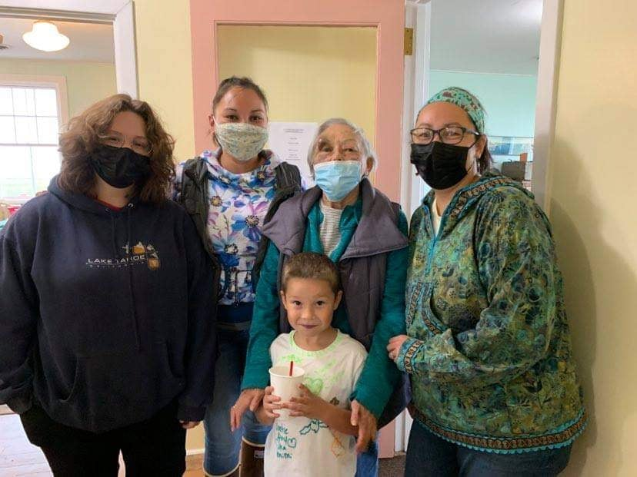
Nome tribal members identified: the need for a local car- wash, an affordable laundry mat that is family friendly environment (the current laundry mat is located inside a bar), a dry cleaning service, appliance repair/ maintenance services, and the need for burial assistance support services (body transport and preparation for burial, crematorium, urns, caskets, grave markers, and other services). Tribal members in Nome and Anchorage find that middle income families do not qualify for burial assistance, and the funeral cost can be exorbitant.

(Pictured L to R: Isabella Bohn, Amy Johnson, Helen Larsen, Tristan Hudson and Helen Bohn)

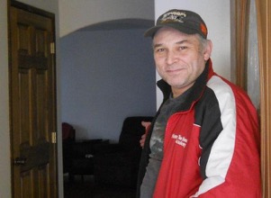
Community Infrastructure

Housing
The following housing data of Nome Census Area, Alaska is from the U.S. Census and based on the year 2020 population of 10,004. 75.3% American Indian/Alaska Native.
Gaps Identified:
(Tim Stettinger in his new house)
Middle income tribal members in Nome and Anchorage have difficulty finding affordable rental units or assistance obtaining a home. Also the age of some rental units in Nome makes them drafty and less desirable due to poor maintenance, over-crowding of living space, and being drafty and costly to heat. There is also a problem with landlord accountability and neglect and insuring all renters know their rights. Some experience issues with smokers in and near the building, and noisy neighbors, pets or unattended children. Some also deal with pests and dangerous animals, such as, foxes and musk oxen. Others pay a high cost for utilities due to the lack of energy efficiency issues.

Housing
Housing units, July 1, 2019, (V2019) 4,100
Owner-occupied housing unit rate, 2015-2019 60.5%
Median value of owner-occupied housing units, 2015-2019 $154,600
Median selected monthly owner costs -with a mortgage, 2015-2019 $1,470
Median selected monthly owner costs -without a mortgage, 2015-2019 $469
Median gross rent, 2015-2019 $1,287
Building permits, 2020 8

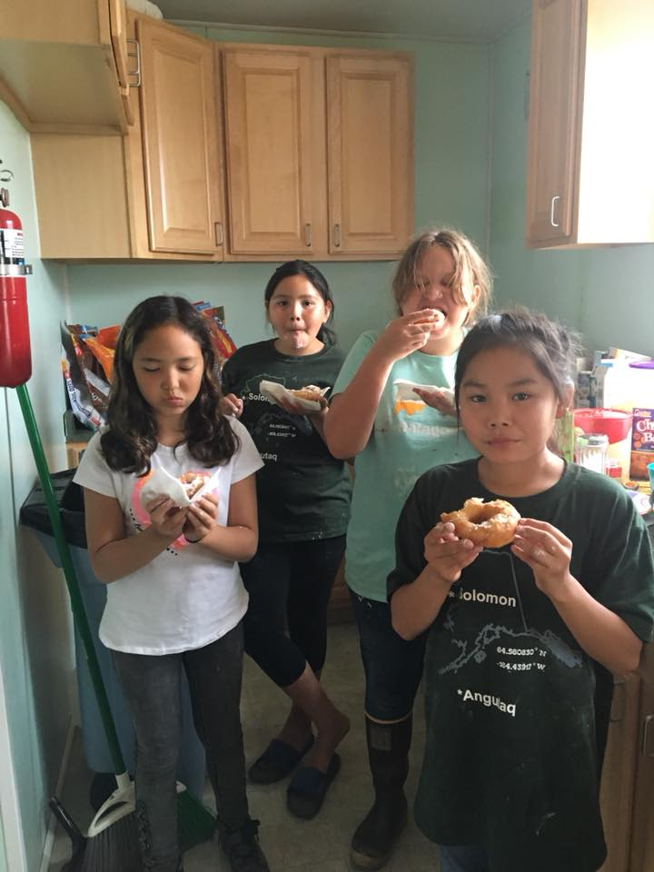
Schools
(Sara James, Jaylene Ondola, Isabella Bohn and Luella Tumulak @ youth camp 2019)

The public school at Solomon was closed in 1956 and since that time all Solomon tribal members living in the Nome area have been served by the Nome Public School district. The student population is 89% Alaska Native, and the student/teacher ratio is 13:92. In 2013 the expense per student annually in Alaska was
$18,175, whereas the national average is $10,700. Some students in the community are homeschooled and some go out of town to attend boarding school. The Kawerak Head Start program has 2 teacher and 24 preschool students. Nome also has a privately-run Nome Preschool. The high school built a new cafeteria a few years ago. In the past the Kawerak Community Education program helped over 30 students per year obtain their GED, but there were fewer graduates the last few years due to the new electronic testing requirements. The Nome elementary School partnered with agencies and tribes to develop a language immersion program, which several VOS youth participated in.
Gaps Identified:
Adults in both Nome and Anchorage need language circles and other language resources in their own dialect to insure the language is maintained and passed on the next generation. Many tribal members wish that there was less emphasis on sports and a more emphasis on cultural activities in the After-School Program. There is a need for more tutors and mentors for low performing students. More emphasis should be placed on tribal history and tribal law. Tribal members also have expressed a concern that some college bound students must take remedial Math and English courses because they were not adequately prepared in high school. The turnover rates for school administrators and teachers are very high, and teachers need cultural sensitivity training. Parents would like to see more life skills taught like firearm safety, swimming, hunting and food processing, parenting classes, budget management, and cooking. More tools should be provided to parents for baby and toddler development and classroom opportunities. Tribal members are concerned about the high drop-out rates and feel the need for more scholarships for Native students. The new electronic tests for the GED program are costly, and it is harder to obtain a passing grade. They were also concerned about the increase in suicide and bullying and see a need for prevention programs. There is a need for more tutors and peer mentoring programs to insure each student succeeds. The middle income tribal members in Anchorage find it challenging to pay for school lunches and do not qualify for assistance.

Contact information for Alaska School Districts and Schools is available at the Department of Education and Early Development's Website. https://education.alaska.gov/State_Board/
Nome Public Schools
Nome Public Schools Operated by City of Nome
Number of Schools 5
Number of Teachers 61
Number of Students 700
Student/Teacher Ratio 13.92
Drop Out Rate 1.40%
% of Alaska Native Students 69 %
Eligible for Free or Reduced Lunches 92.76%

Schools Located in Nome:
School Name | Grades | # of students | # of teachers
Anvil City Science Academy | 5 thru 8 | 60 | 4
Extensions Correspondence | KG thru 12 | 13 | 1
Nome Elementary School | PK thru 6 | 379 | 31
Nome Youth Facility | 8 thru 12 | 7 | 1
Nome-Beltz Jr./Sr. High School | 7 thru 12 | 239 | 23

Water and Sewer
Three wells at Moonlight Springs supply water to the community, which is treated and stored in a million-gallon tank. There is a second million gallon back-up tank available. Water is heated and circulated to residences via a direct buried arctic pipe. Some homes around Nome and on the mountains have their own wells and septic systems or leach fields. A few haul their own sewage and a private company delivers water, mostly to remote cabins outside city limits. Sewage is piped from most homes. Over 98% of residences currently have complete plumbing. There were system upgrades in 2007 and 2010. Funds have been requested to continue upgrading aging sections of the water and sewer systems.
Gaps Identified:
Tribal members in both Nome and Anchorage are concerned about the costs of water and sewer. Anchorage residents are concerned about earthquake damage to water and sewer systems. Not all tribal members with home off the grid may be aware of well digging or septic installation assistance services and grants from ANTHC.

Water Distribution, Source & Treatment Systems:
Water System Operator: | Nome Joint Utility System
Washeteria Operator: | Private
Piped Water System: | Yes
Central Watering Point (Haul): | No
Multiple Watering Points: | No
Water Truck (Delivery): | Yes
Individual Wells: | No
Community Well Source: | Yes
Surface Water Source: |  | No
DEC Water Permit Number: |  | 340010
Water Is Filtered: |  | No
Water Is Chlorinated: |  | Yes
Sewage Collection Systems:
Sewer System Operator: |  | City of Nome
Piped Sewer System: |  | Yes
Honeybucket Haul: |  | Yes
Honeybucket Pits: |  | No
Individual Septic Tanks: |  | Yes
Community Septic Tank: |  | No
Sewage Pumper: |  | No
Sewage Lagoon: |  | Yes
Sewage Lift Station: |  | No
Outhouses: |  | No

Landfill & Mono-fill
The City of Nome operates a Class 2, permitted landfill located on the Beam Road. Refuse collection services are provided by a private contractor. The landfill is located at Mile Beam Road, near Nome, Alaska. The city also operates a mono-fill. Tribal members in Nome and Anchorage do take advantage of free landfill days. Both Nome and Anchorage offer various options for recycling and tribal members are more conscientious about participating in local recycling programs. Anchorage members participate in curb side recycling by sorting household wastes in separate bins. Nome residents use social media and email to swap or give away unwanted items to help reduce wastes. Many tribal members donate unwanted items to thrift stores. The City of Nome has a String Clean-Up project each year, and Kawerak hosts an E-waste event at that time. Kawerak also supports recycling efforts of the tribes by operating a backhaul program.
Gaps Identified:
Nome residents are concerned about the wood and cardboard wastes taking up space at the landfill and wish these items could be efficiently recycled. Tribal members in Anchorage are charged for the recycle bins and “yellow vests” required to go into the landfill. Everyone is concerned about how to properly dispose of hazardous liquids like oil and antifreeze.

Electricity
The City of Nome operates the Nome Joint Utility System. Capacity is 10,895 Kilowatts from Diesel generators and 20 wind turbines on Banner. The rate is 38 cents/kWh with Power Cost Equalization at .17/kWh. The power plant had to upgrade to double its capacity to provide power to Rock Creek Mine which only stayed in operation for a short time.
Gaps Identified:
The costs of the power plant upgrade and maintenance now falls solely on the users in Nome. All residents are concerned about the rising cost of energy, the slow progress in alternative and renewable energy projects, and high costs of weatherization of homes. Low-income families worry about shut offs in cold weather or when a household member is at risk health-wise from a non-payment shut off. More public education is needed on consumer rights and all energy issues.

Bulk Fuel
Tank Owners (Number of tanks / Total capacity): Chevron/Arctic Lighterage (5,233,000 gals.), Bonanza Fuel – jet fuel (1,500,000 gal.), Bonanza Fuel – heating fuel (1,300,000 gals.), Bonanza Fuel – gasoline (850,000 gals.), Bonanza Fuel – diesel (1,300,000 gals.), Air National Guard (20,000), Crowley (20,000). The Village of Solomon has two 500 gallon fuel tanks in Solomon. In May 2016 the cost of heating fuel was $5.18/gal., gas was $4.99/gal. Propane was $6.10/gal. delivered and $169 for a 100 lb. cylinder if exchanged with an empty cylinder.
Gaps Identified:
Nome tribal members worry a lot about the rising costs and about a repeat of the fuel shortage issue of a few years ago, due to the unpredictable weather, limited fuel storage space, and short fuel delivery window in ice free summer barge delivery. We worry about safe fuel transfers, tank compliance and safety issues, leaks, environmental impacts and water seeping into the fuel/gas. Sometimes it does not feel like the costs savings seen elsewhere are reflected in our local fuel prices.

Existing Transportation Systems
Nome is a regional center of transportation for surrounding villages. There are two State- owned airports. The Nome Airport has a two paved runways, one is 6,001' long and 150' wide, and the other is 5,576' by 150' wide. Scheduled jet flights are available, as well as charter and helicopter services. The City Field offers a 1,950' long by 110' wide gravel airstrip.
There are two airstrips in Solomon. The former state owned dirt and gravel airstrip is 1600 feet in length, not maintained and considered abandoned by the State of Alaska. It is up the Authorized Village Entity (AVE) to determine the future of this abandoned airstrip. At Lee's Camp is a privately owned 1000 foot unpaved and unmaintained airstrip located 5 miles north of Solomon.
The entire seaward side of the City of Nome is protected by a 3,350-foot-long sea wall of granite boulders. These huge rocks were trucked in from Cape Nome, 13 miles distant, at a cost of more than one million dollars. A port and berthing facilities accommodate vessels up to 18 feet of draft. Lighterage services distribute cargo to area communities. A new harbor channel entrance and breakwater was completed in 2006. Local development groups and the City of Nome are funding harbor dredging, two seasonal floating docks, and a boat launch. Nome is serviced by different barging companies during the ice-free summer months.
Local roads lead to Teller, Council and the Kougarok River. Access to Nome is primarily by air and sea. However, in the winter the city can also be accessed over land or ice.
Some city streets are paved, and most have culverts to help drainage. The roadways are typically two lanes wide. There are a few conflicts involving approaching wide attempting to pass each other. Local speed limits are posted in Nome. Dust is a problem in spring and summer. The city seeks ways to improve local trails. The Nome Kennel Club and other groups have been involved in trail staking. Recent improvements have been made on the road towards Solomon from Farley’s Camp to Cape Nome which has reduced the amount of snow drift accumulation.

Gaps Identified:
All residents are concerned about the rising costs of transportation. It reduces the number of trips Nome residents can take to Anchorage for goods or services or vacations, and it can prevent Anchorage based tribal members from being able to bring the family to Nome to spend time on ancestral lands or with tribal members and family. In Nome, tribal members are concerned about the limited number, skill quality, and sometimes the reliability and integrity of the local mechanics. Nome has no public transportation system, and Anchorage members are concerned about the rising costs of bus passes. Tribal members are also concerned about maintenance of the roads, driveways, trails, and runway in Solomon, and damage to the river bank from boating launches. It would be nice to have an organized Transportation program to address all transportation issues in Solomon and coordinate maintenance efforts.

Communications
TelAlaska (Mukluk Telephone) provides local phone service; GCI and AT&T provide long distance. Residential and business Internet is primarily provided by GCI, Alaska Communications and TelAlaska.
Gaps Identified:
The Nome post office is understaffed and there are sometimes long waits to be served. There are local people contracted to deliver UPS and FEDEX packages, but no office to adequately obtain all the services of these carriers. Telephone and internet service has improved much in recent years, but still lags, and the costs remain high. Overage charges can hit a family hard and unexpectedly. Periodic outages can impact families more since some have given up landlines for cell phones to cut costs. One positive impact is the internet has improved access and reduced the cost of many goods that were previously difficult to obtain.

In-State Phone: | Mukluk Telephone Co./TelAlaska, ACS
Long-Distance Phone: | AT&T Alascom; GCI; TelAlaska, ACS
Internet Service Provider: | GCI, AT&T Alascom, TelAlaska (Arctic Net), Hughes Net, Exceed,ACS
TV Stations: | ARCS, KUAC, KYAC
Radio Stations: | KICY-AM/FM; KNOM-AM/FM. We have a new public radio station.
Cable Provider: | GCI Cable, Dish Network
Teleconferencing: | Alaska Teleconferencing Network; Legislative Information
Marine/Ham/Other Radios: | SPARC Club, Nome Volunteer Fire Department
VHF Radios: | Local camps
Postal Mail: | United State Post Office,
Deliveries: | Alaska Air Gold Streaks, FedEx, UPS, Local airlines

Health Care
Hospital/Clinic Names: | Norton Sound Regional Hospital; Quayana Care,  Nome Dental Office, Arctic Chiropractic, Hospice, Maternal Home, Nome Public Health Center
Facility Status: | The new hospital opened in 2013.
Alternate Health Care | Nome Volunteer Ambulance Dept. (443-824/5262); Norton Sound Health Corp. Medevac (443-3311 or 443-3306 for emergencies 911)
Owner: Norton Sound Health Corporation

The new hospital is three times the size of the old facility and has new equipment and the latest technology, and has 18 beds. The hospital is a qualified Acute Care facility and Medevac Service. Long Term Care is performed by the Quyanna Care Center. Specialized Care is performed by Norton Sound Community Mental Health Center, Turning Point - Saquigvik (transitional living), and the XYZ Senior Center. Nome is classified as a large town/regional center. It is found in EMS Region 5A in the Norton Sound Region. Emergency services have limited highway, coastal and airport access. Emergency service is provided by 911 Telephone Service and volunteers. There are about 7 doctors, 15 nurses, and 4 PA’s. Some are long term local employees with excellent training and experience. Specialty clinics occur on a regular basis. Public health nurses administer vaccinations. The hospital has a physical therapy, dental, eye, and audiology department. The CAMP department helps with chronic care issues like diabetes and long term recovery. Since the COVID19 pandemic, the hospital has adhered to safely distancing patients and has offered the covid19 vaccines for all citizens at numerous locations throughout Nome, including the airport.
Gaps Identified:
Tribal members feel that some patients need to be more proactive about their healthcare choices in order to get successful results. Also, it is estimated that the average family in Nome makes several trips per year to Anchorage or elsewhere depending on the medical needs of each family member. The ones with chronic issues have more frequent travel, and the costs can be exorbitant. Nome needs a detox center.

Many residents and tribal members in Nome and Anchorage, regardless of income or insurance sources, seem to have had problems getting medications refilled in a timely manner. Indian Health Service policies need to be revised in Nome and Anchorage to expedite the wait time for dealing with chronic or emergency dental issues. Currently, a dental cleaning and checkup appointment is required before an appointment can even be made to have a tooth pulled, which extends the time a patient is in pain.

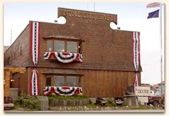
Municipal Buildings
City owned buildings include: city office building, city garage, library/museums, visitor’s center, swimming pool, recreation center, city park, Mini- Convention Center, Old St. Joseph’s Church, power plant, water plant, landfill storage building, police/fire station, new public works building, and animal control shelter.
Gaps Identified:
Tribal members in Nome note that the pool is often closed in summer when it is needed most, and has prime time blocked off for special groups. The Nome Recreational Center is often closed for special events. Not all families can afford to go to the pool or rec. center regularly, which increases their health risks. City Hall chambers are not large enough to accommodate much public participation. There needs to be a large meeting place for conventions and events so that the recreation center can be open full time, year around for recreation. Anchorage tribal members are concerned about the scheduling hours and high cost of the area’s recreational centers.

Tribal Buildings
Solomon owns a multipurpose Community Center/Bed and Breakfast located within Solomon. The Council was able to purchase a 2 story residential home, which was remodeled into an office building and 2 rental units upstairs.

Public Safety – Law Enforcement
The State of Alaska has eight Troopers and two Court Service Officers who work out of Nome or Unalakleet serving 16 communities in the region. The Nome Police Department has one chief, nine Police Officers, one Community Safety Officer and five other staff.
They have several vehicles and bicycles. The Nome Volunteer Fire and Volunteer Ambulance departments serve the community and have adequate equipment to serve a community of this size. A volunteer search and rescue team operates as well. The Nome Police Dept. uses local email Listserv to report and attempt to locate missing persons.
N.E.S.T. operates a homeless shelter, the Bering Sea Women’s Group operates a women’s shelter, and Kawerak operates a Child Advocacy Center in Nome.

Gaps Identified:
Tribal members are concerned about rumors of corrupt or biased officers, racism, Alaska Natives not being treated fairly, hearing that Alaska Native emergencies are not given priority in response time, the need for more Alaska Native officers and staff, and about the limited number of beds at the women’s shelter. The tribe is also concerned about pollution or trespass issues at Solomon, and the need for public safety services in Solomon during subsistence seasons.

Libraries and Museums, Cultural Buildings
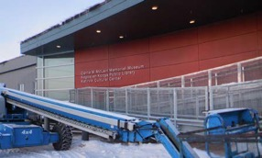
The schools and college libraries are available to students in Nome during the school year. New books are added annually. The City of Nome operates a public library that is open six days a week. The Northwest Campus operates a public library during the fall and spring semester. The city museum is open five days a week. The City of Nome moved the old museum and library to the new Richard Foster Building. Kawerak leases a portion of the new building to the Katirvik Cultural Center.

Gaps identified:
Tribal members felt there was a heavy focus on gold mining and that many cultural exhibits were not displayed due to limited space. It is hoped things will improve in the new facility.

Cemeteries and Graves
Nome has a designated and maintained cemetery near the airport. It has a morgue for cold storage in winter. There are a few burial sites and isolated gravesites in and around Nome. Improvements and expansion is needed to record names, re- mark older graves, and make more room for new graves. There is also a cemetery in Solomon.
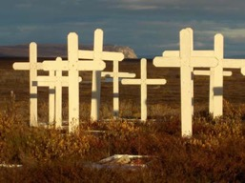
Gaps identified:
There is a concern about erosion at the Solomon cemetery, and the need for more burial assistance services in Nome as mentioned elsewhere. The current status of the crosses need to be repaired as they have been falling apart.Public Buildings and Lands
Tribal and corporation members living in Nome have access to the following meeting places, churches, parks, camps, and recreational areas: The City of Nome owns the city hall building, the old library/museums, the new Richard Foster building, Mini Convention Center, Old St. Joseph’s church, City Park, the swimming pool, and the recreation center. There are several playgrounds and basketball courts around town. The college has a conference room or classrooms that are sometimes rented for events. The various Native councils or Native Corporations also rent meeting space as well as the Pioneer Igloo Hall. In the area are several flat areas on the banks of the shore for picnics and outdoor summer events. The ocean and rivers are used for fishing, events, boating and as a swimming area. Local trails are used for ATV, snow machine, and foot races. There are several other designated picnics areas around the community. Outside of town are snowboarding and ski slopes which are a favorite spot to many from the region. There is also a local outdoor gun range. The Native Corporations will rent and lease campsites outside of the city limits. The tribe operates a B&B in Solomon and offers a reduced rate to tribal members. The tribe has canoes, kayaks, bikes and fishing pools for members to use, as well as a shelter cabin that can be used in the summer for recreational use or subsistence. Several tribal members have camps.
(Solomon Cemetery)

Cultural, Tourism and Other Local Events
Visitor Attractions: | City Convention & Visitors Center; Gold Rush History; Alaska's largest gold pan; 300 miles of local roads for wildlife and bird viewing; Iditarod  dog mushing; Eskimo culture
Gaps Identified:
Tribal members would like to see local language circles for adults and children in their dialect. More information should be disseminated about language tools online, Facebook, phone aps, CD’s and books. They would also like more opportunities to gain cultural skills in Nome and Anchorage (sewing, crafts, dancing, hunting, firearm safety, weather knowledge, food preparation, sled building, etc.)
Churches in Nome
Baha’i Center | Bible Baptist Church
St. Joseph’s Catholic Church | Nazarene Church
United Methodist Church | Our Savior’s Lutheran Church
Nome Covenant Church | River of Life Assembly of God
Seventh Day Adventist Church | Church of Latter Day Saints

Population and Growth Trends – Nome Solomon Census Data

Census data for 2019 revealed that 10,004 people were living in Nome. The above population data for Nome is from the 2019 and 2019 U.S. Census. Additional detail is available from the Alaska Department of Labor and Workforce Development.

Population by Race: | 2000 | 2010
Population in : | 3,505 | 3598
White: | 1,328 | 1,093
Alaska Native or Amer. Indian: | 1,789 | 1,971
Black: | 30 | 18
Asian: | 54 | 78
Hawaiian Native: | 2 | 9
Other Race: | 15 | 18
Two or More Races: | 287 | 411
Hispanic Origin (Any Race): 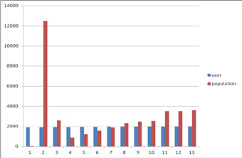 | 72 | 85
Not Hispanic (Any Race): | 3,433 | 3,513
Percent Native*: | 51.04% | 54.78%
Population estimates, July 1, 2019, (V2019) 10,004
PEOPLE
Population
Population estimates, July 1, 2019, (V2019) 10,004
Population estimates base, April 1, 2010, (V2019) 9,492
Population, percent change - April 1, 2010 (estimates base) to July 1, 2019, (V2019) 5.4%
Population, Census, April 1, 2020 10,046
Population, Census, April 1, 2010 9,492
Age and Sex
Persons under 5 years, percent 10.0%
Persons under 18 years, percent 34.6%
Persons 65 years and over, percent 8.0%
Female persons, percent 47.4%
Race and Hispanic Origin
White alone, percent 15.7%
Black or African American alone, percent(a) 0.9%
American Indian and Alaska Native alone, percent(a) 75.3%
Asian alone, percent(a) 1.5%
Native Hawaiian and Other Pacific Islander alone, percent(a) 0.2%
Two or More Races, percent 6.5%
Hispanic or Latino, percent(b) 2.9%
White alone, not Hispanic or Latino, percent 14.9%
Population Characteristics
Veterans, 2015-2019 394
Foreign born persons, percent, 2015-2019 2.5%
Housing
Housing units, July 1, 2019, (V2019) 4,100
Owner-occupied housing unit rate, 2015-2019 60.5%
Median value of owner-occupied housing units, 2015-2019 $154,600
Median selected monthly owner costs -with a mortgage, 2015-2019 $1,470
Median selected monthly owner costs -without a mortgage, 2015-2019 $469
Median gross rent, 2015-2019 $1,287
Building permits, 2020 8
Families & Living Arrangements
Households, 2015-2019 2,844
Persons per household, 2015-2019 3.30
Living in same house 1 year ago, percent of persons age 1 year+, 2015-2019 84.1%
Language other than English spoken at home, percent of persons age 5 years+, 2015-2019 31.0%
Computer and Internet Use
Households with a computer, percent, 2015-2019 90.7%
Households with a broadband Internet subscription, percent, 2015-2019 74.1%
Education
High school graduate or higher, percent of persons age 25 years+, 2015-2019 84.6%
Bachelor's degree or higher, percent of persons age 25 years+, 2015-2019 16.1%
Health
With a disability, under age 65 years, percent, 2015-2019 6.8%
Persons without health insurance, under age 65 years, percent 17.2%
Economy
In civilian labor force, total, percent of population age 16 years+, 2015-2019 64.8%
In civilian labor force, female, percent of population age 16 years+, 2015-2019 66.8%
Total accommodation and food services sales, 2012 ($1,000)(c) 14,821
Total health care and social assistance receipts/revenue, 2012 ($1,000)(c) D
Total manufacturers shipments, 2012 ($1,000)(c) D
Total retail sales, 2012 ($1,000)(c) 78,672
Total retail sales per capita, 2012(c) $7,935
Transportation
Mean travel time to work (minutes), workers age 16 years+, 2015-2019 6.7
Income & Poverty
Median household income (in 2019 dollars), 2015-2019 $61,048
Per capita income in past 12 months (in 2019 dollars), 2015-2019 $23,581
Persons in poverty, percent 20.7%
*Source: http://censusviewer.com/city/AK/Nome
Census counts were are not always done for Solomon each year of the US Census which started in 1880. Below are the numbers for years when it was counted separately.

Year of count | Solomon population
1939 (for 1940 Census) | 106
1950 | 93
1990 | 6
2000 | 4
2019 | 0
*Note: The School closed in 1956, and the last year Solomon had year-around residents was in 2005.

Languages
English is the primary language spoken in Nome. The three Alaska Native language spoken are Yupik’, St. Lawrence Island Yupik, and Inupiaq. The Village of Solomon is primarily Inupiaq. There are some other languages spoken in the community, such as Spanish, Russian, Korean, Vietnamese, German, etc.
Gaps Identified: Tribal members want a strong language program for adults and students of all ages, especially the very young, local language circles, language resources in the Fish River Inupiaq dialect, and a regional Alaska Native Language Emersion school.

Employment and the Economy
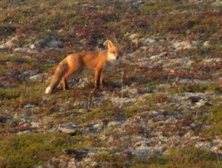
Nome is the supply, service and transportation center of the Bering Strait region. Government services provide the majority of employment. 60 residents hold commercial fishing permits. Retail services, transportation, mining, medical and other businesses provide year-round income.
Several small gold mines continue to provide some employment. The government, schools, native organizations, airlines, and private businesses provide the local employment. Construction jobs provide seasonal employment. Ivory and bone carving, sewing, knitting, beading, wood carving, and ulu making contribute some cash flow to local artists.
Subsistence activities contribute to the local diet. The entire population depends on subsistence hunting and fishing activities, which are supplemented by part-time, wage earnings. Jobs are limited and unemployment is high. Some residents spend part of the summer at camps doing subsistence hunting and fishing. Fish, seal, and moose are the primary subsistence meat sources. An increase in the predator population has had a negative effect on the moose populations. Beluga whale, seal, walrus, reindeer, caribou, musk ox, Brandt ducks, geese, ptarmigan, spruce hens, grouse, and brown bear are also utilized. Seafood harvests include: crab, salmon, trout, grayling, tom-cod, white fish, pike, herring, herring eggs, and ling fish. The decline of fishing in 2003 imposed stricter regulations on silver salmon. Several kinds of bird eggs, roots, greens and berries are gathered.

Environmental Scan

Topography and Vegetation
In the Nome and Solomon area at least six distinct geographic beaches exist on the coastal plain inshore from the present day beach. These ancient marine beaches represent different sea levels that once occurred in the region during Pliocene and Pleistocene times. The ancient beaches are overlain by a mantle of glacial till and outwash deposits between 50 to 60 feet thick. The coastal plain which is approximately a 4 mile wide stretch of poorly drained lowland, extends from Cape Nome to the hills just west of Cripple River. Bordering the coastal plain is a series of hills which were formed by folded and faulted interbedded schists and limestones. Primarily, the soils along the hill sides are rubble or gravel overlying shallow bedrock. These soils are typically well drained.
The primary vegetation cover in the Nome region is tundra. There are virtually no large trees in the area. Vegetation is generally limited to lichens, willows, shrubs, mosses, low bush berries, and various grasses. The entire Seward Peninsula falls within the continuous permafrost zone. The permafrost is continuous throughout the coastal plain except under deep lakes and major streams. This permafrost is known to reach thicknesses of up to 300 feet. The potential flooding from surrounding rivers and coastal storm surges exists; however, there is little documentation of serious flooding within the city. Vegetation on the Seward Peninsula is principally tundra, with alpine dryas-lichen tundra and barrens at high elevations and moist sedge-tussock tundra at lower elevations. Patches of low- growing ericaceous and willow-birch shrubs occur on better-drained areas. Vegetation in Nome is generally limited to willow trees, berry bushes, wild flowers, lichens, shrubs, mosses, low bush berries, and various grasses. Local residents harvest a variety of berries, roots, mushrooms, and greens from the land.

Climate
January temperatures range from -3 to 11; July temperatures are typically 44 to 65. Average annual precipitation is 18 inches, including 56 inches of snowfall. Nome has a transitional climate with less extreme seasonal and daily temperature variations than Interior Alaska. During the ice free summer months, the Norton Sound controls the climate; however, when the sound freezes, the climate changes from maritime to continental. The temperature extremes are -46
degrees F in the winter and 84 degrees F in the summer. Temperatures were milder in 2014 and 2015 due to El Nino. The mean monthly wind speed is between 9 and 12 mph.

Wildlife
A wide variety of fish and wildlife are present around Nome and Solomon. Moose, caribou, wolf, wolverine, beavers, porcupines, duck, geese, and other waterfowl are present. Seal, beluga whale, all species of salmon, whitefish, lingcod, tomcod, smelt, pike, and trout are present in the area waters. No critical habitat areas, refuges, or sanctuaries are listed in the area surrounding the community. No known endangered species habitats are located within the planning area.

Historic Preservation
There are ancient and historical sites in and around Solomon related to the Native culture and mining.

Seismic, Flood, and Wetland Information
Nome lies in seismic risk zone three, subject to earthquakes of magnitude 6.0 or greater. There is no record of damage in Nome from earthquakes or tsunamis. Nome is subject to ice-jam from the Bering Sea and some low frequency flooding. Climate changes and fall and spring storms have done some damage to property on the shore in recent years.
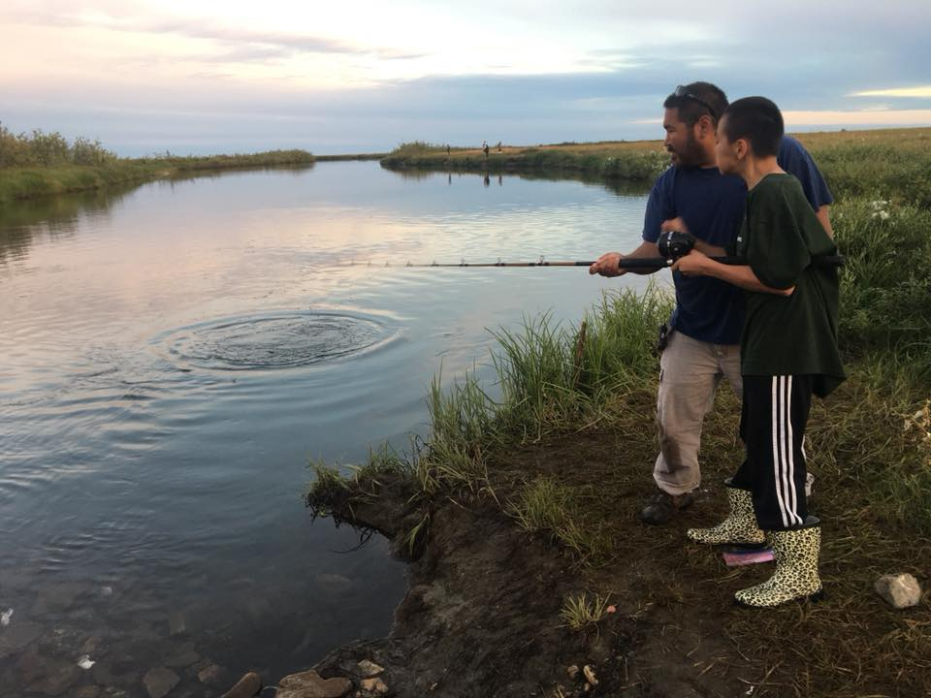
Alaska's wetlands occupy 43.3 % of its 403,247,700 acres. This contrasts to the contiguous US where they occupy only 5.2 % of the land surface. Wetlands in Alaska include: bogs, fens, wet and moist tundra, ponds, forests, mud flats, fresh and salt marshes. Most regions in Alaska have a land surface with extensive areas of wetlands.
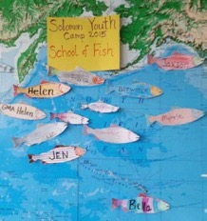
Expanses of moist and wet tundra underlain by permafrost occur in the northern and western regions. Some of the Nation's most extensive complexes of salt marshes and mud flats occur along the coasts of the Bering Sea.
Benny Piscoya and Derek Henry fishing just past the Solomon
Community Center during youth camp 2019

Land Status
The Sitnasuak Native Corporation was the first Village Corporation in the Bering Straits region that received patent title to all of the land it was entitled to under ANCSA.

Designated Land Status and Management Issues

There are no National Wildlife Refuges near Nome according to the U.S Fish and Wildlife Service. There are no designated Wild and Scenic Rivers near Nome, according to the U.S. National Park Service. Nome is included in the Bering Strait Coastal Resource Service Area. Development in Nome may be subject to the Bering Strait Coastal Management Plan developed in 1989, which was updated in 2010. State land includes the Nome airport. Some Native allotments and mining claims do exist within or near the Solomon Community. There are some local right of way and easements issues to consider before developing certain projects.

Land Use Potential
Within Nome there are some possible land areas for future development projects if care is taken not to build on existing wetlands. There are a few places in or near Solomon which should not be used due to mining or other issues. The formerly state-owned airport in Solomon is considered abandoned and could be used or repurposed. There is some interest in doing upkeep on the runway for emergency uses.

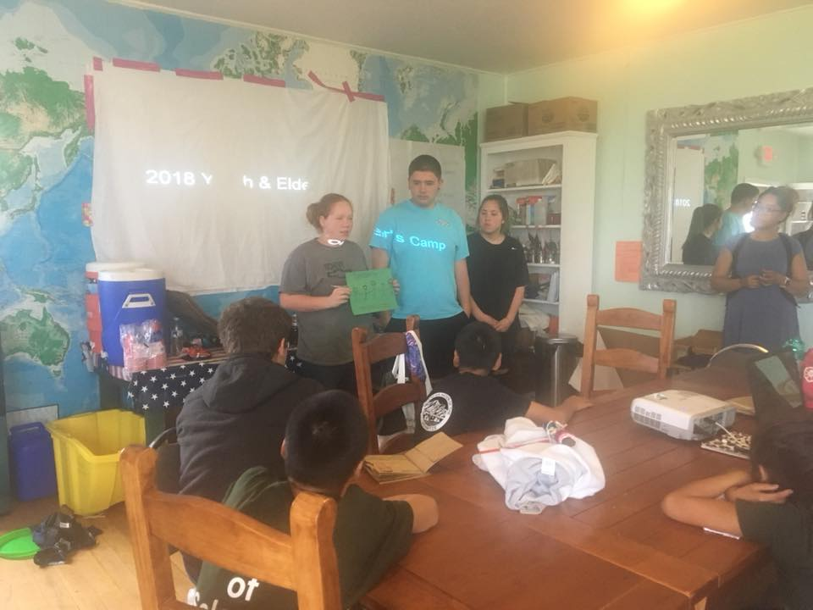
Analysis of Development
The following is a review of the positive and negative issues that affect program and project development in the community of Solomon or on behalf of tribal or corporation members.

Development Opportunities, Trends, and Strengths
What are our development opportunities, current trends in Nome and Solomon, or strengths and assets that will help us as we plan and complete projects in our community?
(Pictured L to R: Ashley, Joshua and Sandra Aycock, Deilah Johnson)

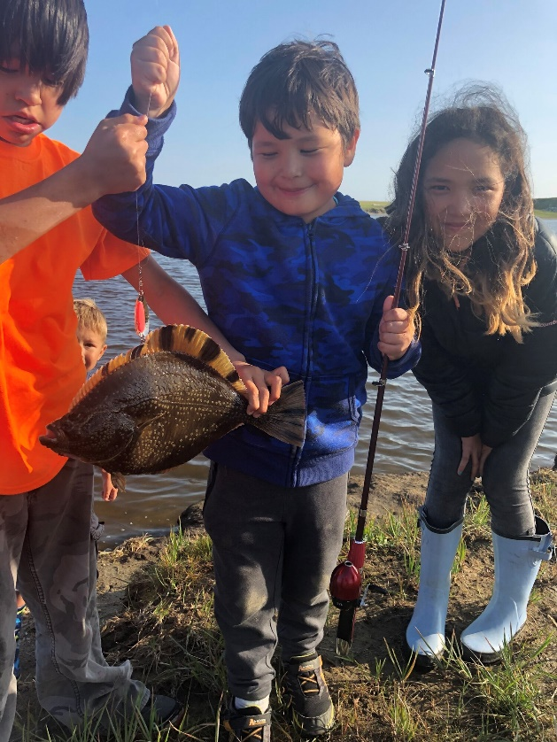
People and Organizations – We are a close knit community, we have talented artists, some tribal members are drummers or dancers, we have strong active educated individuals, we have positive role models, we have skilled workers, our people work together, we have volunteers, we share information, have inter-agency agreements, our tribal office has regular hours, we have a new tribal coordinator, we are improving on communication with our upgraded website and we publish regular newsletters. The internet has improved our access to information like grants and world news and issues. We now have a development coordinator to write grants and help plan important projects.

(Pictured L to R: Skyler Henry, Jack & Sara James)

Health and Safety – We see an increase in health education (prevention, screening have good fire department and search and rescue volunteers, Nome has a variety of recreation opportunities (playgrounds, recreation center, pool, camps and youth activities), and the tribe has satellite phones and a shelter cabin at Solomon.

Economy, Education, and Training – More of our tribal members are seeking higher education; and job opportunities, job training, and tourism opportunities are improving.

Culture – We have been having more community gatherings, we are seeing more respect shown for our Elders and one another, we share subsistence foods, and we see more bicultural programs in the community.
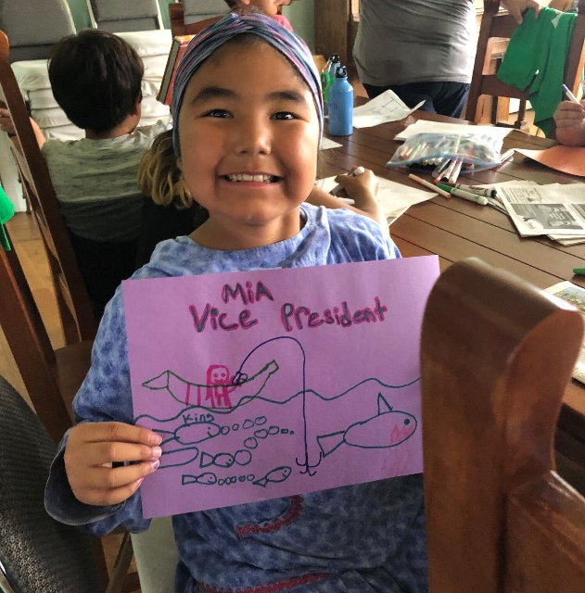
Environmental – We have a wide variety of subsistence foods available (animals, birds, eggs, berries and plants), the corporation has good gravel and mineral sources available for development, we have been involved in cleanup and recycling programs, we provide community education on the proper disposal of wastes, we conduct regular water quality testing, a tribal members serves as an energy champion on a local energy planning group, there have been tests on the local birds, salmon counts and samples taken for testing, and some salmon enhancement projects in Solomon.
(Mia Piscoya @ 2019 Youth Camp
running for the VOS Youth Council)

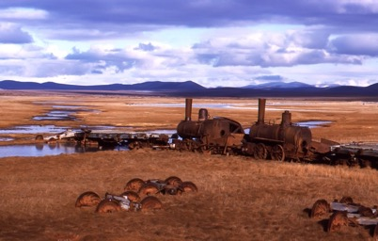
Infrastructure – We maintain the B&B/community building, we installed satellite phones in Solomon, we have water tanks and generators in Solomon, we have a new playground in Solomon, we lend recreational equipment to tribal members, we do some maintenance on the transportation in Solomon (roads, airstrip, driveways, and trails), some tribal members obtained new housing or renovations in Nome, Nome has adequate infrastructure (water and sewer, electricity, landfill, bulk fuel tank farm, communications, new hospital, schools, heavy equipment, air and marine transportation systems, public buildings, library, post office, correctional facilities, city office, tribal buildings, churches, stores, restaurants, hotels, internet, roads, cemetery). The Environmental Coordinator secured funding from the Tribal Solar Accelerator Fund through Wells Fargo in renewable energy efforts. The project was to install a 7kW rooftop solar system with battery storage. Completed July 2021.

Development Barriers, Hazards, and Areas of Concern
What are development barriers, hazards, or areas of concern or challenges that we need to recognize?
- It is challenging to get people to take advantage of programs and activities.
- Planning is more difficult due to having a small tribal membership, some of which live in Nome.
- We need to engage members more in tribal activities.
- We offer the Solomon B&B at a reduced rate and need more tribal members visiting/camping at Solomon.
- We have been operating under occupancy at the B&B.
- Funding is more competitive, and opportunities do not always fit tribal priorities.
- Transportation to and from Solomon, and to and from Nome/Anchorage is a challenge and can add to the cost of important activities or projects.
- We see possible trespass and legal issues in Solomon that need to be monitored or addressed. We are not always aware of who has been granted access to Solomon lands and waterways.
- We would like to see better communication and cooperation so that more tribal members are hired for projects that happen in Solomon like the salmon enhancement or fish counting/testing projects.
- We would like more tribal knowledge of the mining activities going on around Solomon to be sure there is no damage to the environment. We need more local testing to determine possible damages to our lands due to mining activities in the past.
- Our tribal members struggle with the rising costs of living (housing, energy, transportation, communication, and food).
- We need to deal with some of the dilapidated building in Solomon, especially the old mining sites.
- Dust is more of an issue now and can damage meat racks during subsistence seasons. We need more road maintenance, speed limits, and adequate dust control every year.
- We are concerned about the college readiness skills of high school graduates being too low for college coursework.

Solomon’s Vision, Mission and Goals

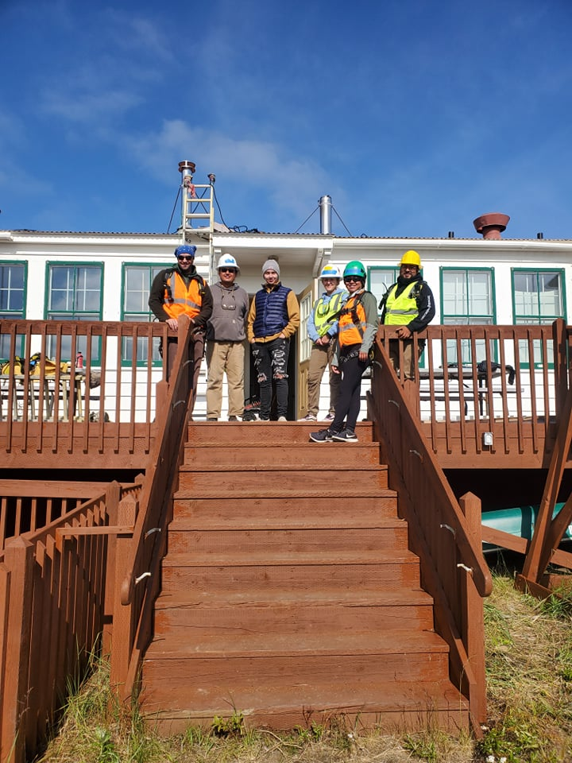
Planning for Solomon’s Future
The Village of Solomon, the Solomon Native Corporation and community members sought to develop priorities for future projects and activities which the community will use to enhance the local economy and build on the identified cultural strengths, economic opportunities, and current community assets over the next five years, 2021 -2026.

Solomon Community Vision:
By 2026 Solomon will:
- Have the VOS & SNC working together for capacity building and creating new projects.
- Enhance the local economy while staying true to subsistence traditions.
- Empower ourselves and each other as a community to enhance and strengthen our social and economic future.
Figure 1 (Pictured L to R: Ken Bungay, Tim Willink, Brewster Bohn, Berlyn Hubler, Deilah Johnson Felix Yepa @ Solar install 2021)
- Engage and empower our youth to be leaders.
- Utilize our elders and youth to revitalize our culture and traditional values.
- Strive for unity.

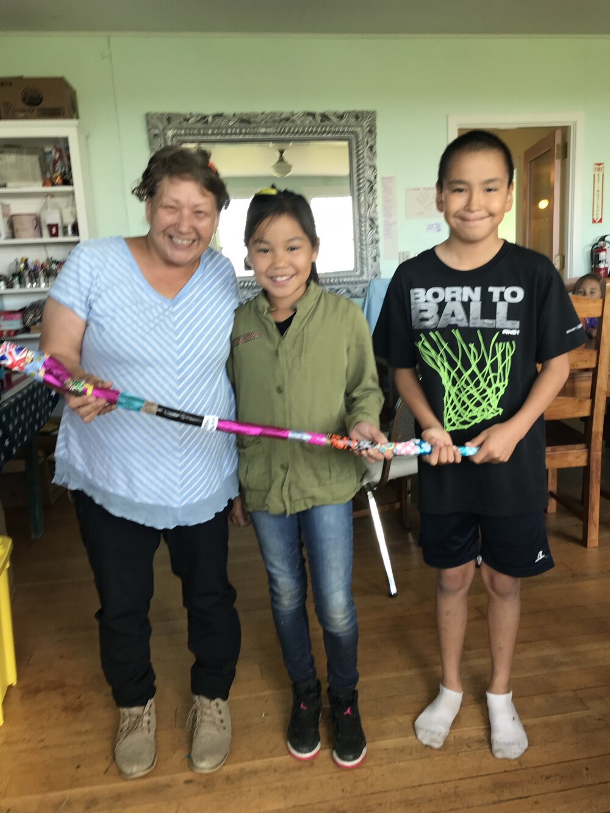
Areas of Responsibility
After reviewing the vision and in preparation of developing a mission statement for the community of Solomon, the planning group identified the areas of responsibility of the VOS and SNC:

Corporation Responsibilities:
Economic growth and development.
Oversight and stewardship of assets for the benefit of shareholders.
Maintaining compliance with corporation policies and bylaws along with the State of Alaska and Federal regulations.

Tribal Areas of Responsibility:
Teach cultural importance of our tribe.
Oversee ICWA cases of tribal members.
Host social and cultural events for tribal members.
(Pictured L to R: Vicki Olson, Luella Tumulak and Phillip Henry)

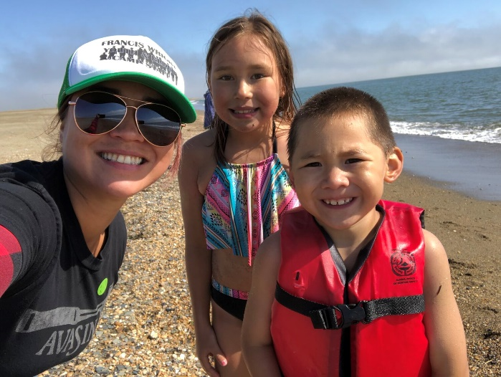
Financial responsibility to manage funds and grants.
Tribal enrollment of new tribal members.
Tribal governance (ordinances, policies, by laws, constitution).
Be caretakers of our lands and environment
Assist and serve our tribal members and meet their needs.

Solomon Community Mission
The planning group developed a community mission statement for the joint entities on behalf of the community of Solomon:
“To increase cultural awareness and promote the wellbeing of our tribal members while protecting our environment”.
(Pictured on the right; Deilah, Autumn and Grafton Johnson)

Solomon Community Development Goals
The planning group also developed three goals to accomplish this mission.
- Develop Solomon into a viable community.
- Maintain and increase tribal self-sufficiency.
- Assist our tribal members to foster future growth and become leaders

Values to Guide Community Development
Values
The planning group identified our community values which will help guide us as we develop and implement projects to improve our community.
- Cultural Values - Knowledge of our language, strong work ethic, arts, Eskimo foods, competence in cultural activities and skills, knowledge of family histories, sharing and caring for each other, love of nature, respect for elders, and sense of community and belonging to the tribe.
- Traditional or Modern Values - Church, formal and higher education, and use of technology, ATV’s, UTV’s and boats.
Applying our Values: When we develop and plan important projects or programs, what are the things we must remember?
We should:
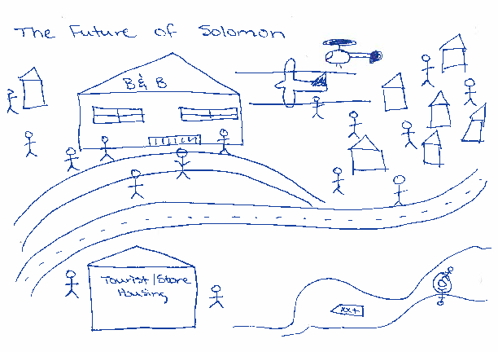
Practice positive communication with each other and outside agencies
Ensure proper clean up and project oversight
Utilize and create our own tribal membership expertise
Seek and secure other financial resources
Be culturally sensitive to our community
Utilize our own natural resources
Have transparency in all stages of the planning process
Protect our land and our resources
Help one another

Development Priorities and Implementation
There were 10 priorities identified by the Village of Solomon in order to meet our tribal members’ needs and improve economic development for the tribe. In order to provide a thorough understanding of each project, the following information will be developed for each priority:
      - Project Description
      - Background
      - Project Needs and Benefits
      - Potential Constraints to Project Development
      - Project Implementation Plan of Action
      - Organizations Responsible and Contact Information
      - Funding Possibilities

Project Ideas for 2021-2026
In no particular order;
Build a community fish rack
Host classes to smoke salmon and bake pie
Advocate for a family friendly washeteria
Develop a preventative ICWA program for struggling families
Approve a new B&B Business Plan to include tourism
Writing and publishing Inupiaq Children’s books
Create and manage our own transportation program to include boat harbor, airstrip and roads
Host more community gatherings

      - BIBLIOGRAPHY

Department of Commerce, Community and Economic Development Division of Community and Regional Affairs https://dcced.maps.arcgis.com/apps/MapJournal/index.html?appid=b98054a5c46941c4b3921af686dd488a

Kawerak and the Bering Strait Development Council, The Bering Strait Comprehensive Economic Development Strategy 2013-2018, Nome, Alaska 2013, available online at: http://www.kawerak.org/forms/csd/2013%20Comprehensive%20Economic%20Development%20Strategy.pdf .

RurAL Cap in partnership with the Denali Commission, Let your Assets Be Your Guide: A handbook for Community Planning, available online at: http://www.ruralcap.com/publications/misc/Let-Your-Assets-Be-Your-Guide-Jan- 2007.pdf

Society of Wetland Scientists, available online at: http://www2.sws.org/regional/alaska/Wetlands.htm

U.S. Army Corps of Engineers, Community Flood Hazard Data, available online at: http://www.poa.usace.army.mil/en/cw/fld_haz/nome.htm

U.S. Census Bureau, Census 2019, Profile of General Demographics
https://www.census.gov/quickfacts/fact/dashboard/nomecensusareaalaska/IPE120219

U. S. Department of the Interior, Bureau of Indian Affairs. Juneau Area Transportation Plan, Nome Agency Report.
Juneau, Alaska. 1993.

U.S. Geological Survey, Narrative Descriptions for the Ecoregions of Alaska and Neighboring Territories, Alaska 2001, available online at: http://agdc.usgs.gov/data/usgs/erosafo/ecoreg/ecoreg.html
Prepared for the Village of Solomon and Solomon Native Corporation by
The Solomon Planning Group and Denali Daniels and Associates

Solomon
The Village of Solomon Solomon Native Corporation
PO Box 2053, Nome, AK 99762 PO Box 243, Nome, AK 99762
(907) 443-4985, (907) 443-5189 fax (907) 443-7526, (907) 443-5189 fax

Denali Daniels & Associates Pearl Mikulski, Kawerak Inc.
880 H Street, Suite 106
Anchorage, AK 99501
(907) 317-0078, info@ddaalaska.com

*Copies of this plan are available at: http://www.kawerak.org/cpd.html No part of this plan may be reproduced in other documents, published or sold without the permission of the Village of Solomon.

