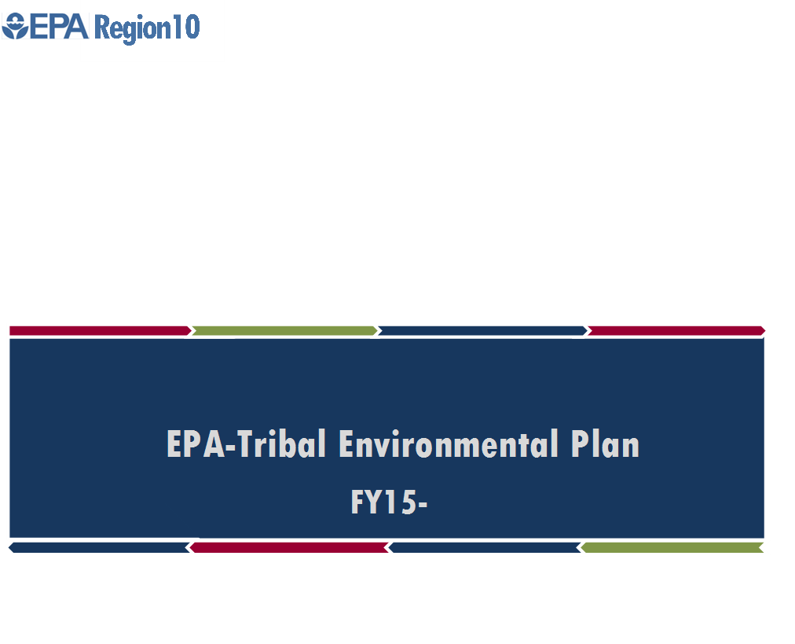

FY20

Village of Solomon

**Introduction**

The Village of Solomon’s (VOS) a federally recognized Tribe under the Indian Reorganization Act of 1993. The Solomon Traditional Council is the governing body of the Village of Solomon. The primary purpose of the Village of Solomon is to design and implement programs to increase the quality of life and well-being of its family and Tribal Members who reside in Nome and Anchorage permanently and Solomon seasonally. In 2010, the Tribal Members and Traditional Council completed their first Local Economic Development Plan (LEDP) with the help of Solomon Native Corporation (SNC) and Kawerak, INC. VOS is currently in the process of completing their second LEDP to serve through 2020. With this plan, the Solomon Traditional Council created a list of priorities that will be addressed and revised every five years. VOS’ Environmental Plan was created to assist the Tribe of Solomon, Environmental Coordinator, Kawerak, Solomon Native Corporation and other various entities to better identify and find solutions, as well as to build capacity to start addressing the Environmental Issues in and around Solomon, AK.

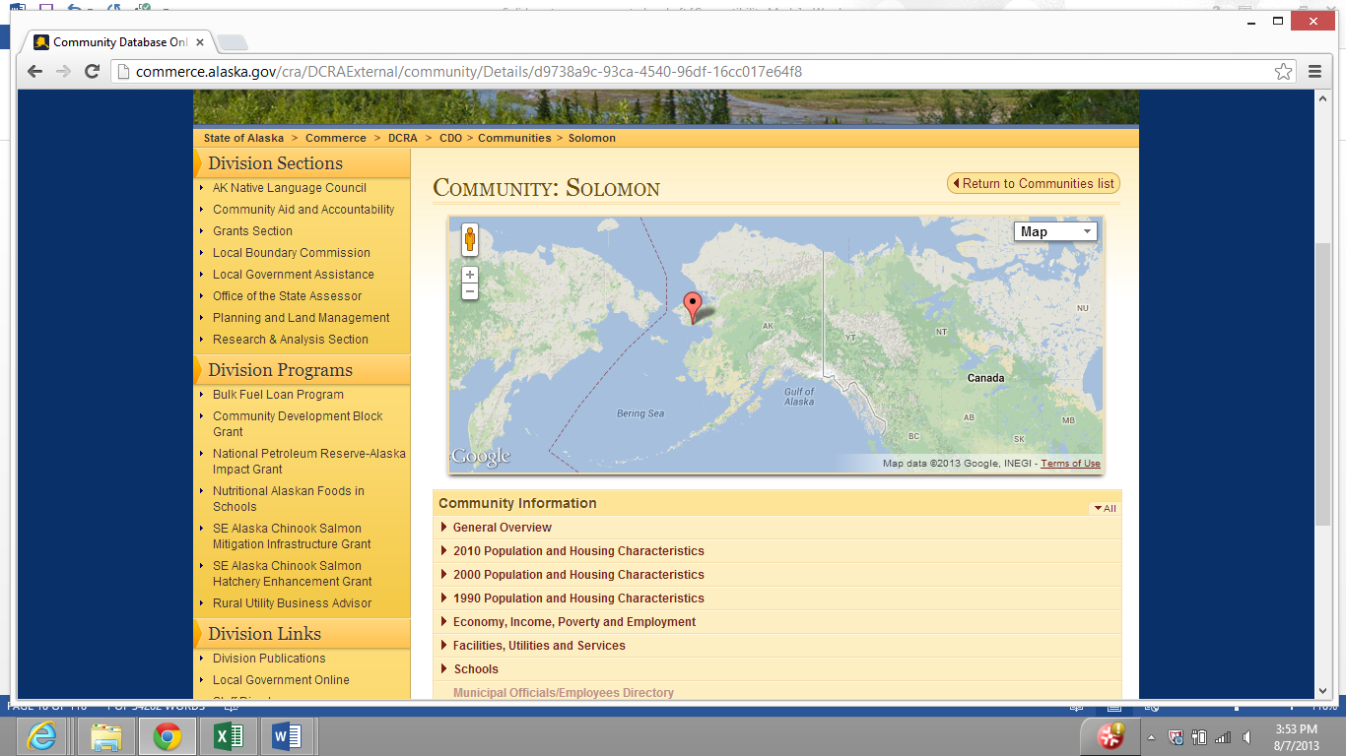

**Geography**

Solomon is located on the west bank of the Solomon River, one mile north of the Norton Sound, 34 miles east of Nome on the Nome-Council Highway. It lies at 64.560830 North Latitude and -164.43917 West Longitude. Solomon is located in the Cape Nome Recording District. The climate is both continental and maritime. Summers are short, wet and mild. Winters are cold and windy. The temperatures range from -30 to 56 degrees. There's also a 1,150 ft. long and 35 ft. wide dirt/gravel airstrip which is not useable as a runway and was abandoned.

**History**

The Village of Solomon was originally settled by Eskimo's of the Fish River Tribe*,* and was noted on the map as "Erok" in 1900. The original site was at the mouth of the Solomon River Delta, where it became a miner’s camp and later moved to the present location on Jerusalem Hill. The gold rush of 1899-1900 brought thousands of people to the Solomon area. By 1904 Solomon had seven Saloon's, a Post Office, a ferry dock, and between 3 and 7 big land dredges along the Solomon River. It was also the terminus of the Council City and Solomon River Railroad that serviced miner's from Solomon to Council. In 1913 the Railroad was washed out by storms and in 1918 the flu epidemic struck. In 1940 Bureau of Indian Affairs (BIA) built a school until the shut down in 1956. The Post Office shut down in 1958. Families relocated to Nome or Anchorage so their kids can continue their education. Pete Curran operated the Roadhouse until the 1970's, it served as a checkpoint for the Iditarod Sled Dog Race, during its first several years.

**Present Day**

Solomon had year round residents until 2004 when the surviving original residents relocated to Nome. Solomon is an abandoned Village but comes alive in the summer months when tourists and subsistence campers occupy the Village. Solomon has a Community Center that is operated out of the 2006 renovated B.I.A school house. Currently there are over 140 Tribal members enrolled with the Village of Solomon. There are only 25-30 Tribal Members that presently reside in the Nome area. Fishing, hunting for waterfowl, and picking berries are the most common ways Tribal members gather subsistence in Solomon. When the Community Center is open, Tribal members are able to utilize the restrooms, kitchen, laundry facilities and common areas. When the Community Center is closed, the potable water tank should be available, if not, you must haul water (such as during the winter months when the potable water tank is expected to be emptied) and outhouses are the primary source for restrooms.

**Vision Statement**

By 2020, Village of Solomon (VOS) envisions to work with the Solomon Native Corporation (SNC) for capacity building, to create new projects together, enhance the local economy while staying true to subsistence traditions, to be empowered, and as a community- to increase cultural awareness and promote the well-being of our tribal members while protecting our environment.

**Environmental Issues**

The VOS tribe would like to address the following Environmental concerns from the Tribal Environmental Plan. The Traditional Council wants to sustain an Environmental Program than can respond to a wide range of issues, including; Water Quality, Salmon Enhancement, Alternative Energy and Tribal membership involvement.

As Water Monitoring has just begun the first year of sampling in FY15, VOS would like to maintain a water monitoring program for a minimum of 5 years for an effective baseline data. VOS acknowledges the importance of a clean, healthy watershed and would like to continue to address this concern in the IGAP grant program as a component similar to previous years. The purpose is to have clean, healthy water for potential mining operations and climate change to compare the effects of the watershed to the baseline data. The water monitoring will also benefit the Salmon enhancement issue and potable water testing in our natural water sources which was once used as a drinking water source. The Village of Solomon Tribe has been working with the Solomon Native Corporation in addressing the Salmon Enhancement Issue, SNC is working with Alaska Department of Fish and Game and Norton Sound Economic Development Corporation on counting the salmon runs and rehabilitation, the VOS Tribe would like to contribute by conducting appropriate water sampling and providing accurate data. The tribe also plans to revise the QAPP to include water sampling testing for natural drinking water.

Our seasonal Solomon residents do not have community electricity available. Community Power/Electricity (solar, wind and diesel backup) has been on VOS’ LEDP Village Priority List since 2011. The tribe would like to conduct a feasibility study on alternative energy for the Community Center and neighboring campsites for wind/solar energy. Elders and their families continue to use their cabins in Solomon during the summer months to enjoy the traditional subsistence Solomon lifestyle and to utilize all of Solomon’s natural resources to become a self-sustaining community.

VOS would like to continue to educate and actively engage community outreach for the tribal membership. The idea is to instill a new Reducing, Reusing, Recycling, Upcycling lifestyle to not only become role models within our own displaced community, but as well as a role model in the Bering Strait Region.

The Village of Solomon seeks to improve the quality of the environment to eventually become a sustainable healthy community to live in.

**Environmental Department**

VOS was awarded two 2 year IGAP grants from 2012-2016 and 1 year IGAP grant awards for 2017, 2018 & 2019 as well as an Additional Funding Request award for 2018. The IGAP program has been able to assist VOS in accomplishing an approved Solid Waste Management Plan, an approved Quality Assurance Project Plan and hire two Water Quality Experts and an approved Renewable Energy Plan. Within these accomplishments, VOS has been able to set up a mobile communal trash trailer in Solomon, distribute 5 Bear Safe Trash Can’s with signed User Policy’s, Solid Waste Education Outreach in various methods, began Water Monitoring for collection of baseline data within the Solomon Watershed, install a meteorological tower for solar and wind data collection. Unfortunately, the Environmental Department had gone through a staff-turnover which meant VOS had to hire and train new employees with a new strategy. This resulted in two Water Quality Experts to complement the new Environmental Coordinator to maintain a successful Environmental Department. Although VOS had undergone a staff-turnover, the Environmental Department was still able to successfully assess the tribe’s environmental concerns through assessments and outreach which led to addressing the Solid waste issues and implement an Environmental Committee and Solid Waste Management Plan.

VOS completed a SWMP, ETEP, REP and QAPP. The Environmental Department and Council members have attended environmental and IGAP trainings/conferences despite the staff turn-over. VOS acknowledges in order to have a successful program, we must all engage ourselves and contribute in unity. VOS successfully hired and trained three tribal members to carry-out the FY15 & FY16 IGAP grant. Trainings/conferences include ATCEM, AFE, Water Quality Phases I & II courses, Solid Waste conference, Bering Strait Regional Conference, and ANTHC Effective IGAP Management. Village of Solomon has not had any trouble with the grant or any corrective actions against the IGAP grant. The only challenge VOS faced during the first 4 yr grant cycle was the staff turn-over which caused unspent funding in FY14 and the loss of a trained employee. The Council strategically manages the authorized environmental programs by developing a teleworking policy to ensure sustainability with environmental staff. VOS plans to continue to build capacity by applying for appropriate grant programs.

Long Term Development Goals:

To have an accessible Water Quality baseline data for the Solomon River Watershed for future activities and salmon enhancement for 5+ years.

To keep the knowledge of Pollution Prevention fresh and updated for the Tribal Membership

To have a sustainable and Solid Waste Management Program.

The Village of Solomon seeks to improve the quality of the environment to eventually become a sustainable healthy community to live in.   
To resource renewable’s for current and future energy demands.



**Tribal Programs and Priorities (short-term & long-term)**

* Manage Environmental office- President or designee will supervise the Environmental Coordinator. The Environmental Coordinator will require pre-determined qualifications and must be able to follow the living Tribal environmental plan with minimum supervision, take initiative and maintain active grants (as well as apply for new opportunities).
* Revise Solid Waste Management Plan (SWMP) as applicable. SWMP was written by the Environmental Coordinator and approved by Council September 18, 2014.
* Build capacity to develop and administer environmental programs- Working well with local entities, have formed great relationships which has also been a great resource in moving forward with the current EPA IGAP grant work plan. Continue to build capacity by applying for grants as they become available.

* Implement Solid Waste Management Plan for VOS – After SWMP was approved, implementation is the current step. To implement all activities in order to become Solid waste sustainable.
* Conduct baseline meteorological study in Solomon- VOS to purchased meteorological equipment under the FY 13 & FY 14 IGAP grant to conduct measurements in Solomon. Data is being recorded and will continue until baseline is completed. Solomon plans to conduct a 5 year water baseline data to ensure Solomon’s Watershed is protected for the subsistence lifestyle, drinking water source and through climate changes. The water quality experts must also be trained and certified on a regular basis.
* Draft and finalize Quality Assurance Project Plan (QAPP) and to begin collecting baseline water quality data within Solomon River – QAPP has been approved. Approved March 2015. The QAPP will also be revised as needed by the tribe and the Solomon Watershed to also include safe drinking water testing and to be extended more than 5 years of data collection.

* Implement home recycling program for community – Environmental Coordinator has been able to research recycling facts, tips, and ideas for tribal members for the bi-annual newsletters and handouts in tribal gatherings. Incentives were given in a Quiz and contest format to act as encouragement to implement community recycling efforts. Under the IGAP workplan and budget, VOS was able to purchase rechargeable battery chargers to distribute to the community as they turn in their disposable batteries for proper disposal and as encouragement for Reusing, Reducing and Recycling. VOS set up a social media page to encourage and share Recycling, Reducing and Reusing facts, tips. Educational post cards are sent to membership using an environmentally friendly company. VOS must continue the Recycling, Reducing, and Reusing tips in creative, new ways every year. A Swap Drive annually during Spring and another region wide event to act as a role model recycling community as well as bi-annual Educational IGAP gatherings and to host Environmental Educational Youth Summits. Recycling pickups from Tribal member homes, the environmental assistant will deliver recyclables to recycling center.

* Purchase mobile communal dumpster for Village under approved Solid Waste Management Plan – VOS purchased a trash trailer locally and constructed an enclosed fence around the structure. It has been completed and set up in Solomon for Bear Safe Trash Can User’s. To maintain the mobile trash trailer.
* Create Bear safe trash can user policy to ensure cleanest waste disposal – Bear safe trash cans were purchased under the IGAP grant to distribute in Solomon for the summer residents. As part of the communal dumpster idea, a user policy will be created to ensure clean disposal for trash trailer hauling. To keep the user policy updated as needed. And to keep recycling bins accessible in the community.
* Maintain 200 gallon potable water tank purchased through IGAP grant – A VOS employee will follow a list of duties when maintaining potable water tank. To ensure 200 gallon water tank is filled for all seasons. If the members of Solomon feel that there was water available, they would stay for longer periods.
* Bi-annual community clean-ups – As an effort to include the community within the Tribal environmental plan, a spring and fall clean-up will be hosted by VOS. Clean up supplies were purchased. Implement clean up events within Nome during the winter when Solomon is not an active community.

* Continue to educate Tribal members and Council on proper waste disposal, recycling and backhaul through Community meetings, tribal gatherings, newsletter and Village of Solomon Facebook – Environmental Coordinator has been researching fun ways to present educational material to tribal members. Spring 2015, Environmental Coordinator was able to host an educational IGAP gathering and again in September 2015. Mailing out educational postcards to membership beginning May 2015. Will also include community events during the summer in Solomon as well as in the Nome area when Solomon is an inactive community. VOS removed the scrap metal located in the community after discovering asbestos in a fallen down church, to improve the drainage and to maintain a clean land for subsistence and the history of Solomon.
* Maintain the weather station and continue to collect environmental measurements (weather station was purchased through the IGAP grant) – Environmental Coordinator has been recording data from the National Oceanic and Atmospheric Administration website where the weather station has been listed under Solomon, Alaska. To generate some type of graph data over the course of 5 years.
* Salmon Enhancement - VOS’ Environmental Coordinator will work closely and support SNC’s salmon enhancement project collaborated with Norton Sound Economic Development Corporation and Alaska Department of Fish & Game. Will also include Salmon Enhancement through the IGAP QAPP for data baseline and seek other opportunities to ensure improved watershed subsistence.
* Assess effects of climate change. River flooding and climate change affects the Solomon area by causing road damage and coastal erosion.
* As one of the top 10 on the priorities list LEDP, Community Power needs to be addressed. Step by Step to create a Renewable Energy Plan and seek funding opportunities to implement the plan. Research the feasibility of solar power and Community Center power consumption, Research costs and develop project to gather data on wind and solar resource. Identify partners. Expand the knowledge of the Renewable Energy world to introduce ideas and activities in order to become more aware and resourceful in the community for the Environmental Dept., Council members and tribal membership. September 2018, through the approved Renewable Energy Plan and current partners, a meteorological tower had been installed in Solomon to conduct a year long feasibility study.
* Obtain a local Community Hall/office building for the Environmental Department and other VOS programs to operate.
* To continue seeking funding opportunities to implement the Renewable Energy Plan
* To create a tribal membership recycling shed near the office to increase recycling efforts
* To conduct home energy audits for tribal membership. Distribute weatherization kits to all membership households
* To have a ride a bike program to decrease fossil fuels and encourage exercise. The tribe can purchase some bicycles to keep at the office for bicycle check-out
* Share a ride program, to increase carpooling in a small community
* To create a Household hazardous waste program to decrease HHW in landfills
* To begin focusing more on our youth as leaders today by allowing them to take ownership of their reduce, reuse or upcycling efforts and act as the role models within their families
* Create a new environmentally friendly campaign each Earth Day to raise awareness i.e. say to no straws, beach clean ups, pledge to not use disposable plastics for one day, carpool/ride a bike
* Plant a community garden and provide fresh vegetables and fruit, potatoes and such for our elders and families with small children, as well as the community center
* Keep an Environmental Assistant on staff, especially during the busy summer season, train assistant to book keep
* Keep an Environmental Committee active on a quarterly teleconference schedule

**A word from the Tribal members through Community Surveys**

The VOS tribal members listed the top five Environmental issues that were voted in a survey fall 2013. VOS hopes to build relationships with SNC, Kawerak, Norton Sound Regional Hospital, State of Alaska, Environmental Protection Agency (EPA), Norton Sound Economic Development Corporation (NSEDC) and any other tribal entity in implementing such solutions.

These are the top 5 environmental issues resulting in the Community Survey:

* Lack of waste disposal resources which has caused trash to fly around the Village. Waste material has not been disposed of properly.
* Unsafe drinking water
* Decrease in salmon population in our Solomon River. Salmon has always been a very active healthy part of Solomon’s subsistence way of living. Old broken down equipment left all over the village is a risk for contaminants in the soil and River.
* Gravesite land bank erosion
* Landfill dumpsite – Waste management has become obsolete.

**Environmental Planning Committee**

A Committee was formed on June 25th, 2014 – January 1, 2015. This committee was comprised of 4 members. They represented different parts of our community. Their job was to make sure that our plan fits our community and will work best for our community. Between 3 meetings, their ideas included:

* Making sure that we find solutions that are environmentally safe, economical and effective to benefit the whole community.
* Creating a solid waste management program by purchasing a trailer to haul gathered waste using the bear safe trash cans that were purchased under the IGAP grant. User policies will be signed in order to receive a trash bin to ensure clean organized trash disposal.
* Recycling program. Crushing our aluminum cans to combine with home recycled aluminum cans. The plan is to send the cans using our Alaskans for Litter Prevention and Recycling (ALPAR) account for free on Northern Air Cargo to Anchorage and get paid $0.35/lb. Proceeds will go to trash collectors.
* To purchase clean up supplies for a fall and spring clean-up. It is suggested that VOS provides lunch.
* Work closely with NSEDC’s program to increase salmon counts. SNC has been working with NSEDC and Alaska Department of Fish & Game for the last few years on chum rehabilitation. VOS plans to follow updates and offer support in ways they can.
* To fill our existing 200 gallon potable water tank purchased through the IGAP grant and to keep that maintained. The long term idea is to insulate a 500 gallon potable water tank and bury it in Solomon, and to refill an empty tank to haul back and forth.

The following people have served on our committee:

* Grace Davenport, Tribal member
* Cheryl Komakhuk, Tribal member
* Greg Timbers, Former President & CEO of SNC, Tribal member
* Deilah Johnson, Environmental Coordinator, Former Council member

**Energy Leadership Committee**

The ELC was created September 2017 and is comprised of 5 members who expressed a letter of interest and were invited to participate in the committee.

**Commitment & Responsibilities to E.L.C**

“As a Village of Solomon Energy Leadership Committee member, I pledge to

provide my knowledge, to advise the Traditional Council and the VOS Community at an all-encompassing service in regard to the Renewable Energy Planning for my tribe to the best of my ability.

* I understand this Committee could exceed 2+ years.
* I understand that I can be asked to report to the Council or Community as a spokesperson for the Committee.
* I will respect each idea, suggestion or concern raised in each meeting, I will expect respect in the same form.
* I understand each Committee member will bring something unique to the discussion and I will value each member.
* I will be expected to attend at least 75% of the Committee meetings to remain in active status. (3 of the 4 meetings annually = 75%)
* If I am unable to attend a meeting, I will notify the Environmental Coordinator and request a schedule change as needed.
* I understand this is a volunteer service for my tribe.
* I understand I may be invited to meetings or calls in regard to Energy partnerships, networking or collaborative efforts and act as a sounding board, representing Solomon’s E.L.C.”



|  |  |
| --- | --- |
| **EPA Region 10 Office of Ecosystems, Tribal, & Public Affairs** | |
| **Region 10’s Office of Ecosystems, Tribal and Public Affairs unit works to tie together ecosystem health and the people who reside in those ecosystems. An ecosystem is the natural system in which energy and nutrients cycle between plants, animals and their environment. People are a part of that system, and we influence the natural processes with our activities. This office is responsible for a variety of programs and efforts dealing with the interactions between people and their ecosystems.** | |
| **Units & Programs** | ** Priorities & Activities** |
| **Public Affairs Unit**  **The Public Environmental Resource Center offers publications, educational material, and video loans, and routes calls and questions about environmental matters. Specialists communicate EPA’s mission and efforts through the website, news and social media outlets, and educational institutions. Coordinators work with state, Congressional, and international partners.** | * **maintaining environmental resources for the public** * **developing web/internet content and press releases** * **responding to public, press, and Congressional inquiries** * **responding to Freedom of Information Act (FOIA) requests** * **coordinating on international issues and projects** * **managing environmental education grants** |
| **Tribal Trust & Assistance Unit**  **The United States has a unique relationship with and responsibility to federally recognized tribes. The Tribal Program works to assist EPA programs in coordinating and consulting with tribes, and in partnering to address environmental issues and challenges. Tribal Coordinators work with tribes and consortia to build capacity to manage environmental programs.** | * **facilitating communication, coordination and consultation** * **supporting Government-to-Government relationships** * **managing IGAP and Performance Partnership grants** * **facilitating the development of EPA-Tribal Environmental Plans** * **providing training and technical assistance** * **coordinating R10 Tribal Specialists Team** * **coordinating R10 Tribal Operations Committee** |
| **Community Engagement & Environmental Health Unit Community Involvement Coordinators assist EPA programs in engaging communities on clean-ups and other actions. The**  **Children’s Environmental Health Program offers information to help protect children wherever they live, learn, and play. The Environmental Justice Program works to integrate environmental justice into EPA’s programs and to assist in evaluating issues raised by communities.** | * **coordinating outreach for clean-ups and other projects** * **providing information for healthy children, homes and schools** * **coordinating the R10 Children’s Health Working Group** * **evaluating and coordinating on environmental justice issues** * **connecting communities and EPA programs on EJ issues** * **managing environmental justice grants and contracts** * **coordinating the R10 Environmental Justice Integration Team** * **providing training and technical assistance** |
| **Aquatic Resources Unit**  **The EPA co-administers a Clean Water Act (CWA) section 404 program with the Army Corps of Engineers (ACE) that regulates the discharge of dredge and fill materials from development, water resource, infrastructure, and mining projects into waters of the U.S., including wetlands. R10 also works to enhance state and tribal wetlands programs with grants and technical assistance.** | * **reviewing and evaluating CWA 404 permit applications** * **ensuring adequacy of compensatory mitigation** * **enforcing CWA 404 regulations** * **evaluating state and tribal applications for program assumption** * **managing wetland program development grants** * **encouraging development of state and tribal wetland program plans • providing training/ technical assistance** |
| **NEPA Review & Sediment Management Unit**  **National Environmental Policy Act (NEPA) reviewers evaluate assessments of environmental impacts that may result from federally funded projects. Reviewers conduct evaluations and provide comments and recommendations to responsible agencies. Specialists manage and monitor ocean disposal sites for sediments, vessels, and fish processors, and participate in ocean workgroups.** | * **reviewing assessments for mining, transportation, and other projects** * **ensuring adequacy of financial assurance** * **assisting ACE in ocean disposal site permitting** * **managing and monitoring ocean disposal sites** * **assisting NOAA with National Ocean Policy Initiative** * **assisting WA with Ocean Acidification/ WA Marine Resources** * **assisting Superfund with evaluating Marine Debris impacts** |
| **Ecosystems Tribal and Public Affairs Tribal Specialists:**  **Katherine Brown (206) 553-7263, brown.katherine@epa.gov / JR Herbst (206) 553-2116, herbst.john@epa.gov** [**Ecosystems Tribal and Public Affairs: http://yosemite.epa.gov/R10/ecocomm.nsf**](http://yosemite.epa.gov/R10/ecocomm.nsf) | |

|  |  |
| --- | --- |
| **EPA Region 10 Office of Water & Watersheds** | |
| **The Office of Water and Watersheds (OWW) is responsible for carrying out EPA's mandates under the** [**Clean Water Act**](http://www.epa.gov/r5water/cwa.htm) **and** [**Safe Drinking Water Act.**](http://www.epa.gov/region5/defs/html/sdwa.htm) **OWWs' mission is to restore, maintain, and enhance the overall quality of the Region's water resources in order to protect the health and diversity of the environment for present and future generations. Our environmental objectives are to:**   * **protect diverse ecosystems and ensure healthy watersheds.** * **safeguard human health through vigorous protection of ground and surface waters and drinking water sources.** * **prevent and minimize the discharge of pollutants to land, air, and water.** * **promote stewardship for the Region's waters through education and public involvement.** | |
| **Main Programs** | ** Priorities & Activities** |
| **Drinking Water**  **Oversees implementation of the Safe Drinking Water Act, which is the national law safeguarding tap water in America.** | * **implementing drinking water rules.** * **direct implementation for the approximately 140 drinking water systems on tribal lands.** * **conducting compliance and enforcement on drinking water systems on tribal lands.** * **administering drinking water state revolving funds.** * **administering tribal drinking water set-aside funds.** |
| **Wastewater (NPDES)**  **The National Pollutant Discharge Elimination System (NPDES) permit program controls water pollution by regulating industrial, municipal, and other facilities that discharge pollutants via point sources, storm water and sewer overflow discharges into waters of the United States.** | * **writing NPDES permits, including the following sectors: municipal, stormwater, industrial, oil and gas, concentrated animal feeding operations, pesticides, offshore seafood processors, and mining.** * **directly implementing the NPDES permits program throughout ID, as well as federal facilities in WA and facilities on tribal lands within AK, WA, and OR.** * **issuing NPDES permits off the shores of the states of AK, WA, OR.** * **overseeing permitting in states to which the NPDES program has been delegated (WA, OR, AK).** |

|  |  |  |
| --- | --- | --- |
| **Watersheds**  **Watersheds are areas that drain to a common waterway, such as a stream, lake, estuary, wetland, aquifer, or even the ocean. A** [**watershed approach**](http://www.epa.gov/owow/watershed/approach.html) **is the most effective framework to address many of today's water resource challenges.** | **•**  **•**  **•** | **managing and oversee state 319 grants in AK, WA, ID, and OR and supports nonpoint source management.**  **reviewing and acting on Integrated Reports / Impaired Waters (303(d)) Lists in Alaska, Washington, Idaho, and Oregon.**  **reviewing and acting on Total Maximum Daily Loads (TMDL) and provides technical support for TMDL development.** |
|  | **•** | **administering the Tribal NonPoint Source (319) Program.** |
| **Water Quality**  **Studies and monitors the effects of water pollution and uses this information to set healthy emissions standards and enforce environmental regulations.** | **•**  **•** | **providing oversight on, and must review and approve or disapprove, state and tribal water quality standards actions.**  **conducting tribal consultation and coordinates on state water quality standards.** |
|  | **•** | **providing funding for Clean Water Act Section 106 Water Pollution Control Program Grants so that tribes can run their water quality programs.** |
| **Tribal Infrastructure Programs**  **Helps ensure clean and safe water for the 271 federally recognized tribes and Alaska Native Villages in Region 10 by providing technical, funding, and other assistance.** | **•**  **•** | **providing funding for drinking water and wastewater infrastructure projects identified as priorities in cooperation with Indian Health Service.**  **providing funding to support training and technical assistance in the operations and management of Alaska Native Village (ANV) and rural community systems through a grant to the State of Alaska. The remaining Tribes in R10 receive these services through the drinking water direct implementation program.** |
|  | **•** | **providing funding to support capacity development (technical, financial and managerial) to ANVs and rural communities in cooperation with the State of Alaska Remote Maintenance Worker Program and the Rural Utility Business Advisor Program.** |
| **Puget Sound**  **Puget Sound is one of the most ecologically diverse ecosystems in North America. The health and productivity of Puget Sound is a cornerstone of the region’s quality of life and vibrant economy, from sport fishing to salmon and shellfish production to tourism. EPA receives federal funding to support efforts to protect and restore Puget Sound, most of which are used for financial assistance to state, local and Tribal governments for efforts to implement the Puget Sound Action Agenda.** | * **directing a substantial amount of overall Puget Sound funding to projects that protect treaty-reserved salmon and shellfish resources and the habitat that supports them, and to other Puget Sound protection and restoration work of highest Tribal priority. Provides EPA project officer and technical monitor support of these Cooperative Agreements.** * **strongly supporting Tribal engagement in the National Estuary Program Management Conference through financial support for**   **Tribal coordination and participation in the Management**  **Conference; and through oversight of the Puget Sound Partnership and its integration of tribal priorities.**   * **co-leading the federal response to a 2011 initiative by Western Washington treaty tribes calling on the federal government to better protect treaty-reserved resources (the "Treaty Rights at Risk" whitepaper).** * **under a joint 'Statement of Cooperation' with Environment Canada regarding Salish Sea ecosystem efforts, we seek to provide a forum and focus for transboundary issues of concern to Coast Salish tribes (this includes most Puget Sound tribes) and First Nations.** | |
| **Office of Water & Watersheds Tribal Specialist: Catherine Gockel (206)-553-0325, gockel.catherine@epa.gov**  [**EPA Region 10 Office of Water & Watersheds: http://yosemite.epa.gov/R10/WATER.NSF/**](http://yosemite.epa.gov/R10/WATER.NSF/bbb2e0bec35db236882564f700671163/7bc375c64c55f59d8825687900597d80!OpenDocument)  **EPA Office of Water:** [**http://water.epa.gov/**](http://water.epa.gov/) | | |

|  |  |
| --- | --- |
| **EPA Region 10 Office of Air, Waste and Toxics** | |
| **The Office of Air, Wastes and Toxics’ (OAWT) mission is to be a steward of the environment to protect air quality, control toxics, and manage waste. In coordination with partners, OAWT provides technical, policy and monetary assistance to Tribes, states, and local governments to build capacity for environmental management. This Office implements program activities under these environmental laws: Clean Air Act (CAA), Federal Air Rules for Reservations (FARR), Resource Conservation and Recovery Act (RCRA), Toxic Substances Control Act (TSCA) and the Pollution Prevention (P2) Act.** | |
| **Units & Programs** | ** Priorities and Activities** |
| **Tribal Air and Toxics Unit**  **TheTribal and Air Toxics Unit (TATU) carries out regulatory air quality programs under the statutory authority of the Clean Air Act. TATU provides regulatory and technical assistance regarding the air toxics program, including National Emission Standards for Hazardous Air Pollutants (NESHAP), and implementation of clean air programs, including the Federal Air Rules for Reservations, on tribal lands.** | * **awarding and managing CAA 103 and 105 grants to tribes** * **implementing the Federal Air Rules for Reservations in Oregon, Washington and Idaho** * **implementing NESHAP and NSPS in Indian Country and states without delegation** * **reviewing and acting on Treatment as a State applications from tribes** * **reviewing and acting on applications for CAA delegation from states and tribes** * **implementing and supporting radiation protection programs** * **maintaining oversight of programs delegated to states and tribes** * **supporting national rule-making for NESHAP and NSPS** * **implementing EPA indoor air programs and initiatives** * **providing technical assistance and training to states, tribes and the regulated community** * **coordinating with states, tribes, and other federal agencies that have a role in implementing air toxics and tribal air programs** |

|  |  |  |
| --- | --- | --- |
| **Air Planning Unit**  **The Air Planning Unit develops designations for attainment and non-attainment of the National Ambient Air Quality Standards (NAAQS). This unit acts on state and tribal implementation plan submittals and develops federal implementation plans when needed. The Air Planning Unit provides coordination and support for state and tribal smoke management programs and supports state and tribal air monitoring programs.** | **•**  **•**  **•**  **•** | **providing technical assistance and coordination for smoke management review and act on State and Tribal Implementation Plan submittals.**  **developing Federal Implementation Plans as needed to implement CAA requirements**  **designating areas as attainment or nonattainment for the NAAQS, including Indian Country awarding and managing CAA 103 and 105 grants to state and local agencies** |
|  | **•** | **providing programmatic air monitoring support** |
| **Air Permits and Diesel Unit**  **The Air Permits and Diesel Unit issues air permits in places where there is no authorized state or tribal program. This unit approves and oversees state and tribal air permitting programs, and implements diesel emissions reduction programs** | **•**  **•**  **•**  **•** | **issuing major source operating permits (Title V) in Indian Country issuing major and minor source construction permits in Indian Country issuing major source construction and operating permits in areas with federal jurisdiction (including Indian Country) issuing FARR permits in WA, OR, and ID** |
|  | **•** | **acting on applications from tribes for delegation of air permit programs** |
|  | **•** | **awarding and managing tribal air and Diesel Emission Reduction Act grants** |
|  | **•** | **maintaining oversight of state permitting programs** |
|  | **•** | **performing program reviews of state and local Title V programs** |
| **Resource Conservation and Recovery Act (RCRA) Program Unit**  **The RCRA Program Unit authorizes the RCRA Subtitle C Hazardous Waste Program in the States of WA, OR and ID and directly implements it in AK. The purpose of the RCRA Subtitle C program is to ensure the safe handling of hazardous wastes. The Unit supports hazardous and solid waste activities on tribal lands. And, it provides expertise into the development of national RCRA-related strategies, policies, and guidance documents.** | **•**  **•**  **•**  **•**  **•**  **•**  **•** | **managing hazardous waste grants in authorized states implementing the hazardous waste program in AK reviewing all state RCRA program activities overseeing the Hanford Dangerous Waste Permit providing technical assistance and training to tribes managing the Biannual Reporting for AK RCRA sites maintaining the RCRA Info Database** |
| **Corrective Action and Permits Unit (CAPT)**  **The Corrective Action and Permits Unit manages the RCRA Hazardous Waste Permitting and Corrective Action programs and the Toxics Substances Control Act (TSCA) Permitting program. This Unit issues RCRA Permits and PCB Approvals and oversees corrective actions at select RCRA facilities.** | * **issuing RCRA Permits** * **managing and overseeing the clean-up of contamination at regulated**   **facilities**   * **providing technical and regulatory information, advice and assistance to permitted facilities, the public, tribes, states, local agencies and other federal agencies** * **consulting, as appropriate, with tribes whose interests are affected by**   **EPA Region 10 RCRA Hazardous Waste Permits or Corrective Action** | |
| **Prevention and Materials Management Unit**  **The Prevention and Materials Management Unit implements**  **The TSCA Lead Paint and Asbestos rules, the Pollution**  **Prevention (P2) Act, the RCRA Sustainable Materials**  **Management (SMM) Program and the Energy Star Program.**    **The Unit’s special areas of emphasis are the protection of children from lead-based paint and lead hazards, source reduction for the prevention of chemical releases, energy efficiency and the reduction of upstream impacts of manmade materials on the environment.** | * **educating about and enforcing the TSCA Lead Paint Rules** * **educating about and enforcing the TSCA asbestos in schools rule, asbestos worker protection and asbestos training providers rule** * **awarding and managing P2 grants to achieve source reduction of hazardous chemicals, pollutants and substances** * **developing the P2 technical assistance network (agencies, tribes, businesses)** * **fostering energy efficiency and renewable energy, including Energy Star** * **implementing the SMM program and work to reduce upstream, impacts of materials on the environment** | |
| **Office of Air Waste and Toxics Tribal Specialists:**  **Nancy Helm (206) 553 6908 helm.nancy@epa.gov / Fran Stefan (206) 553-6639 stefan.fran@epa.gov**  [**EPA Region 10 Office of Air Waste and Toxics: http://yosemite.epa.gov/R10/AIRPAGE.NSF/webpage/Air+Quality**](http://yosemite.epa.gov/R10/AIRPAGE.NSF/webpage/Air+Quality) **http://yosemite.epa.gov/r10/owcm.nsf/recycle/waste** | | |

|  |  |
| --- | --- |
| **EPA Region 10 Office of Compliance & Enforcement** | |
| **The Office of Compliance & Enforcement (OECA) provides enforcement, compliance assurance, and compliance assistance for ground water, pesticides and toxics, wastewater (NPDES), air, and solid and hazardous waste (RCRA) programs. Working in partnership with tribal governments, state governments, and other federal agencies, EPA ensures compliance with the nation's environmental laws.**  **Nationally, EPA maintains a website to allow citizens to report a potential violation of environmental laws and regulations. Information submitted will be forwarded to EPA environmental enforcement personnel or to the appropriate regulatory authority.** [**http://www.epa.gov/tips/**](http://www.epa.gov/tips/) | |
| **Programs** | ** Priorities & Activities** |
| **Clean Air Act Compliance**  **Investigates suspected noncompliance of emission sources in Indian Country. Federal Air Rules for Reservations (FARR) lists certain “prohibited materials” that cannot be burned. These materials are commonly prohibited by air agencies because burning these materials produces toxic chemicals. Certain existing sources of air pollution must also register their emissions with EPA on an annual basis.** | * **ensuring compliance with the Clean Air Act.** * **ensuring compliance with the FARR** * **evaluating suspected noncompliance of emission sources in Indian Country through investigation of tips/complaints and, where needed, conduct compliance inspections, determine the appropriate enforcement response, and resolve violations in order to bring sources into compliance** * **implementing the terms of authorization agreements for those tribes in Region 10 with CAA inspector credentials, including the development of annual inspection plans, review of inspection reports, and coordination of any follow-up enforcement action that EPA proposes to take** |

|  |  |  |
| --- | --- | --- |
| **Resource Conservation and Recovery Act (RCRA)**  **The Resource Conservation and Recovery Act (RCRA)**  **Enforcement Program closely monitors hazardous waste handler activities, taking legal action when handler is in noncompliance, and providing compliance incentives and assistance.** | **•**  **•** | **ensuring compliance with the RCRA Subtitle C Hazardous Waste Program.**  **evaluating suspected noncompliance at regulated facilities in Indian Country through investigation of tips/complaints and, where needed, conduct compliance inspections, determine the appropriate enforcement response, and resolve violations in order to bring facilities into compliance.** |
| **Pesticides**  **The pesticides program works to reduce pesticide risk through enforcement and outreach activities.Our region currently has two pesticide cooperative agreements with tribes; one with the Yakama Nation and one with the Coeur d’Alene tribe that also covers the following tribes: Kootenai, Nez Perce, Colville, Kalispell, and Spokane. EPA also has an interagency agreement with the Indian Health Service to provide free pest and pesticide consultations and technical assistance to tribes in WA, OR, and ID.** | **•**  **•**  **•**  **•** | **ensuring FIFRA compliance through investigation of reported pesticide misuse implement the terms of cooperative agreements for those tribes in R10 receiving FIFRA STAG funds, including the review of inspection reports and coordination of any follow-up enforcement action that EPA proposes to take ensuring pesticide products are being legally sold and distributed providing a legal mechanism for applicators to apply restricted use pesticides in Indian Country** |
|  | **•** | **providing integrated pest management outreach as requested** |
|  | **•** | **providing pesticide worker protection outreach as requested** |
|  | **•** | **coordinating with water monitoring efforts that affect tribes** |
| **EPCRA non313**  **The objective of the Emergency Planning and Community RightTo-Know Act (EPCRA) is to: (1) allow state and local planning for chemical emergencies, (2) provide for notification of emergency releases of chemicals, and (3) address communities' right-to-know about toxic and hazardous chemicals.** | **•**  **•** | **ensuring compliance with Sections 304/311/312 of EPCRA and Section 103 of CERCLA**  **evaluating suspected noncompliance at regulated facilities in Indian Country through investigation of tips/complaints and, where needed, conduct compliance inspections, determine the appropriate enforcement response, and resolve violations in order to bring facilities into compliance** |

|  |  |  |
| --- | --- | --- |
| **Clean Air Act 112r**  **When Congress passed the Clean Air Act Amendments of 1990, Section 112r required EPA to publish regulations and guidance for chemical accident prevention at facilities using substances that posed the greatest risk of harm from accidental releases. These regulations require companies of all sizes that use certain listed regulated flammable and toxic substances to develop a Risk Management Program.** | **•**  **•** | **ensuring compliance with Section 112r of the Clean Air Act evaluating suspected noncompliance at regulated facilities in Indian Country through investigation of tips/complaints and, where needed, conduct compliance inspections, determine the appropriate enforcement response, and resolve violations in order to bring facilities into compliance** |
| **Polychlorinated Biphenyls**  **Congress enacted the Toxic Substances Control Act (TSCA) to control the distribution, use, and disposal of harmful chemicals, including Polychlorinated Biphenyls (PCBs)** | **•** | **ensuring compliance with PCB cleanup standards through the approval and management of facility cleanups (40 CFR pt 761)** |
| **Clean Water Act Compliance**  **The National Pollutant Discharge Elimination System (NPDES) Compliance Unit monitors compliance with EPA-issued NPDES permits and takes appropriate actions to enforce the provisions of those permits as well as other issues of compliance with the Clean Water Act.** | **•**  **•** | **ensuring compliance with the Clean Water Act evaluating suspected noncompliance of pollutant discharges into waters of the United States, in Indian Country through investigation of tips/complaints and, where needed, conduct compliance inspections, determine the appropriate enforcement response, and resolve violations in order to bring facilities into compliance** |
| **Underground Storage Tank**  **The Underground Storage Tank (UST) / Leaking Underground Storage Tank (LUST) Program works to prevent petroleum and other products stored in USTs from contaminating groundwater.** | **•** | **ensuring compliance with Solid Waste Disposal Act, Subtitle I. Requires every regulated Underground Storage Tank system be inspected every 3 years, and requires reporting and cleanup of leaking Underground Storage Tank (LUST) systems. Approximately**  **120 UST facilities exist in Indian Country in Region 10, and 13**  **LUST sites awaiting cleanup or in progress** |
| **Underground Injection Control**  **The Underground Injection Control (UIC) program is designed to prevent ground water contamination from injection wells and ensure appropriate underground disposal of hazardous wastes.** | **• ensuring compliance with Safe Drinking Water Act. Requires any injection of a fluid into a well or other underground fluid distribution system be registered with EPA prior to use.**  **Approximately 800 registered UIC wells currently inventoried in Indian Country in Region 10. Current program focus is closure of banned motor vehicle waste disposal wells, and periodic inspection of other well categories including large capacity MBR wastewater treatment systems** | |
| **Office of Compliance and Enforcement Tribal Specialist:**  **Juliann Barta (206) 553-1495, barta.juliann@epa.gov**  [**Compliance and Enforcement: http://yosemite.epa.gov/R10/ENFORCE.NSF/homepage/OCE+Main+Page**](http://yosemite.epa.gov/R10/ENFORCE.NSF/homepage/OCE+Main+Page) | | |

|  |  |
| --- | --- |
| **EPA Region 10 Office of Environmental Assessment** | |
| **The Office of Environmental Assessment (OEA) provides scientific and technical leadership and expertise for assessing the condition of the environment in support of media program decision-making and scientific initiatives. The work involves the collection and analysis of data to characterize the environment, investigating environmental problems, and evaluating proposed solutions. Scientific and engineering capabilities are directed toward environmental modeling, monitoring and assessment, chemical and microbiological laboratory analyses, facility compliance inspections, geographic information system (GIS) support, risk assessments, management of Region 10's Quality Assurance Program, and providing technical assistance to partner agencies and the public. OEA is the lead office for climate change work.**    **OEA works closely with programs to identify priority program work as well as special cross-cutting projects. Tribal requests that come through the programs are supported by much of OEA’s work and OEA provides several key additional support functions related to Tribes.** | |
| **Units & Programs** | ** Priorities & Activities** |
| **Risk Evaluation Unit**  **Responsible for characterizing the environment as well as assessing risks to people and ecosystems. The Unit includes experts in the physical, chemical, and biological sciences that work on a variety of issues such as consumption of fish and shellfish; stressors to aquatic ecosystems; and recommending ways to reduce human health and ecological risks from exposure to persistent, bioaccumulative and/or toxic chemicals (lead, pesticides, PCBs, dioxins)** | **Involvement with Tribes in risk assessment and hydrogeology is through *technical support to R10 programs and cross-cutting projects* such as:**   * **Superfund and RCRA sites (assessment, response, 5 year reviews)** * **Water: Drinking water; NPDES; water quality standards** * **Air Toxics** * **Compliance and enforcement** * **Wetlands** * **Endangered Species Act support** * **Northwest Forest Plan** * **Nitrates in groundwater in agricultural areas** * **Pesticide exposure**   **Specific Tribal-related Activities :**   * **Tribal exposure factors (for example, fish consumption rates)** |

|  |  |
| --- | --- |
| **The Environmental Characterization Unit**  **Provides broad scientific and technical support to Regional programs, focusing on the air and water programs. The Unit includes experts in atmospheric sciences and meteorology, aquatic ecosystems, fisheries biology, landscape ecology, hydrogeology, engineering, geographic information systems (GIS), and data analysis, quality, and systems. The Unit staff members provide advice and technical assistance to state, local, and tribal agencies, other federal agencies, international organizations, and the general public. The staff members participate in the development of Regional and National technical guidance in their respective areas of expertise, and participate in professional organizations and conferences.** | **Involvement with Tribes is through *technical support to R10 Programs Including specialized support such as:***   * **supporting Geographical Information Systems (GIS) and other software applications** * **managing national environmental databases** * **implementing data quality policy and planning; facilitating regional data system development.** * **air quality modeling and impact assessment** * **reviewing and commenting on NEPA documents.**     **Specific Tribal-related Activities:**   * **overseeing state, local, and tribal air quality monitoring and modeling programs – e.g., FARR** * **developing burn ban procedures for Reservations** * **managing submittal of state, local, and tribal data to national data bases** * **giving technical and programmatic oversight to state, local, and tribal water quality monitoring programs** * **characterizing ecosystems including the conditions in Indian Country.** * **managing central data exchange (CDX) network grants for recipients under R10 jurisdiction.** |
| **Environmental Services Unit**  **Supports the Regional program offices through: QA support by reviewing and approving Quality Assurance Project Plans, scheduling Contract Lab Program support, and data quality validation; Dive Team support of various projects throughout the Region; asbestos sampling and analysis; biology support to EIS development; mining geochemistry support to various programs; and field support in the form of sampling and monitoring and supporting a fleet of 6 watercraft for Regional field work.** | **Involvement with Tribes is through t*echnical support to R10 Programs* such as:**   * **inspections** * **QA support** * **Field and Dive team operations management** * **asbestos sampling and analysis** * **mining geochemistry** |
| **The Region 10 Laboratory**  **The Laboratory is NELAC accredited with state-of-the-art instruments. It is staffed with expert EPA chemists, microbiologists and support staff who support the analysis of environmental and criminal samples for chemical and microbiological contaminants in a wide range of sample matrices. Staff assure proper method selection, serve as expert witnesses in criminal investigations, audit and certify States’ drinking water laboratories, and develop unique methods to address specific Regional project needs. Under a Department of Homeland Security initiative, the Laboratory is a member of the Environmental Response Laboratory Network and is developing capabilities to respond to National incidents.** | **Involvement with Tribes is through *technical support to R10 Programs* such as:**   * **Water, Superfund, Brownfields, Enforcement** * **developing new methods; create new instruments** * **utilizing specialty equipment for unique applications** * **Field and Dive Team operations** |
| **Unique Functions/Expertise**  **OEA’s Immediate Office includes climate change, the liaison to EPA’s Office of Research and Development, quality assurance management, and water modeling, and soon to add sustainability** | **Involvement with Tribes is through *technical support to Region 10 Programs* such as:**   * **aquatic and temperature modeling that supports TMDL establishment and implementation as well as National program implementation (e.g., Lakes surveys)** * **climate change senior advisor – supports climate change adaptation and mitigation for all programs including Tribal-related programs and Tribal-specific concerns** * **Quality Assurance - General: QMP and QAPP development and training; Superfund and RCRA related sampling; Special project sampling; QA assistance/training for grantees. Specific Tribal-related Activities** * **Quality Assurance – Tribal Capacity building** |
| **Office of Environmental Assessment Tribal Specialist:**  **Bruce Duncan (206) 553-0218, duncan.bruce@epa.gov**  [**Environmental Assessment: http://yosemite.epa.gov/r10/oea.nsf/webpage/Environmental+Assessment**](http://yosemite.epa.gov/r10/oea.nsf/webpage/Environmental+Assessment) | |

|  |  |
| --- | --- |
| **EPA Region 10 Office of Environmental Cleanup** | |
| **The Office of Environmental Cleanup (ECL) is responsible for Superfund Removal and Remedial programs, the Brownfield’s program, the Emergency Response and Management program and the Federal Facility Oversight program. EPA conducts and supervises investigation and cleanup actions at sites where oil or hazardous chemicals have been or may be released into the environment. The National Priorities List(NPL) includes the national priorities of known or threatened releases of hazardous substances, pollutants, or contaminants throughout the United States and its territories. This list is intended primarily to guide the EPA in determining which sites warrant further investigation.**    **There are currently 106 National Priority List (NPL) sites in Region 10 (majority of them affect tribal interests).**   * **AK = 9 NPL sites** * **ID = 14 NPL sites** * **OR = 18 NPL site** * **WA = 65 NPL sites**     **OSWER 2014 National Program Manager’s Guidance also has “National Areas of Focus” (integrated into most activities below). These focus areas include, community engagement, integrated cleanup initiative, advancing Superfund cleanup action (strategies/prioritizing high risk sites), E-manifest, Green remediation/sustainability and BF Area-wide planning.** | |
| **Units & Programs** | ** Priorities & Activities** |
| **R10 EPA - Remedial Cleanup Program (Site Cleanup**  **Units 1, 2 and 3 and Hanford Cleanup Office)**  **EPA R10’s Remedial (Superfund) Cleanup Program protects human health and the environment by assessing and cleaning up some of most contaminated hazardous waste sites in Idaho, Oregon, Washington and Alaska.** | * **managing and overseeing National Priority List (NPL) sites and non-NPL sites. Community involvement activities are incorporated into most phases of CERCLA work. Tribal consultation notifications typically occur prior to decision documents for the following phases of CERCLA work:** * ***Non-Time Critical Removal Actions (NTCRA) or “Early Actions*” are actions deemed to be necessary to protect human health or the environment prior to completion of the RI/FS and remedy decision process. Consultation would typically occur at or near the completion of the Engineering Evaluation/Cost Analysis (EE/CA) and conclude with the issuance of an Action Memorandum which reflects the meaningful input received during consultation.** |

|  |  |
| --- | --- |
| **Emergency Management Program (Emergency Response**  **Unit and the Emergency Preparedness and Prevention Unit)**    **The R10 Emergency Management Program responds to Emergency,**  **Time-Critical and Non-Time Critical Responses to Remove Imminent and Substantial Threats to Human Health and the**  **Environment at National Priority List (NPL) and non-NPL Sites.** | ***Removal Responses* are typically short-term response actions to address releases or threatened releases containing hazardous substances that pose acute risks to human health and the environment. Removal actions are classified as (1) emergency; (2) time-critical; and (3) non-time critical.**     * ***Emergency Response Actions* – The emergency response program provides immediate responses to chemical, oil, biological and radiological releases and large-scale national emergencies, including homeland security incidents. Support is provided when requested or when state and local first responder capabilities have been exceeded.** * ***Time-Critical Removal Actions* – are generally limited to planning periods of less than 6 months where evaluating the environmental condition and mitigating responses occur relatively quickly.** * ***Non-Time Critical Removal Actions* are generally limited to 12 months and $2M in scope and include preparation of an Engineering Evaluation/Cost Analyses (EECA). These include a comprehensive description of the work to be performed, including the media to be investigated (e.g. air, ground water, surface water, surface and subsurface soils, and sediments), and the methodologies for human health and ecological risk assessments.** * **Oil Spills – under the Oil Pollution Act (OPA) the EPA helps prevent, prepare for, and respond to oil spills that occur in and around inland waters of the United States. EPA is the lead federal response agency for oil spills occurring in inland waters, and the US Coast Guard is the lead response agency for spills in coastal waters and deepwater ports.** * **Spill Prevention, Control, and Countermeasures (SPCC) and Facility Response Plans (FRP) – this rule provides the requirements for oil spill prevention, preparedness, and response to prevent oil discharges to navigable waters and adjoining shorelines. It requires specific facilities to prepare, amend, and implement SPCC and FRP Plans.** |

|  |  |
| --- | --- |
| **Remedial Program (*continued*)**    **Site Assessment and Brownfield Unit**  **The R10 Site Assessment/Brownfield Unit combines two distinct functions into one group.**    **Site Assessment is the process EPA uses to gather information about and evaluate sites for potential inclusion on the National Priorities List (NPL), among other options. Generating reports called Preliminary Assessments (typically no sampling), and Site Inspections, is part of the evaluation process.**    **This Unit also works on Brownfield and Land Revitalization and balances protecting human health and the environment with redevelopment. Many "Brownfield" sites were created when manufacturing plants closed or moved. EPA manages cooperative agreements (grants) that fund assessment and cleanup of these sites for re-use.** | **Preliminary Assessments (PA) and Site Inspections (SI) - Reports are generated by EPA, State or federal counterparts to evaluate potential sources of site contamination, pathways for releases of contamination, and potential targets (people, endangered species, habitat, etc.) that may be impacted by releases from the site.**   * ***Preliminary Assessments* - are typically a desktop exercise relying on existing information and best professional judgment to determine if site sampling is warranted.** * ***Site Inspections* - typically involves a degree of field sampling and collection of additional information to determine if further action is required at the site, including the potential for listing on the NPL.** * ***Hazard Ranking System (HRS)* is a model which serves as the principal mechanism authority EPA uses to place uncontrolled waste sites on the National Priorities List (NPL). These are the most serious sites identified for possible long-term cleanup.**   **Brownfield**   * **Tribal Response Program Brownfield Grants**   **This program is intended for States and Tribes that have the management and administrative capacity required to administer a federal grant. The primary goal is to ensure the State and Tribal response programs include, or are taking steps to include, certain elements of an environmental response program and the program establishes and maintains a public record of sites addressed.**    **Four elements include: (1) Timely survey and inventory of Brownfield sites on State or Tribal land. (2) Oversight and enforcement authorities or other mechanisms and resources (3) Mechanisms and resources to provide meaningful opportunities for public participation, and (4) Mechanisms for approval of a cleanup plan and verification and certification that cleanup is complete.** |

|  |  |
| --- | --- |
| ***Remedial Program (continued)*** | * **Brownfield Assessment Grants**   **The Assessment grants are intended for recipients to inventory, characterize, assess, and conduct planning and community involvement related to Brownfield sites. An eligible entity may apply for up to $200,000 to assess a site contaminated by hazardous substances, pollutants, or contaminants (including hazardous substances co-mingled with petroleum) and up to $200,000 to address a site contaminated by petroleum. A coalition of three or more eligible applicants can submit one grant proposal under the name of one of the coalition members for up to $ 1,000,000. Federally Recognized Tribes of Alaska (with the exception of Metlakatla) are not eligible for this funding opportunity. Alaska Village and Regional corporations are eligible entities.**     * **Brownfield Revolving Loan Fund Grants (RLF)**   **These grants provide funding for recipient to capitalize a revolving loan fund and to provide sub-grants to carry out cleanup activities at Brownfield sites. Through these grants, EPA seeks to strengthen the marketplace and encourage stakeholders to leverage the resources needed to clean up and redevelop the Brownfield. When loans are repaid, the loan amount is returned into the fund and re-lent to other borrowers, providing an ongoing source of capital within a community. Federally Recognized Tribes of Alaska (with the exception of Metlakatla) are not eligible for this funding opportunity. Alaska Village and Regional corporations are eligible entities.**     * **BF Job Training Grants- Annual Environmental Workforce Development and Job Training grants**   **These grants allow nonprofit and other organizations to recruit, train, and place predominantly low-income and minority, unemployed and under-employed people living in areas affected by solid and hazardous waste. Residents learn the skills needed to secure full-time, sustainable employment in the environmental field, including assessment and cleanup. These green jobs reduce environmental contamination and build more sustainable futures for communities. Federally Recognized Tribes of Alaska (with the exception of Metlakatla) are not eligible for this funding opportunity. Alaska Village and Regional corporations are eligible entities. In addition, non-profit organizations are eligible, including tribally based non-profits.** |
| ***Remedial Program (continued)*** | **• BF Cleanup Grants**  **The Cleanup grants provide funding to carry out cleanup activities at Brownfield sites. An eligible entity may apply for up to $200,000 per site. These funds may be used to address sites contaminated by petroleum and hazardous substances, pollutants, or contaminants (including hazardous substances co-mingled with petroleum). Cleanup grants require a 20 percent cost share, which may be in the form of a contribution of money, labor, material, or services, and must be for eligible and allowable costs. An applicant must own the site for which it is requesting funding at time of application. Federally Recognized Tribes of Alaska (with the exception of Metlakatla) are not eligible for this funding opportunity. Alaska Village and Regional corporations are eligible entities.** |
| **Program Management Unit**  **Provides management and technical support for the ECL Office.** | * **Grants/Cooperative Agreements/Interagency Agreements management - Technical Assistance Services for Communities (TASC), Superfund Job**   **Training Initiative and Environmental Workforce Development and Job**  **Training (EWDJT) grants, State and Tribe IA/CAG’s**   * **Contracts management – Remedial, Removal and ER, State SF Contracts • Tribal Coordination** * **FOIA’s** * **Budgets and SEMS** |
| **Office of Environmental Cleanup Tribal Specialist:**  **Joanne Moore (206) 553-0310, moore.joanne@epa.gov**  [**Environmental Cleanup: http://yosemite.epa.gov/R10/CLEANUP.NSF/webpage/Cleaning+Up+the+Pacific+Northwest+and+Alaska**](http://yosemite.epa.gov/R10/CLEANUP.NSF/webpage/Cleaning+Up+the+Pacific+Northwest+and+Alaska) | |

|  |  |
| --- | --- |
| **EPA Region 10 Office of Regional Counsel** | |
| **The Office of Regional Counsel (ORC) provides legal representation, advice, and support to all other offices within R10. ORC’s lawyers are either in one of three units managed by a unit manager, or report directly to the Regional Counsel. The responsibilities of the three units and the immediate office are generally divided by statute or legal subject area, as listed below.** | |
| **Units & Programs** | ** Priorities & Activities** |
| **Immediate Office**  **General Law**  **Grants**  **Contracts**  **Indian Law**  **Criminal Enforcement** | * **handling appeals of grant denials** * **processing TAS applications** * **WETG Training** * **Tribal Basic Inspector Training** |
| **Unit 1**  **Clean Air Act (CAA)**  **Resource Conservation and Recovery Act (RCRA)**  **Underground Storage Tanks (UST – part of RCRA)**  **Federal Insecticide, Fungicide, and Rodenticide Act (FIFRA)**  **Toxic Substances Control Act (TSCA)**  **Emergency Planning and Community Right-to-Know Act (EPCRA)** | * **compliance assistance and enforcement activities regarding Tribal facilities** * **consultation regarding enforcement response to violations by non-Tribal**   **facilities**   * **use of tribal fish experts in enforcement actions against non-Tribal facilities** * **consultation regarding cleanup options and procedures at Tribal facilities or other facilities in Indian Country** |
| **Unit 2**  **Comprehensive Environmental Response, Compensation, and**  **Liability Act (CERCLA, aka Superfund)** | * **cooperative agreements for support activities at CERCLA cleanup sites** * **consultation regarding enforcement response to violations by non-Tribal**   **facilities**   * **use of tribal fish experts in enforcement actions against non-Tribal facilities** * **consultation regarding cleanup options and procedures at Tribal facilities or other facilities in Indian Country** |
|  | **• negotiating CERCLA cleanup agreements (AOC or CD) with responsible parties.** |
| **Unit 3**  **Clean Water Act (CWA)**  **Safe Drinking Water Act (SDWA)**  **Public Water Supply (PWS)** | * **water quality standards approvals** * **supporting program re CWA § 401 certifications** * **supporting program re NPDES Permit Issuance** * **supporting program re NPDES Permit Appeals** * **compliance assistance and enforcement activities regarding Tribal facilities** * **consultation regarding enforcement response to violations by non-Tribal**   **facilities**   * **National Environmental Policy Act (NEPA)** |
| **All Units** | * **responses to questions from Tribes regarding implementation of federal environmental laws in Indian Country** * **National Historic Preservation Act (NHPA)** * **other general training sessions (e.g. FARR, FIFRA, UIC, etc.)** |
| **ORC Tribal Specialists:**  **Lisa Castanon (206) 553-0464, castanon.lisa@epa.gov / Ted Yackulic (206) 553-1218, yackulic.ted@epa.gov**  **Regional Counsel:** [**http://www.epa.gov/ogc/regional.htm**](http://www.epa.gov/ogc/regional.htm) | |

|  |  |
| --- | --- |
| **EPA Region 10 Office of Management Programs** | |
| **The Office of Management and Programs (OMP) manages the implementation of administrative programs and provides resource assistance to all components of the Region 10 office. Our work includes fiscal management and strategic planning; grants administration and interagency agreements; human resources; infrastructure management; and information technology.** | |
| **Units & Programs** | ** Priorities & Activities** |
| **Grants and Interagency Agreement Unit** | * **application Reviews and Grants/Interagency Agreements Issuance** * **closeout of Grant Awards and Interagency Agreements** * **streamlining Grants Policies, Procedures and Guidance** * **providing timely and accurate grant information and data to grant recipients; provides administrative/technical assistance** * **Grant Compliance and Enforcement** * **Audit Resolutions, On/Off-site Assistance Reviews, Advanced/Baseline Post Award Monitoring** * **training** * **Grants Management, IGMS, Grants.gov, DBE, IA’s** |
| **Fiscal Management Planning Unit** | * **strategic planning** * **budgeting** * **finance** * **cost recovery** |
| **OMP Tribal Specialist:**  **Vacant (206) 553-1250**  **Grants:** [**http://yosemite.epa.gov/R10/HOMEPAGE.NSF/webpage/GRANTS**](http://yosemite.epa.gov/R10/HOMEPAGE.NSF/webpage/GRANTS) | |



There are no regulated entities of concern.



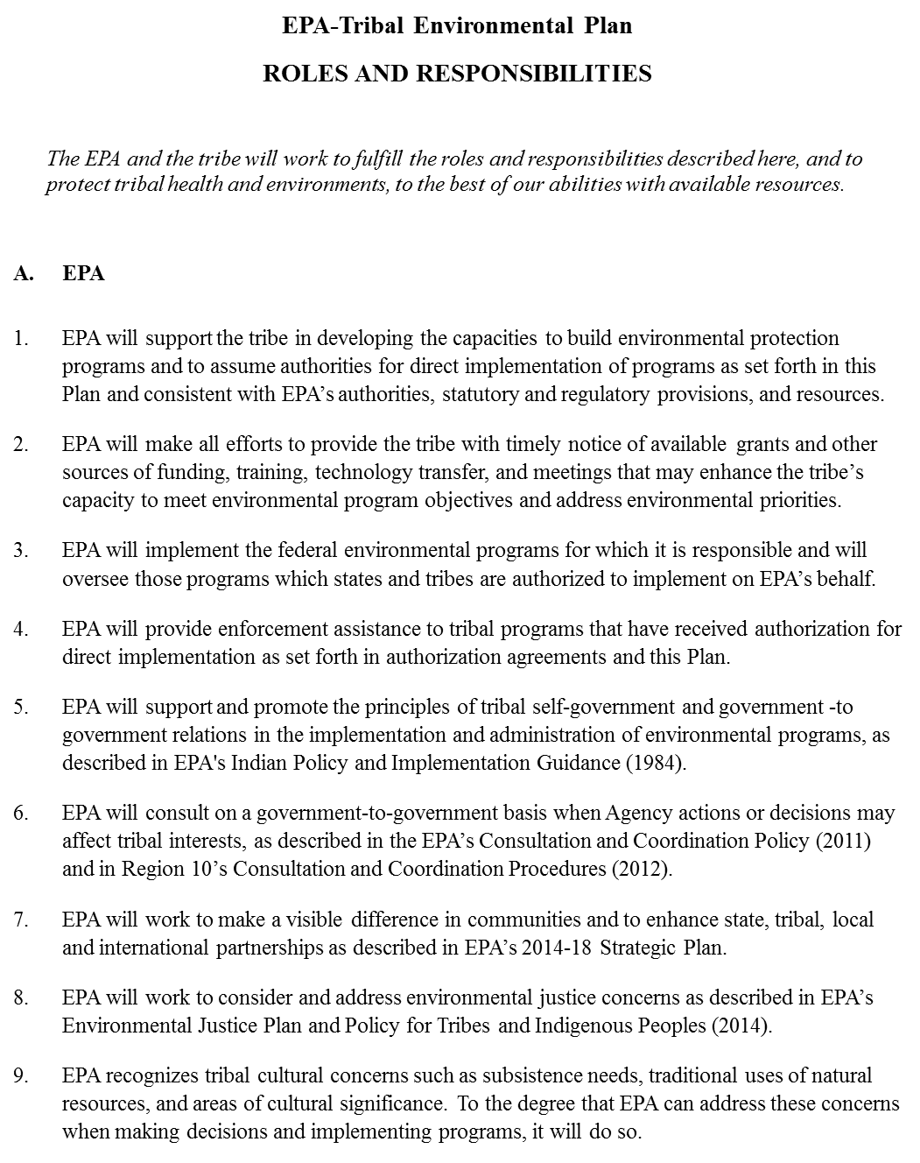

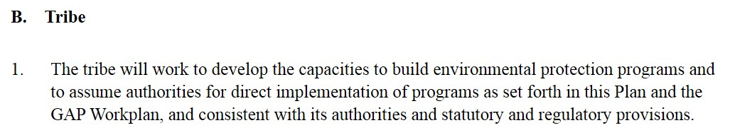

**Mutual Roles and Responsibilities for Tribal Program Development Milestones and Environmental Program Implementation**

The Village of Solomon will be responsible for accomplishments under the Indian Environmental General Assistance Program work plan with EPA’s technical assistance as needed.

EPA will monitor work plan commitment progress to ensure project completion.

EPA and VOS will ensure the current and future IGAP grants will reflect the Tribal Environmental Plan. Each component listed in the work plan will be monitored within a specific time frame to serve as implementation and momentum building in order for VOS to become self-sustaining within the component.

**Revision on February 7, 2019. Approved by the Traditional Council on _________ of _______________ 2019.**

**_____________________________________________ __________________**

**Signed by Date**