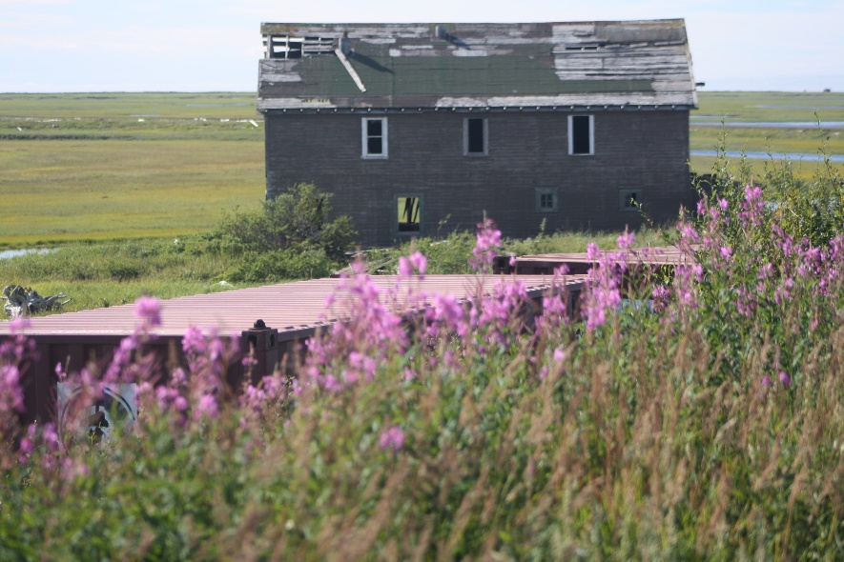

Village of Solomon
Renewable Energy Plan
August 12, 2017
REVISED 2/15/2018
PO Box 2053
Nome, Alaska 99762
(907) 443-4985
Igap.solomon@gmail.com

Table of Contents

Project Timeline……………………………………………………………………………………………3
Introduction…………………………………………………………………….…….…………………….4
Geography…………………………………………………………………….……….…………………….4
Background…………………………………………………………………………………..…………..…5
Vision Statement…………………………………………………………………….………………….…7
First Renewable Energy Community Gathering……………………………………….………..8
REP Gathering Notes..……………………………………………………….……….….……….…….8
Part II REP Gathering……………………………………………………………………………………9
Leadership Committee………………………………………………………………………………….10
Data Collection Survey’s………………………………………………………………………………11
REP Plan Objectives…………………………………………………………………………………….17
Technical Potential………………………………………………………………………………….…..17
Resource Assessment…………………………………………………………………………………..18
Implementation Plan……………………………………………………………………………………20
Appendix A: Funding sources……………………………………………………………………….22
Appendix B: Tribal member participation at REP events………………………………….23

Village of Solomon Project Timeline
0-2 years | 2-5 years | 5-10 years
Comprehensive Community Energy Audit | Mini Micro Grid in Solomon | More Homes/dwellings
Feasibility Study in Solomon | Solar Energy | Library
ELC Quarterly Meetings | Wind Energy | Washeteria
Meter on Generator for data usage | Power Utilities | Small Store
Ongoing Community Education | Water infrastructure | Clean Water
Home Assessments | Water storage | Sewer Facility
Weatherization Kits | Gasoline Storage | Gym
Community Building Insulation | Public Freezer for big Game in Solomon | Tank Farm
Wind turbine for Tribal Office | Grant Funding for dwellings
Energy Efficiency Measures | Public bathroom at the Bonanza Bridge

Introduction
The Village of Solomon is (VOS) a federally recognized Tribe under the Indian Reorganization Act of 1993. The Solomon Traditional Council is the governing body of the Village of Solomon. The primary purpose of the Village of Solomon is to design and implement programs to increase the quality of life and well-being of its family and Tribal Members who reside in Nome and Anchorage permanently and Solomon seasonally. In 2010, the Tribal Members and Traditional Council completed their first Local Economic Development Plan (LEDP) with the help of Solomon Native Corporation (SNC) and Kawerak, INC. VOS has completed their second LEDP to serve through 2020. With this plan, the Solomon Traditional Council created a list of priorities that will be addressed and revised every five years. VOS’ Environmental Plan was created to assist the Tribe of Solomon, Environmental Coordinator, Kawerak, Solomon Native Corporation and other various entities to better identify and find solutions, as well as to build capacity to start addressing the Environmental Issues in and around Solomon, AK.
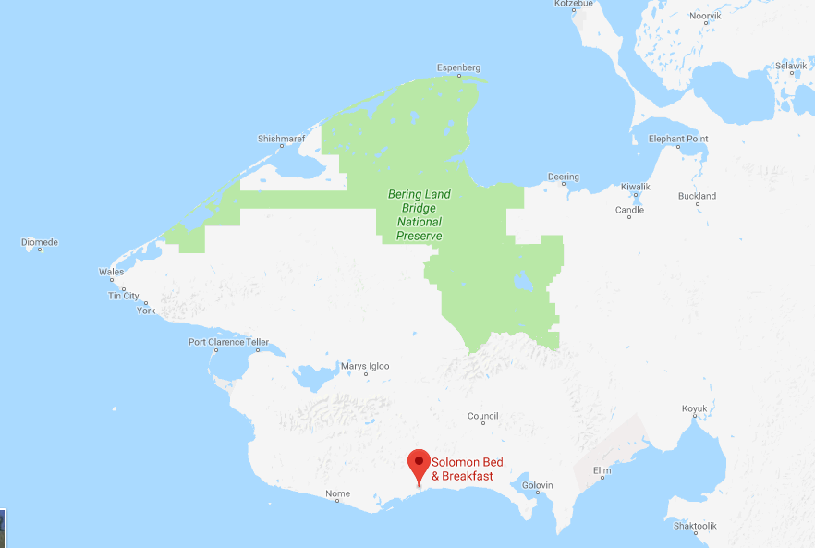
Geography
Solomon is located on the west bank of the Solomon River, one mile north of the Norton Sound, 34 miles east of Nome on the Nome-Council Highway. It lies at 64.560830 North Latitude and -164.43917 West Longitude. Solomon is located in the Cape Nome Recording District. The climate is both continental and maritime. Summers are short, wet and mild. Winters are cold and windy. The temperatures range from -30 to 56 degrees. The closest NOAA weather station is PAOM in Nome, AK, and data from this station is provided in figure 2. The area’s median average annual temperature and median annual precipitation from 2001-2016 were recorded at 33⁰F and 16 inches of water equivalent respectively.
Figure 1: Solomon geography

Figure 2: PAOM Annual Precipitation and Temperature

Background
The Village of Solomon was originally settled by Eskimo's of the Fish River Tribe, and was noted on the map as "Erok" in 1900. The original site was at the mouth of the Solomon River Delta, where it became a miner’s camp and later moved to the present location on Jerusalem Hill. The gold rush of 1899-1900 brought thousands of people to the Solomon area. By 1904 Solomon had seven Saloon's, a Post Office, a ferry dock, and between 3 and 7 big land dredges along the Solomon River. It was also the terminus of the Council City and Solomon River Railroad that serviced miner's from Solomon to Council. In 1913 the Railroad was washed out by storms and in 1918 the flu epidemic struck. The Bureau of Indian Affairs (BIA) built a school in 1940, but was shut down by 1956. Families began relocating to Nome or Anchorage so their kids can continue their education, and the Post Office was closed by 1958. Pete Curran operated the general store “the Roadhouse,” until the 1970's, which served as a checkpoint for the first several years of the Iditarod Sled Dog Race.
Today, Solomon serves as a seasonal village for community members with a few dwellings privately owned and originally built in the mid 1900’s, to include: the abandoned fallen down church (scheduled for clean-up by 2018), the re-purchased privately owned Roadhouse still stands and the reconstructed old BIA Schoolhouse that is now the tribally owned Bed & Breakfast/Solomon Community Center.
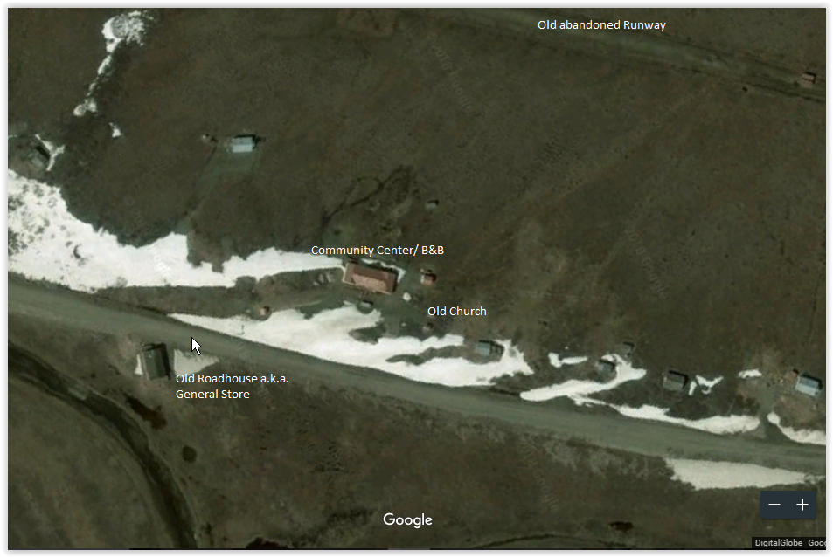

The village site had been relocated from the beach to Jerusalem Hill due to a flood in the early 1900’s. The current village location on Jerusalem Hill is approximately 34 miles south of Nome, Alaska off the Nome-Council Highway. Solomon has a dirt/gravel airstrip, 1,150 ft. long by 35 ft. wide, but is not maintained and currently not useable as a runway. The Highway is closed during the winter months which makes Solomon seasonal unless one travels by dog sled and/or snowmobile. The tribal council purchased tracks for the 4x4 Truck, which may be utilized for travel during the winter months as needed. The tribe has also received grant funds to make their Emergency Communication goal a reality. They partnered with a vocational school’s carpentry class to construct an insulated shed to place on mile 32 at our Iditarod marker and set up a Satellite phone charged by a car battery in case of an emergency for any travelers in the area. The Shelter cabin was named after the last Solomon inhabitant in 2004, Garfield Okitkon, for getting lost in a ground storm to gather firewood, catching pneumonia and passing a way a few days later.
The Community center established a 200 gallon potable water tank for seasonal residents, located outside of the center, and was funded by an Environmental Protection Agency grant award. The community center’s natural water source is tested by a lab annually for safe consumption.
The only electricity available in Solomon today, is the 10 kW diesel generator located in the generator house next to the Community Center. All other dwellings in Solomon could potentially have power if a stand-alone generator was individually used. Table 1 lists the available energy data for review and analysis.
Table 1: Available data for analysis
Solomon Community Center/Bed & Breakfast Data
Electricity Data usage (Robert Moss, AK Inspections Energy Audit 2014)
Diesel Generator 10kW for the Community Center at 2,704 square feet
West Furnace, efficiency 83.9%, oil fired
East Furnace, efficiency 83.5%, oil fired
Domestic Hot Water, efficiency 86.7%, oil fired storage tank
Space Heater West Meeting room, efficiency 73%, oil drip
Space Heater Central Meeting room, efficiency 73%, oil drip

Village of Solomon’s Energy Vision
“Develop and innovate Renewable Energy that is consistent with our cultural identity.”
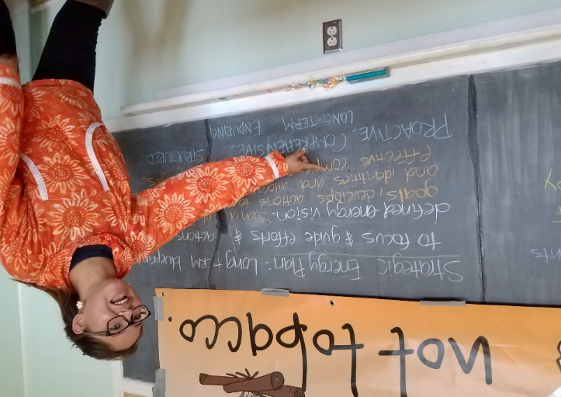
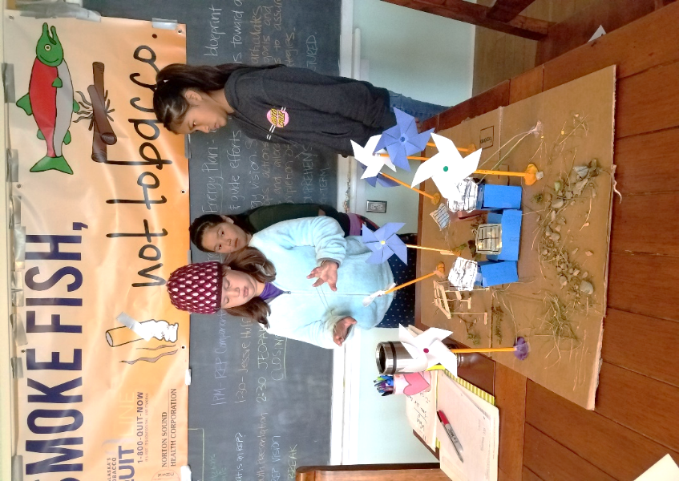
Solomon’s energy vision was created in 2017, partially to support the goal of returning Solomon to a year-round village. The community gathered for the first renewable energy planning session at the village community center in August of 2017. This was an opportunity to teach the youth about energy and allow council member and elders an opportunity to discuss energy visions with each other.
Figure 3 Environmental Coordinator leading the first Renewable Energy Plan Community Gathering
Figure 4 Pictured Youth Campers; Isabella, Jaylene and Destiny as they presented their community model.
The community defined their collective vision and their first approach at achieving their Alternative Energy for Solomon Village Priority, which has been listed on their Local Economic Development Plan since 2010. The first community gathering focused on Renewable Energy Planning (REP) efforts, and was hosted on the last day of the Annual Solomon Youth & Elder Camp at the Community Center. This gave the Environmental Coordinator a full week to educate the youth on Renewable Energy, which resulted in the youth campers creating a community model of Alternative Energy in Solomon.
In addition to creating an energy vision, a youth inspired REP, and goals and values, the community decided to form an Energy Leadership Committee (ELC). The members of the committee are tasked to advance Solomon’s energy goals and advocate Renewable Energy for all Tribal Membership. The committee is made up of four tribal members that responded to the invitation letter to serve at the Annual meeting in September 2017. The committee meets quarterly and serves as an advisory board to the community and council members.

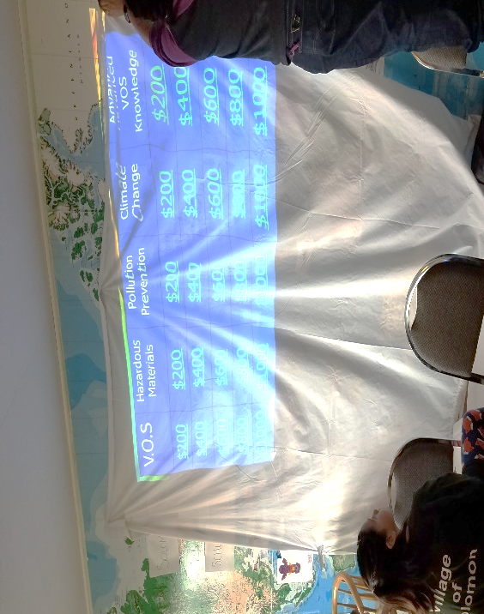
REP Gathering Agenda
Figure 5: Jeopardy Game
- Welcome, Intro & Goals of Planning Session
- What is Renewable Energy
- VOS Youth Presentation
- Renewable Energy Plan Vision, Goals, Values
- USDA Opportunities w/Jessie Huff
- Rob Bensin Input, future partnering
- Kawerak Partnerships, Community Energy Profile
- Closing Thoughts
- Environmental Educational Jeopardy Game

Table 2: RFP 1 Take-aways
REP Gathering Notes, Objective ideas
Identify Needs | Get Meter on generator for data usage
Educating tribal members/staff | Energy efficiency upgrades
Prioritizing Energy audit | Energy Committee @ Annual meeting
Future Potential Energy Audit | REP Document updates, 5 year increments
Form a Leadership Committee | Partner with Kawerak and DOE in the planning of the Renewable Energy Plan
Establish Goals at Annual Meeting and prioritize goals

PART II Renewable Energy Education Gathering Anchorage, Alaska

Figure 6: Homewood Suites. Anchorage, Alaska. December 2nd, 2017
Tribal Gathering Agenda:
- Welcome, Introductions
- Renewable Energy Video Presentation
- Renewable Energy Education activity
- Renewable Energy Plan Review & Discussions
- Jeopardy Game
- Survey Prizes Drawing
- Lunch & Environmental Coordinator Annual Meeting Video Presentation
- Conclude, closing comments

Leadership Committee Meeting
DRAFT AGENDA
ENERGY LEADERSHIP COMMITTEE
THURSDAY NOVEMBER 2ND, 2017
TIME TBD
- Introductions – what knowledge do you have on Renewable Energy already?
- Explain Renewable Energy Plan
- Establish goals of Energy Leadership Committee
- Objectives ‘sounding board’
- Responsibilities of ELC
- Commitment of ELC
- Weatherization Kits for TM homes
- Update them on drafted REP, send draft prior to meeting
- Closing comments
- Next meeting date

Data Collection
Tribal Membership Data Collection, collected through SurveyMonkey
First Survey Q&A, Collected August-November 2017
Question 1: Where do you live, and rent or own? | Answered: 17 | Skipped: 0
 | Location, rent or own | %, number of answers
 | Nome, rent | 11.76%, 2
 | Anchorage, rent | 11.76%, 2
 | Nome, own | 35.29%, 6
 | Anchorage, own | 11.76%, 2
Other responses | Illinois, own  Sterling, AK owned  Tacoma, WA, own  Big Lake, AK  Bertha, MN while husband’s deployed | 29.41%, 5
Question 2: Do you use Energy Saver/ Energy efficient appliances? | Answered: 16 | Skipped: 1
 | Yes | 68.75%, 11
 | No | 25.00%, 4
 | I don’t know what that is | 6.25%, 1
Question 3: A) What is your average monthly electricity bill? B) Do you know your electricity rate, what you pay per kWh? | Answered: 16 | Skipped: 1
 | - Monthly Bill | - Rate
 | $425
 | $250
 | $60-70
 | I don’t know
 | About $260
 | $100 on budget billing
 | $150
 | $300
 | $400-450
 | $43.98 | $0.042/kWh
 | $120
 | $473 | Don’t know my kWh but we have a very old house and need our wiring changed
 | I have no idea
 | $280 | Not sure
 | $150
 | $150-200 | Don’t know the kWh
Q4: What is your heat source? | Answered: 16 | Skipped: 1
 | Fuel | 75%, 12
 | Electric | 12.50%, 2
 | Stove | 6.25%, 1
 | I don’t know | 6.25%, 1
Q5: How many people live in your household? | Answered: 16 | Skipped: 1
 | How many people? | Other
 | 2
 | 2
 | 3
 | 5
 | 5
 | 5
 | 3 | Upper question: My heating source is a wood stove, pellet stove and a monitor.
 | 7
 | 2
 | 1 | 2 cats
 | 2
 | 8
 | 4
 | 6
 | 8
 | 5
Question 6: Have you ever had an Energy Audit or weatherization done in your home? | Answered: 16 | Skipped: 1
 | Yes | 6.25%, 1
 | No | 62.50%, 10
 | If No, would you like one? | 31.25%, 5
 | I have only had weatherization. | 0.00%, 0
Question 7: What is your average A) summer heat bill? B) Winter? | Answered: 15 | Skipped: 2
 | Summer | Winter
 | $0 | $320/month
 | We don't have a heat bill in summer...we do have a higher electric bill do to central air conditioning - $280 | Winter- $220 with gas bill about $250
 | In the process of moving and do not have a confirmed place of residency to comment on
 | I usually use 60 gallons of fuel between May and September
 | $139 Budget billing | $139 Budget billing
 | $200 wood, $200 pellets, $200 gas. For all year round I believe.
 | $200 | $400
 | Guessing $70 | $200
 | $25
 | 200.00 from April to Sept
 | I have no clue
 | $409 | $800
 | $0 | Winter fuel $600, wood $50
 | $150-200 | $200-250
Question 8: Would you be interested in taking a home energy efficient class? | Answered: 16 | Skipped: 1
 | Absolutely | 50.00%, 8
 | No thanks | 18.75%, 3
 | Possibly, if I was free | 31.25%, 5

Second Survey Q&A, Collected December 2017-January 2018.
Question 1: A) Do you spend any time in Solomon? B) If yes, when and with who? | Answered: 20 | Skipped: 0
 | - Time in Solomon | - When, who
 | Yes | Summer with family
 | No | But I wish I can
 | Yes | Fishing with my two girls
 | Not recently | 2016 with VOS Liz Johnson Curran
 |  | Summer with Family
 |  | Summers, and I’m with family
 | Yes | Spring, summer and fall
 | Yes | August. With the tribe for youth camp.
 | Not in Solomon but at my fish camp mile 31 | Spring, summer and fall, whatever fish and game is in season. Usually myself.
 | Yes | My great grandma as child once a year
 | Yes | When they first opened
 | Yes | With my family
 | Yes | During youth camp and during summer with family. We sometimes rent out rooms and stay weekends there.
 | Yes | Family in the summer
 |  | Solomon Youth Camp
 | Yes | With my grandson and cousin Rodney
 | Yes | Summertime with family and Solomon family
 | Yes | So far once, can’t wait to go back again
 | No
 |  | Family during visits to Nome
 |  | During youth camp with everyone who attends. Sometimes I will go fishing in the watershed or go to the beach.
Question 2: Would you be interested in moving to Solomon if it was made available? | Answered: 21 | Skipped: 0
 | Absolutely | 38.10%, 8
 | Maybe | 42.86%, 9
 | No | 19.04%, 4
Question 3: If you have a swelling in Solomon currently, do you need energy” i.e. heat, electricity? | Answered: 21 | Skipped: 0
 | Do not currently have a dwelling | 47.62%, 10
 | Shared Dwelling, need energy | 4.76%, 1
 | Shared Dwelling, do not need energy | 0.00%, 0
 | I have a dwelling and need energy | 9.52%, 2
 | N/A | 33.33%, 7
 | Other: My grandmother’s house needs energy | 4.76%, 1
Question 4: Would you consider building a dwelling in Solomon in the next 10 years? | Answered: 21 | Skipped: 0
 | Yes | 33.33%, 7
 | No | 9.52%, 2
 | Yes, if money was not an issue | 38.10%, 8
 | It is a possibility if energy becomes an available resource | 9.52%, 2
 | Other: 1) I already have a dwelling 2) I would like to have a cabin for camping in the summer | 9.52%, 2
Question 5: If you currently have a dwelling in Solomon, do you have water/sewer infrastructure? | Answered: 21 | Skipped: 0
 | No, I have an outhouse and no running water | 9.52%, 2
 | Yes, I have both | 0.00%, 0
 | Yes, I have running water. No sewer | 0.00%, 0
 | N/A | 85.71%, 18
 | Other: Grandmothers house has out house and no running water | 4.76%, 1
Question 6: Do you think additional housing is needed in Solomon? If so, How much? | Answered: 19 | Skipped: 2
 | A few more family houses
 | Yes. 2 to 4 more would be nice. And we can rent them out to help profit out Tribe.
 | I would love a camp down there to hang fish and hunt birds
 | No
 | Yes, but also land for people. I don’t know how 23 acres could sustain a town.
 | No
 | Yes. Enough for our Nome based tribal families.
 | No
 | Yes, for me it would be good because if some kind of weather event happens I can take shelter in Solomon
 | Yes, however many it takes to house whomever wants to move
 | Idk
 | Yes 6 houses
 | Maybe
 | Yes, 3 or 4 houses
 | About 15 family houses
 | 20 houses
 | I’m not sure
 | No
 | Yes! At least 10 houses and maybe an apartment complex.
Question 7: List at least 3 community facilities needed in Solomon, if any. | Answered: 17 | Skipped: 4
 | Meeting facility Library Play area for kids
 | A small store would be nice.
 | Roadhouse. Public restroom at Bonanza boat launch. 10 person bunk house
 | tank farm for heating fuel and gasoline storage. Water storage or water infrastructure. Power utilities
 | N/a
 | Laundromat Wind/sun energy More cabins for use by tribal members with water and energy.
 | Store, washeteria, movie theater
 | Can't think of any for now.
 | Maybe a mini mart.
 | Idk
 | Tribe Washeteria Internet
 | Landry hot water clean water
 | Washeteria, game processing plant, wastewater treatment, basic utilities
 | Store, utilities, and Maintance road to Nome in winter
 | A place for kids to play, like a gym, a library, and a school
 | N/A
 | Sewer facility. Grocery/Garden store, Gym, electricity building/micro-grid facility.

Renewable Energy Plan Objectives

Technical Potential
A technical potential analysis estimates the resources that can be used for large, commercial-scale renewable energy generation based on commercially available technologies, developable land, and system performance. It may not reflect the developable potential because it does not incorporate technology costs, competing land uses, transmission and infrastructure availability, policy, investor, or energy competitiveness environments. As technical potential considers commercial- scale projects only, a site-specific assessment for distributed applications, such as residential solar photovoltaics (PV) and micro wind, is needed to adequately evaluate the potential for small-scale renewable energy development on tribal land. Table 3 provides a summary of the Bering Straits Native Region’s technical potential for renewable energy. More detailed information on the methodology used to calculate technical potential is available at www‌.nrel‌.gov‌/docs‌/fy13osti‌/56641‌.pdf.
Table 3: Technical Potential of Various Renewable Energy Resources in the Bering Straits Native Region
Resource |  | Availability
Biopower from Solid Residues (MW) |  | 0 MW
Rural Utility PV Potential Installed Capacity (MW) |  | 634,522 MW
Rural Utility PV Available Land (km2) |  | 13,219 km2
Wind Potential Installed Capacity at 80m and GCF>=30% (MW) |  | 7,422 MW
Wind Available Land at 80m and GCF>=30% (km2) |  | 7,361 km2
Hydropower Capacity Potential (MW) |  | 28 MW
Geothermal Hydrothermal Potential Installed Capacity (MW) |  | 0 MW

Resource Assessment
The Bering Straits Native Region has potential for renewable energy generation. The highest technical potential is likely the development of rural utility-scale PV. Figure 7 illustrates the technical potential of renewable energy resources throughout the Bering Straits Native Region. For more information on the basics of renewable energy technology and links to further resources, see https://energy.gov/indianenergy/resources/education-and-training.
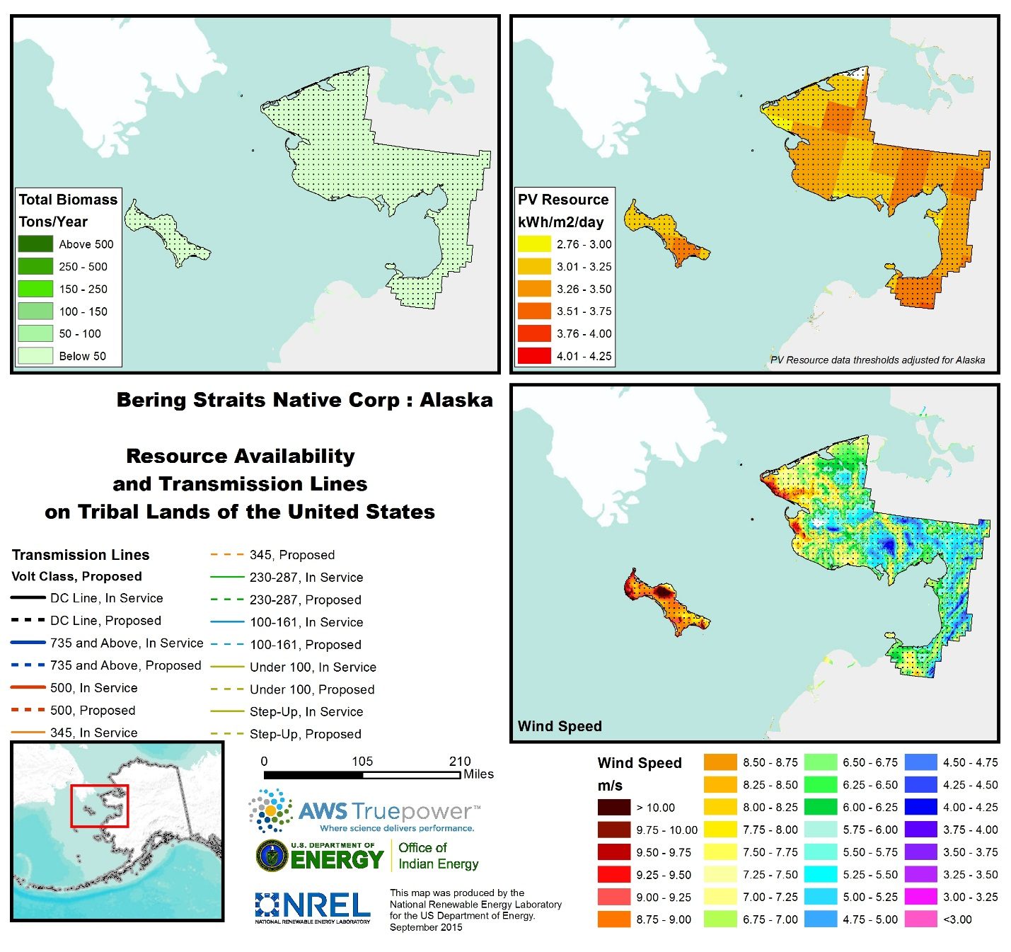
Figure 7: Resource Potential in the Bearing Straits Region:

Implementation Plan

Resources and Incentives
Several programs offer financial programs, technical assistance, and procurement support to help tribal communities achieve their energy goals. The programs below represent various assistance programs that may be leveraged to complete the Village’s energy related projects.
- The Energy Development Assistance Tool
  - Provides information for Tribes about federal grant, loan, and technical assistance programs available from more than 10 federal agencies to support energy development and deployment in Indian Country and Alaska Native villages.
    - https://energy.gov/indianenergy/energy-development-assistance-tool
- Grants
  - Programs that offer grants relevant to the above listed energy programs and projects include:
    - US Department of Energy
      - Energy Efficiency and Renewable Energy
      - http://www.energy.gov/indianenergy/office-indian-energy-policy-and-programs
    - US Department of Agriculture
      - Energy Efficiency and Community Upgrades
      - Rural Utility Service (electrical and communications)
      - http://www.usda.gov/wps/portal/usda/usdahome?navid=otr
    - Housing and Urban Development
      - Energy Efficiency and Housing Weatherization
      - http://portal.hud.gov/hudportal/HUD?src=/topics/grants
    - Bureau of Indian Affairs
      - Renewable Energy and Energy Offices
      - http://www.bia.gov/WhoWeAre/AS-IA/IEED/DEMD/TT/TF/index.htm
- Loan Programs
  - Programs that offer loans relevant to the above listed energy programs and projects include:
    - US Department of Agriculture and Rural Development
      - https://www.rd.usda.gov/programs-services/all-programs/electric-programs
    - Office of Indian Energy and Economic Development
      - https://www.bia.gov/WhoWeAre/AS-IA/IEED/index.htm
- Technical Assistance
  - Programs that offer technical assistance relevant to the above listed energy programs and projects include:
    - US Department of Energy:
      - Energy Efficiency and Renewable Energy (all technologies)
      - Strategic planning
      - Financing
      - http://www.energy.gov/indianenergy/office-indian-energy-policy-and-programs
    - Housing and Urban Development
      - Energy Efficiency, Weatherization
      - http://portal.hud.gov/hudportal/HUD?src=/topics/grants
    - Bureau of Indian Affairs
      - Renewable Energy
      - http://www.bia.gov/WhoWeAre/AS-IA/IEED/DEMD/TT/TF/index.htm
- Procurement
  - The following entities offer procurement assistance:
    - GSA
      - Comprehensive
      - https://www.gsaglobalsupply.gsa.gov/
- Alaska Programs and Incentives
  - Additional programs and incentives specific to Alaska are also available:
    - http://programs.dsireusa.org/system/program?fromSir=0&state=AK
    - Alternative Energy Conservation Loan Fund
      - https://www.commerce.alaska.gov/web/ded/FIN/LoanPrograms/AlternativeEnergyLoanProgram.aspx
    - AIDEA Loan Program
      - http://www.aidea.org/Programs/LoanParticipation.aspx

Alaska State Policies and Incentives
Alaska employs a suite of regulatory policies and financial incentives related to renewable energy and energy efficiency; although, the state does not have a renewable portfolio standard or goal. Furthermore, all utilities with annual retail sales of 5,000 megawatt-hours (MWh) or more must offer net metering for renewable energy systems, however, the overall enrollment is limited to 1.5% of a utility’s retail sales from the previous year and a system capacity limit of 25 kilowatts (kW). Customers are compensated monthly for net excess generation (NEG) at a “non-firm rate” or essentially the avoided-cost rate which is carried over indefinitely to the following billing periods. The state has also promulgated interconnection guidelines, although not the preferred IREC standards, to facilitate the interconnection process.
There are a variety of financial incentives available to those interested in developing renewable energy and energy efficiency projects in Alaska. Among these incentives are property tax incentives, loan programs, rebates, and renewable energy grant programs. More detailed information on financial incentives is available on the Alaska Energy Authority website (http://www.akenergyauthority.org/) as well as within the Database of State Incentives for Renewables & Energy Efficiency (www.dsireusa.org).

Appendix A: Potential funding sources

FUNDING SOURCES
Alaska Energy Authority – Jed Drolet, 907-771-3000
Energy Audit, Category 1,2 or 3. VOS Would pay 25% of the audit
USDA Rural Energy for America Program (REAP) – Jessie Huff 907-761-7768
25% grant to implement the items in the energy audit, VOS would pay 75% of the Energy Efficiency upgrades
Community Facilities Loans & Grants Program, Rural Community Development Initiative
Dept. of Energy – Givey K. (we know Givey, he is familiar with VOS) Free Technical Assistance
Kawerak, Inc. – Obie Simonis, Leroy Seppilu
Planning and strategizing/prioritizing a Renewable Energy Plan, Community Energy Profile funds, request more info

Appendix B: Tribal member participation at REP events
First Renewable Energy Community Gathering Attendees:
Village of Solomon Tribal Member Youth Camp Attendees; Helen Bohn, Cheryl Kalerak, Amy Johnson, Helen Larsen, Brewster Bohn, Bronson Bohn, Isabella Bohn, Tessa Payenna, Kim Henry, Phillip Henry, Derrick Henry, Skylar Henry, Brandon Henry, Peter Curran, Autumn Johnson, Tristan Hudson, Sophia Piscoya, Fitz Piscoya, Ethan Piscoya, Jennifer Curran
Kirsten Timbers, Traditional Council President
Liz Johnson, Traditional Council Secretary, Tribal Coordinator, Solomon Native Corporation President
Cameron Piscoya. Traditional Council Vice President
Jessie Huff, USDA State Energy Coordinator
Leroy Seppilu, Energy Specialist Kawerak Inc.
Obie Simonis, Community Planning Dept. Director Kawerak Inc.
Robert Bensin, Energy Efficiency & Renewable Energy Division Manager BSDC
Part II Renewable Energy Community Gathering Attendees:
Cheryl & Ron Komakhuk, Jaylene ____, Harmony Huntsman, Jaxson Huntsman, Vicki Olson, Sarah Tumulak, Luella Tumulak, Liz Johnson, Liam Nyitrai, Deilah Johnson & Helen Larsen. Not Pictured: Annette Piscoya, Amy & Autumn Johnson, Manuel Tumulak, Dilyn Tumulak & Michael Kuca (Office of Indian Energy, DOE).

An UberConference call was available for Tribal members to call in, Amy Johnson opened the office in Nome and made the conference line available as well as the video presentations. There is an audio recording available online at https://www.uberconference.com/getmp3/AMIfv96Cq57Y4QRHtQaQQVLCxbqucWXLfpY82w_9vjicRDld5vHBWYHc_fxHfwuI27PdfuDaEcBQHsZp_Rpb7VfiRrpxkl-3H5gaakjUUniDZsAmTJEdcqxd0wfq9wNbsg6-GKoDkrTy_Csux2NW62KF6_i27RTE-w.mp3
A video presentation played during the gathering is available here: https://www.youtube.com/watch?v=cPHeyOWCJ5M&t=16s

Energy Leadership Committee members:
Elizabeth Johnson, Tribal Coordinator, Tribal Member, Traditional Council Secretary and Solomon Native Corporation President.
Grace Davenport, Tribal Member.
Timothy Stettinger, Tribal Member.

Traditional Council members:
President, Kirsten Timbers (see Solomon Native Corporation)
Vice President, Cameron Piscoya
Treasurer, Annette Piscoya
Secretary, Liz Johnson (see Staff, Energy Leadership Committee)
Assistant Secretary, Sarah Tumulak
Ad-Hoc Youth, Alex Gray
Ad-Hoc Elder, Myrtle Komakhuk
Staff:
Tribal Coordinator, Liz Johnson (see Traditional Council, Energy Leadership Committee, Solomon Native Corporation)
Environmental Coordinator: Deilah Johnson
Grant Writer: Deilah Johnson
Field Worker: Derek Johnson

